**PROPERTY MANAGEMENT SYSTEM**

**A**

**Project Report**

***Submitted in partial fulfillment of the requirement for the award of***

***Degree of***

**Bachelor of Computer Applications**

**Submitted to**

**CIMAGE PROFESSIONAL COLLEGE**



|  |  |  |
| --- | --- | --- |
| **Submitted By** |  | **Under Guidance of** |
| **Prince Kumar** |  | **Ravi Soni Sir** |
| Registration No. 19303310040 |  | Asst. Professor |
| BCA-6TH Sem  Session-2019-2022 |  | Computer Science & Information Technology |

 **Cimage Professional College**

**Department of Computer Science & Information Technology**

**Session 2019-22**

**Date:………………………**

**Certificate**

This is to certify that the work embodies in this project entitled, **PROPERTY MANAGEMENT SYSTEM,** being submitted by **Prince Kumar (19303310040)** in partial fulfillment of the requirement for the award of “**Bachelor of Computer Applications”** to ***ARYABHATTA KNOWLEDEGE University, Patna*** during the academic year 2019-22 is a record of bonafide piece of work, carried out by him/her under our/my supervision and guidance in the **“Department of Computer Science & information Technology”, Cimage Professional College .**

**Prof. Neeraj Agrawal Er. Amit Kumar Shukla Ravi Kumar Soni**

Director Head of Department-IT Assistant Professor-IT

**Cimage Professinal College**

 **Department of Computer Science & Information Technology**

**Session 2019-22**

**Date:---------------------------**

**Approval Certificate**

 The project report entitled **PROPERTY MANAGEMENT SYSTEM,** being submitted by **Prince Kumar (19303310040)** has been examined by us and is hereby approved for the award of degree “**Bachelor of Computer Applications”,** for which it has been submitted. It is understood that by this approval the undersigned do not necessarily endorse or approve any statement made, the opinion expressed or conclusion drawn therein, but approve the project only for the purpose for which it has been submitted.

Internal Examiner External Examiner

Date: Date:

**CIMAGE Professional College**

 **Department of Computer Science & Information Technology**

**Session 2019-22**

**Date:---------------------------**

**Declaration**

I, **Prince Kumar** hereby declare that the work, which is being presented in the project report entitled **PROPERTY MANAGEMENT SYSTEM,** partial fulfillment of the requirements for the award of degree of “**Bachelor of Computer Applications”** submitted in the department of **Computer Science & Information Technology (CIMAGE Professional College)** is an authentic record of my own work carried under the guidance of **Ravi Kumar Soni**. I have not submitted the matter embodied in this report for the award of any other degree.

**Prince Kumar**

Registration No : **19303310040**

BCA 6TH Sem

Session-2019-2022

**ACKNOWLEDGEMENT**

*“A journey is easier when you travel together. Interdependence is certainly more valuable than independence.”*

I would like to thanks, **Er. Neeraj Kumar Singh Sir and Prof. Ravi Kumar Soni Sir**, for providing regular guidance and insight into my project work. I also thank them for all advice he has given me in the past year, and for always having time for me, whenever I needed.

I give special thanks to **Er. Amit Kumar Shukla** **Sir, Er. Dinesh Kumar Sir, Er. Nilesh Sir** for always being willing to help find solutions to any problems I had with my work.

***“The completion of any project depends upon the cooperation, coordination, and combined efforts of several resources of knowledge, inspiration, and energy”.***

I also extend my deepest gratitude to **Director**, CIMAGE GROUP OF INSTITUITIONS, PATNA, **Prof. Neeraj Agrawal Sir, Dean** CIMAGE GROUP OF INSTITUITIONS, PATNA, **Prof. Neeraj Kumar Sir** and **Centre Head Mrs. Megha Agrawal Mam** for providing all the necessary facilities and true encouraging environment to bring out the best in my endeavors.

I express my gratitude and thanks to all the staff members of Computer Science departments for their sincere cooperation in furnishing relevant information to complete this Project well in time successfully.

I extend a special word to my friends, who have been a constant source of inspiration throughout my project work.

Lastly but not least I must express my cordial thank to my parent and family members who gave me the moral support without that it is impossible to complete my project work. With this note, I thank everyone for the support.

**Prince Kumar**

Registration No : **19303310040**

BCA 6TH Sem

Session-2019-2022

Contents

INTRODUCTION 8

OBJECTIVE 9

FEATURE OF THE PROJECT 10

MODULE OF PROJECT 11

TOOLS/PLATFORM REQUIRED 13

HARDWARE & SOFTWARE REQUIREMENTS 13

GANTT CHART 14

PROGRAMMING LANGUAGE 16

HTML 17

CSS 19

BOOTSTRAP 22

JAVASCRIPT 23

MYSQL 25

PERT CHART 27

FEASIBILITY STUDY 29

SCOPE AND FUTURE ENHANCEMENT 34

IMPLEMENTATION METHODLOGY 35

TESTING 36

SYSTEM ANALYSIS 39

DATA FLOW DIAGRAM 40

CODE OF PROJECT 44

SAMPLE PROJECT

# INTRODUCTION

This project will effectively in managing property for the user whether Be it selling ,buying ,or renting of land or home, it will provide owners option to upload their contact details and details about the property he want to sell or open for rent and buyer and hirer can get the details about property and also about owner by which he can contact for buying or hiring that property from the owner.

# OBJECTIVE

The motive of the project entitled “**Property Management System”** is to maintain the selling , buying and renting of land or home for the owner , hire and buyer with convenience.

**The objectives of this system:**

* To manage the selling,renting for owner.
* Record the information uploaded by seller
* Provide useful information to buyer
* Ensure the security details uploaded by owner

# FEATURE OF THE PROJECT

* To see all the properties which are open for sell
* To see all the properties which are open for rent
* Those who want to upload their property for sale can upload on it
* Those who want to upload their property for rent can upload on it
* If you want you buy or hire any property you can see its price
* Agents are also their to assist you if you want any help.And much more….

# MODULE OF PROJECT

* **Sell** :- Before entering this module login first is mandatory.In this section those who want to sell their properties can upload the details about their property which will include location of property,dimension of property, image of that property , name of owner ,contact details of owner which will include their name ,address , mobile number , whatsapp number,price etc.

* **Buy :-** In this section those who want to get details about any property which is uploaded on this web they need to login first after that they can navigate through all the properties which is open for sale.User who is looking for buying any property can see information about the property like image of that property, address of that property ,contact details of that owner,price etc.
* **Rent:**- In this section those who want to upload their property for rent can upload in it , the details about their property which will include location of property,dimension of property, image of that property , name of owner ,contact details of owner which will include their name ,address , mobile number , whatsapp number,price etc.

* **Hirer:-** In this section those who want to get details about any property which is uploaded on this web they need to login first after that they can navigate through all the properties which is open for rent.User who is looking for buying any property can see information about the property like image of that property, address of that property ,contact details of the owner,price etc.
* **Agent:-** In this section those who user who want any assistance for any issue related to buying of property , selling of property or renting of property can get it by contacting with authorized expert agent who can give them valid solutions.
* **About us:**- In this section those user who want to contact to administration for any issue related to this web can contact via chatting with them , mobile calling , visit office via location provided on web , social media official page of this web like Instagram , facebook , gmail , twitter etc .
* **Properties** :- In this section those who want to buy or hire on rent any property , can specify the property after entering details in it on like price minimum to maximum , location ,dimension , etc. and after entering they can view the specified property .
* **Property in Metro**:-By this section people can navigate directly to the metro cities of india like delhi , Mumbai , banglore etc. where properties are available for sell or rent can navigate through it and can get details about the property , those properties he/she will like.

# TOOLS/PLATFORM required

**Operating System**

* Windows 7 and above.

## HARDWARE & SOFTWARE REQUIREMENTS

**Hardware Requirements:**

* Dual core Processor
* 512 MB RAM
* 80 GB Hard Disk

**Software Requirements:**

* Web browser
* Web server

# gantt chart

Gantt charts (developed by Henry L. Gantt) are a project control technique that can be used for several purposes including scheduling, budgeting and resource planning. A Gantt chart is a bar chart with each bar representing an activity.

The bars are drawn against a time line. The length of each bar is proportional to the length of time planned for the activity. Gantt chart can take different phase depending on their intended use. The Gantt chart of **Property Management System** is drawn for the time management. The Gantt chart is drawn below:

**YEAR 2022**

**15th May 31s May 10th April 25th June 10th July 25th July 31th May**

**Start**

**Analysis**

**Design of front-end**

**Report Generation**

**Write Manual**

**Integration & Testing**

**Finish**

**Designing of Database**

# Programming language

********

# HTML

HTML, or Hyper Text Markup Language, allow web users to create and structure sections, paragraphs, and links using elements, tags and attributes. However, it’s worth noting that HTML is not considered a programming language as it can’t create dynamic functionality.

**HTML has a lot of use cases, namely:**

* **Web Development:** Developers use HTML code to design how a browser displays web page elements, such as text, hyperlinks, and media files.
* **Internet navigation**. Users can easily navigate and insert links

between related pages and websites as HTML is heavily used to embed hyperlinks.

* **Web documentation**. HTML makes it possible to organize and format documents, similarly to Microsoft Word.

It’s also worth noting that HTML is not considered a

programming language as it can’t create dynamic functionality. It is now considered an official web standard. The World Wide Web Consortium (W3C) maintains and develops HTML specifications, along with providing regular updates

HTML documents are files that end with a .html or .htm extension. A web browser reads the HTML file and renders its content so that internet users can view it.

Originally, HTML was developed with the intent of defining the structure of documents like headings, paragraphs, lists, and so forth to facilitate the sharing of scientific information between researchers. Now, HTML is being widely used to format web pages with the help of different tags available in HTML language

# CSS

CSS is a language for specifying how documents are presented to users – how they are styled, laid out, etc.

A document is usually a text file structured using a markup language Presenting a document to user means converting in into a form usable by your audience. Browsers, like Firefox, or Edge are designed to present documents visually, for example, on a computer screen, projector, or printer.

Cascading Style Sheets (CSS) is a style sheet language used for describing the presentation of a document written in a markup language such as HTML or XML (including XML dialects such as SVG, MathML or XHTML). CSS is a cornerstone technology of the World Wide Web, alongside HTML and JavaScript.

CSS is designed to enable the separation of presentation and content, including layout, colors, and fonts. This separation can improve content accessibility; provide more flexibility and control in the specification of presentation characteristics enable multiple web pages to share formatting by specifying the relevant CSS in a separate .css file, which reduces complexity and repetition in the

structural content; and enable the .css file to be cached to improve the page load speed between the pages that share the file and its formatting.

Separation of formatting and content also makes it feasible to present the same markup page in different styles for different rendering methods, such as on-screen, in print, by voice (via speech-based browser or screen reader), and on Braille-based tactile devices. CSS also has rules for alternate formatting if the content is accessed on a mobile device.

CSS is a MUST for students and working professionals to become a great Software Engineer specially when they are working in Web Development Domain. I will list down some of the key advantages of learning CSS:

Create Stunning Web site - CSS handles the look and feel part of a web page. Using CSS, you can control the color of the text, the style of fonts, the spacing between paragraphs, how columns are sized and laid out, what background images or colors are used, layout designs,variations in display for different devices and screen sizes as well as a variety of other effects.

Become a web designer - If you want to start a carrer as a professional web designer, HTML and CSS designing is a must skill.

Control web - CSS is easy to learn and understand but it provides powerful control over the presentation of an HTML document. Most commonly, CSS is combined with the markup languages HTML or XHTML.

Learn other languages - Once you understands the basic of HTML and CSS then other related technologies like javascript, php, or angular are become easier to understand.

Multiple Device Compatibility - Style sheets allow content to be optimized for more than one type of device. By using the same HTML document, different versions of a website can be presented for handheld devices such as PDAs and cell phones or for printing.

Global web standards - Now HTML attributes are being deprecated and it is being recommended to use CSS. So its a good idea to start using CSS in all the HTML pages to make them compatible to future browsers.

# BOOTSTRAP

Bootstrap is a [free and open source](https://www.techtarget.com/whatis/definition/Free-and-open-source-software-FOSS-or-free-libre-open-source-software-FLOSS) [front end](https://www.techtarget.com/whatis/definition/front-end) development framework for the creation of websites and [web apps](https://www.techtarget.com/searchsoftwarequality/definition/Web-application-Web-app). The [Bootstrap framework](https://www.theserverside.com/quiz/12-tough-Bootstrap-5-quiz-questions-for-web-developers) is built on [HTML](https://www.theserverside.com/definition/HTML-Hypertext-Markup-Language), [CSS](https://www.theserverside.com/definition/cascading-style-sheet-CSS), and JavaScript ([JS](https://www.theserverside.com/definition/JavaScript)) to facilitate the development of [responsive](https://www.techtarget.com/whatis/definition/responsive-design), [mobile-first](https://www.techtarget.com/searchmobilecomputing/definition/mobile-first) sites and apps.

Responsive design makes it possible for a web page or app to detect the visitor’s screen size and orientation and automatically adapt the display accordingly; the mobile first approach assumes that [smartphones](https://www.techtarget.com/searchmobilecomputing/definition/smartphone), [tablets](https://www.techtarget.com/searchmobilecomputing/definition/tablet-PC) and task-specific Mobile apps are employees' primary tools for getting work done and addresses the requirements of those technologies in design.

Bootstrap includes user interface components, layouts and JS tools along with the framework for implementation. The software is available precompiled or as [source code](https://www.techtarget.com/searchapparchitecture/definition/source-code).

Mark Otto and Jacob Thornton developed Bootstrap at Twitter as a means of improving the consistency of tools used on the site and reducing maintenance. The software was formerly known as Twitter Blueprint and is sometimes referred to as Twitter Bootstrap.

In computers, the word bootstrap means to boot: to load a program into a computer using a much smaller initial program to load in the desired program (which is usually an operating system).

# JavaScript

JavaScript, often abbreviated JS, is a programming language that is one of the core technologies of the World Wide Web, alongside HTML and CSS. As of 2022, 98% of websites use JavaScript on the client side for web page behavior, often incorporating third-party libraries. All major web browsers have a dedicated JavaScript engine to execute the code on users' devices.

JavaScript is a high-level, often just-in-time compiled language that conforms to the ECMAScript standard.[14] It has dynamic typing, prototype-based object-orientation, and first-class functions. It is multi-paradigm, supporting event-driven, functional, and imperative programming styles. It has application programming interfaces (APIs) for working with text, dates, regular expressions, standard data structures, and the Document Object Model (DOM).

Javascript is a MUST for students and working professionals to become a great Software Engineer specially when they are working in Web Development Domain. I will list down some of the key advantages of learning Javascript:

Javascript is the most popular programming language in the world and that makes it a programmer’s great choice. Once you learnt Javascript, it helps you developing great front-end as well as back-

end softwares using different Javascript based frameworks like jQuery, Node.JS etc.

Javascript is everywhere, it comes installed on every modern web browser and so to learn Javascript you really do not need any special environment setup. For example Chrome, Mozilla Firefox , Safari and every browser you know as of today, supports Javascript.

Javascript helps you create really beautiful and crazy fast websites. You can develop your website with a console like look and feel and give your users the best Graphical User Experience.

JavaScript usage has now extended to mobile app development, desktop app development, and game development. This opens many opportunities for you as Javascript Programmer.

Due to high demand, there is tons of job growth and high pay for those who know JavaScript. You can navigate over to different job sites to see what having JavaScript skills looks like in the job market.

Great thing about Javascript is that you will find tons of frameworks and Libraries already developed which can be used directly in your software development to reduce your time to market.

# MYSQL

MySQL is a relational database management system based on the Structured Query Language, which is the popular language for accessing and managing the records in the database. MySQL is open-source and free software under the GNU license. It is supported by Oracle Company.

Our MySQL tutorial includes all topics of MySQL database that provides for how to manage database and to manipulate data with the help of various SQL queries. These queries are: insert records, update records, delete records, select records, create tables, drop tables, etc. There are also given MySQL interview questions to help you better understand the MySQL database.

**Advantage of MySql :-**

DATA SECURITY:- MySQL is globally renowned for being the most secure and reliable database management system used in popular web applications like Wordpress, Drupal, Joomla, Facebook and Twitter. The data security and support for transactional processing that accompany the recent version of MySQL, can greatly benefit any business especially if it is an E-Commerce business that involves frequent money transfers.

THE FLEXIBILITY OF OPEN SOURCE:-All the fears and worries that arise in an open source solution can be brought to an end with My SQL’s round-the-clock support and enterprise indemnification. The secure processing and trusted software of MySQL combine to provide effective transactions for large volume projects. It makes maintenance, debu- gging and upgrades fast and easy while enhancing the end-user experience.

REDUCE TOTAL COST AND OWNERSHIP:-By migrating current database apps to MySQL, enterprises are enjoying significant cost savings on new projects. The dependability and ease of management that accompany MySQL save your troubleshooting time which is otherwise wasted in fixing downtime issues and performance problems.

COMPLETE WORKFLOW CONTROL:-With the average download and installation time being less than 30 minutes, MySQL means usability from day one. Whether your platform is Linux, Micro-soft, Macintosh or UNIX, MySQL is a comprehensive solution with self-management features that automate everything from space expansion and configuration to data design and database administration.

ROUND THE CLOCK OF UPTIME:-MySQL comes with the assurance of 24X7 uptime and offers a wide range of high availability solutions like specialized cluster servers and master/slave replication configurations.

HIGH PERFORMANCE:-MySQL features a distinct storage-engine framework that facilitates system administrators to configure the MySQL database server for a flawless performance. Whether it is an E- Commerce website that receives a million queries every single day or a high-speed transactional processing system, MySQL is designed to meet even the most demanding applications while ensuring optimum speed, full-text indexes and unique memory caches for enhanced performance.

# PERT CHART

PERT (Project Evaluation and Review Technique) charts consist of a network of boxes and arrows. The boxes represent activities and the arrows represent task dependencies.

PERT is organized by events and activities or tasks. PERT have more advantages and they are likely to be used for more complex projects. Through PERT chart the various task paths are defined. PERT enables the calculation of critical path. Each path consists of combination of tasks, which must be completed. The time and the cost associated with each task along a path are calculated, and the path that requires the greatest amount of elapsed time is the critical path. Calculation of the critical path enables project manager to monitor this series of task more closely than others to shift resources to it, if it begins to fall behind schedule.

PERT controls time and cost during the project and also facilitate finding the right balance between completing a project on time and completing it within the budget. There are thus not one but many critical paths, depending on the permutations of the estimates for each task. This makes analysis of critical path in PERT charts very complex. The PERT chart representation of the **Property Management System** is shown below.

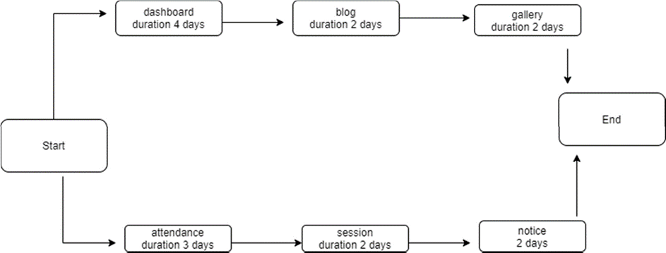

# FEASIBILITY STUDy

Not everything imaginable is feasible, not even in software, even as it may appear to outsiders. Feasibility is the determination of whether or not a project is wrong doing on the contrary, software feasibility has seven solid dimensions as below:-

* Technical feasibility
* Operational feasibility
* Economical feasibility
* Social feasibility
* Management feasibility
* Legal feasibility
* Time feasibility

The processes followed in making this determination is called a feasibility study. The type of feasibility determines if a project can and should be taken. Once it has been determined that a project is feasible, that analyst can go ahead and prepare the project the project specification which finalizes project requirements. Generally, feasibility studies are undertaken within tight time constraints and normally culminate in a written and oral feasibility report. The contents and recommendation of such a study will be used as a sound basis for deciding whether to processed, postpone or cancel the project. Thus, since the feasibility study may lead to the commitment of large resources, it becomes necessary that it should be conducted competently and that no fundamental errors of judgement are made.

In others words we can say that a feasibility study is conducted to select the best system that meets performance requirement. This contains and identification description, an evaluation of candidate system and the selection of best system for the job.

The system required a statement of constraints; the identification of specific system objective and description of outputs define performance.

TECHNICAL FEASIBILITY:-

Technical feasibility is concerned with specifying equipment and software that will successfully satisfy the user requirement. My project is fit in technical feasibility because

it requires neither too much heavy configuration system for its run nor in its development.

Following hardware and software components are used in the development of proposed system.

The same configuration system is also meets all the requirements to run or for implements to run or for implementation of system. Thro-ugh I have also tested this software for that systems the systems whose configuration is lower than the specified.

ECONOMICAL FEASIBILITY:-

Economic analysis is the most frequently used technique for evaluation of the effectiveness of a proposed system. More commonly known as cost/benefit analysis, the procedure is to determine the benefits and saving that are expected from a proposed system and compare them with costs. If benefits outweigh costs, a decision is taken to design and implement the system. Other weight costs, a decision is taken to design and implement the system. Otherwise, further justification or alternative in the proposed system will have to made if is to have a chance of being approved. This is an ongoing effort that6 improves in accuracy at each phase system life cycle.

Before establishing Economical feasibility so as to justify the expenses that different organization working under this category has bear for this software. It is crystal clear that the user or customer of this software has no need to invest heavy amount for this software. As my project has been written in such a language, which is a platform independent. It has also the

feature of WORM.It means possess the technology of write once and read many.

OPERATIONAL FEASIBILITY:-

My project I also fit in operational feasibility study. As I have explained before this about Technical feasibility and Economical feasibility, this software is very easy and under- friendly.

I have used a very easy menu system and also used some control buttons in the easy way by which one can choose the option on his desire.

Through this is fully protected with the security by world (password and user name), if both are matched only once can get access of this software.

Various reports, forms and queries can generated on the fingerprintsfor the user.

In nutshell we can say that it has following operational features:

1.It is a user-friendly.

2.It is having less tractability.

3.It is having less paperwork.

4.Query can be generated.

5.Various reports and forms can be generated.

6.Fully protected by password and user name for unauthorized access.

# SCOPE AND FUTURE ENHANCEMENT

.

The scope of project “**Property Management of System”** is to enable the buyers to search for property listings online.The motive of developing this application is to design a feature search engine which can make the search of commercial land/properties an easy task.

User can easily hire any property according to their needs with convenience and it will increase the hiring of land and home also.

It will reduce use of paper from banner.Reducing searching for property which is use to done by visiting that place , it will save time. If you want you buy or hire any property you can see its price

# IMPLEMENTATION METHODLOGY

Implementation of a tested system is done on the actual location with the actual hardware, software and manpower platforms or limitation. To implement of this software, the following are the necessary.

This project run on internet or intranet, so I have to selected internet supportive software. For implementing this software a web server is required. I have to install IIS (internet information service). Know this project is web based so it will need a web- browser which will act as its interface, so for this project such as internetExplorer/Mozilla Firefox /opera etc. and many other browser. And for back-end operation, I have to install XAMPP which handle all the software. In future also use better database. We know that this project will be developed on heavy platform PHP with JAVASCRIPTS, so there is requirement of advance processor and proper RAM and other advance hardware configuration.

# TESTING

Software testing consist of the following stages:

**TEST PLAN DEVELOPMENT:-**

The importance of software testing and its implications need not be emphasized. Software testing is critical element of software quality assurance and represented the ultimate review of specifications, design and coding. The main objective of testing is to uncover a host errors, systematically, with min-mum effort and time.

**TESTING STRATEGY:-**

A testing strategy explains how to conduct a test to uncover all the errors with minimum possible time and effort. It should be flexible enough to promote customization that may be necessary in due course of development process.

**UNIT TESTING:-**

Unit testing focuses verification effort on the smallest unit of the software module using the detailed design criteria. Process specification testing are done to uncover errors within the boundaries of the module. All module must be successful in the unit test before start of the integration testing. The software developed for e-banking is tested module wise by giving normal values and extreme values input. All the bugs have been identified and removed. The software designed is tested module wise. Before using the software, an employee has to give organization name and password.

In next stage he has to provide division name, employee ID and password. If any of this information is wrong, the gives an error message- “ invalid user and password”.

**INTEGRATION TESTING:-**

It is a systematic technique for constructing different program module in to an integrated software structure. This test uncovers the errors during integration process. The integration aspect is tested after integrating all the module and validated.

**VALIDATION TESTING:-**

After the culmination of integration testing the software is ready as per the specification. But it has to be validated as per specification and uncover the unexpected future errors and to improve its reliability. The random value and boundary values as input is fed to the software developed and studied the software performance and validated.

**CONDITIONAL TESTING:-**

Conditional testing is test case design method that exercise the logical conditions contained statement are a Boolean operator, Boolean variable, relational operator, arithmetic expression and parenthesis.

# SYSTEM ANALYSIS

Systems analysis is the process by which an individual studies a system such that an information system can be analyzed, modeled, and a logical alternative can be chosen. Systems analysis projects are initiated for three reasons: problems, opportunities, and directives. The people involved include systems analysts, sponsors, and users. The process by which systems are developed can be described by the systems development life cycle. The tasks, techniques, and tools used by the systems development life cycle can be referred as a methodology. There are three classifications of the methodologies: traditional, information engineering, and object-oriented. CASE tools are automated tools that support specific methodologies.

The systems engineering process is a discovery process that is quite unlike a manufacturing process. A manufacturing process is focused on repetitive activities that achieve high quality outputs with minimum cost and time. The systems engineering process must begin by discovering the real problems that need to be resolved, and identifying the most probable

or highest impact failures that can occur – systems engineering involves finding solutions to these problems.

# DATA FLOW DIAGRAM

A Data Flow Diagram (DFD) is a traditional visual representation of the information flows within a system. A neat and clear DFD can depict the right amount of the system requirement graphically. It can be manual, automated, or a combination of both.

It shows how data enters and leaves the system, what changes the information, and where data is stored.

The objective of a DFD is to show the scope and boundaries of a system as a whole. It may be used as a communication tool between a system analyst and any person who plays a part in the order that acts as a starting point for redesigning a system. The DFD is also called as a data flow graph or bubble chart.

SYMBOLS FOR DATA FLOW DIAGRAM:-

Circle: A circle (bubble) shows a process that transforms data inputs into data outputs.

Data Flow: A curved line shows the flow of data into or out of a process or data store.

Data Store: A set of parallel lines shows a place for the collection of data items. A data store indicates that the data is stored which can be used at a later stage or by the other processes in a different order. The data store can have an element or group of elements.

Source or Sink: Source or Sink is an external entity and acts as a source of system inputs or sink of system outputs.

Levels in data flow diagram

There are three level in DFD

1.0 level of DFD

2.1 level of DFD

3.2 level of DFD

**0 level of DFD:-**

It is also known as fundamental system model, or context diagram represents the entire software requirement as a single bubble with input and output data denoted by incoming and outgoing arrows. Then the system is decomposed and described as a DFD with multiple bubbles. Parts of the system represented by each of these bubbles are then decomposed and documented as more and more detailed DFDs.

This process may be repeated at as many levels as necessary until the program at hand is well understood. It is essential to preserve the number of inputs and outputs between levels, this concept is called leveling by DeMacro. Thus, if bubble "A" has two inputs x1

and x2 and one output y, then the expanded DFD, that represents "A" should have exactly two external inputs and one external output as shown in fig- **want to buy Home/Land**

**BUYER**

**Property Management System**

**Buy flat/home**

**1level of DFD:-**

In 1-level DFD, a context diagram is decomposed into multiple bubbles/processes. In this level, we highlight the main objectives of the

system and breakdown the high-level process of 0-level DFD into subprocesses.

Generate selling request

Seller

Generate seller want to sell property

**Property Management System**

Buyer

Generate Buyer want property

# CODE OF PROJECT

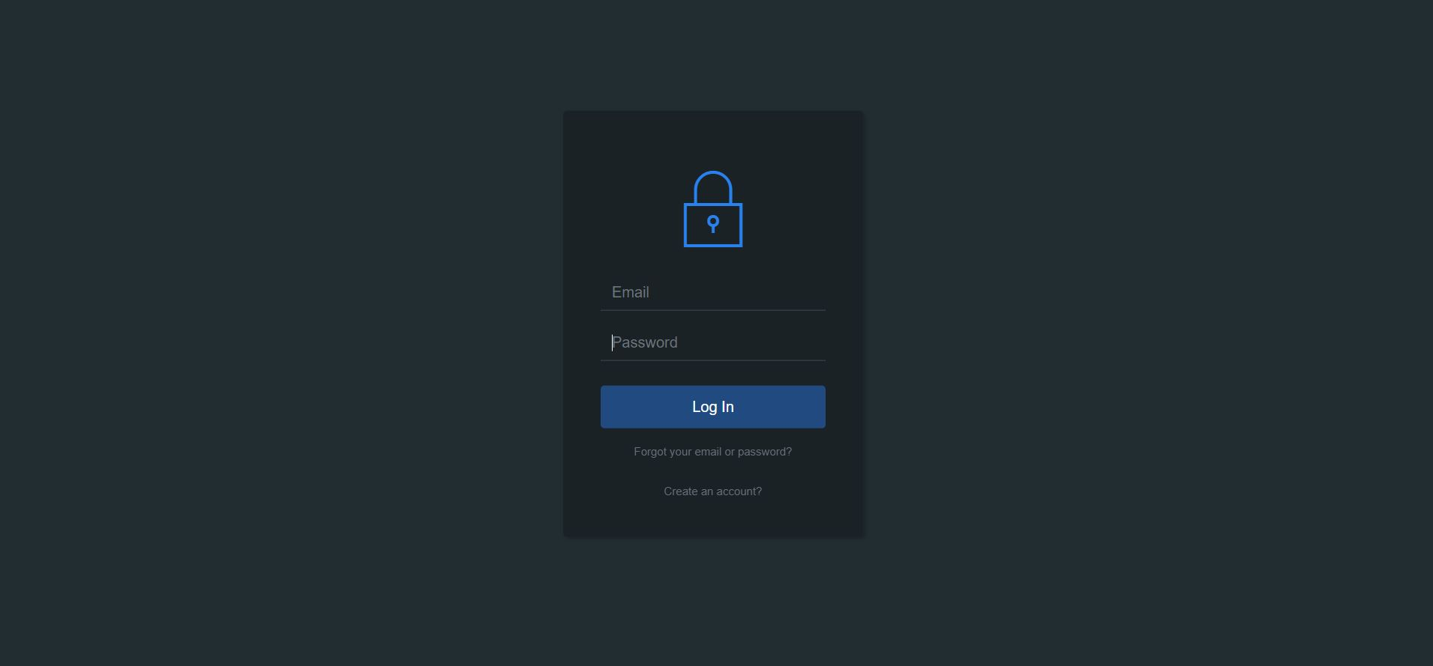

Index.php

<?php **include**('includes/header.php'); ?>

<!-- Begin Main -->

<div role="main" class="main">

<!-- Begin Main Slide -->

<section class="main-slide">

<div id="owl-main-slide" class="owl-carousel pgl-main-slide" data-plugin-options='{"autoPlay": true}'>

<div class="item" id="item1"><img src="images/slides/slider1.jpg" alt="Photo" class="img-responsive">

<div class="item-caption">

<div class="container">

<div class="property-info">

<span class="property-thumb-info-label">

<span class="label price">358,000</span>

<span class="label"><a href="property-details.php" class="btn-more">More Detail</a></span>

</span>

<div class="property-thumb-info-content">

<h2><a href="property-details.php">1 RK 350 Sq.ft. House & Villa</a></h2>

<p>IS ONE BEDROOM FULLY FURNISHED WITH TV CUPBOARD TEA COFFEE MAKER IN GREEN POLLUTION FREE Campus, close to Airport✈️ & Paras Hospital.</p>

</div>

</div>

</div>

</div>

</div>

<div class="item" id="item2"><img src="images/slides/slider2.jpg" alt="Photo" class="img-responsive">

<div class="item-caption">

<div class="container">

<div class="property-info">

<span class="property-thumb-info-label">

<span class="label price">358,000</span>

<span class="label"><a href="property-details.php" class="btn-more">More Detail</a></span>

</span>

<div class="property-thumb-info-content">

<h2><a href="property-details.php">2 BHK 1200 Sq.ft. House & Villa</a></h2>

<p>This Semi-furnished residential house can be a comfortable and affordable home for you and your family. It is a 2 BHK + Study unit available on rent in Shivpuri, Patna. This Apartment comes with a plethora of amenities to meet your modern lifestyle needs</p>

</div>

</div>

</div>

</div>

</div>

<div class="item" id="item3"><img src="images/slides/slider3.jpg" alt="Photo" class="img-responsive">

<div class="item-caption">

<div class="container">

<div class="property-info">

<span class="property-thumb-info-label">

<span class="label price">358,000</span>

<span class="label"><a href="property-details.php" class="btn-more">More Detail</a></span>

</span>

<div class="property-thumb-info-content">

<h2><a href="property-details.php">Warehouse,844504</a></h2>

<p>The property is newly built, located at bypass. road, easily transportable. Easy connectivity for trucks and cars. Electricity and Water 24*7 and guardrooms are also made with CCTV security.</p>

</div>

</div>

</div>

</div>

</div>

</div>

</section>

<!-- End Main Slide -->

<!-- Begin Advanced Search -->

<section class="pgl-advanced-search pgl-bg-light">

<div class="container">

<form name="advancedsearch">

<div class="row">

<div class="col-xs-6 col-sm-3">

<div class="form-group">

<label class="sr-only" for="property-status">Property Status</label>

<select id="property-status" name="property-status" data-placeholder="Property Status" class="chosen-select">

<option selected="selected" value="Property Status">Property Status</option>

<option value="sale">For Sale</option>

<option value="rent">For Rent</option>

</select>

</div>

</div>

<div class="col-xs-6 col-sm-3">

<div class="form-group">

<label class="sr-only" for="location">Location</label>

<select id="location" name="location" data-placeholder="Location" class="chosen-select">

<option selected="selected" value="Location">Location</option>

<option value="Bihar">Bihar</option>

<option value="Uttar Pardesh">Uttar Pardesh</option>

<option value="Noida">Noida</option>

<option value="Panjab">Panjab</option>

<option value="Karnataka">Karnataka</option>

<option value="Assam">Assam</option>

<option value="Patna">Patna</option>

<option value="Tamilnadu">Tamilnadu</option>

<option value="Kolkata">Kolkata</option>

<option value="Goa">Goa</option>

<option value="Maharashtra">Maharashtra</option>

<option value="West Bengal">West Bengal</option>

<option value="Gujarat">Gujarat</option>

<option value="Odisha">Odisha</option>

<option value="Tripura">Tripura</option>

<option value="Kerla">Kerla</option>

<option value="Sikkim">Sikkim</option>

<option value="Jharkhand">Jharkhand</option>

<option value="Nagaland">Nagaland</option>

<option value="Delhi">Delhi</option>

</select>

</div>

</div>

<div class="col-xs-6 col-sm-3">

<div class="form-group">

<label class="sr-only" for="property-types">Property Types</label>

<select id="property-types" name="property-types" data-placeholder="Property Types" class="chosen-select">

<option selected="selected" value="Property Types">Property Types</option>

<option value="residential">Residential</option>

<option value="commercial">Commercial</option>

<option value="land">Land</option>

</select>

</div>

</div>

<div class="col-xs-6 col-sm-3">

<div class="form-group">

<label class="sr-only" for="area-from">Area From</label>

<select id="area-from" name="area-from" data-placeholder="Area From" class="chosen-select">

<option selected="selected" value="Area From">Area From</option>

<option value="450">450</option>

<option value="350">350</option>

<option value="250">250</option>

<option value="150">150</option>

<option value="100">100</option>

<option value="50">50</option>

</select>

</div>

</div>

</div>

<div class="row">

<div class="col-xs-6 col-sm-3">

<div class="form-group">

<label class="sr-only" for="search-bedrooms">Bedrooms</label>

<select id="search-bedrooms" name="search-bedrooms" data-placeholder="Bedrooms" class="chosen-select">

<option selected="selected" value="Bedrooms">Bedrooms</option>

<option value="0">0</option>

<option value="1">1</option>

<option value="2">2</option>

<option value="3">3</option>

<option value="4">4</option>

<option value="5">5</option>

<option value="5plus">5+</option>

</select>

</div>

</div>

<div class="col-xs-6 col-sm-3">

<div class="form-group">

<label class="sr-only" for="search-bathrooms">Bathrooms</label>

<select id="search-bathrooms" name="search-bathrooms" data-placeholder="Bathrooms" class="chosen-select">

<option selected="selected" value="Bathrooms">Bathrooms</option>

<option value="0">0</option>

<option value="1">1</option>

<option value="2">2</option>

<option value="3">3</option>

<option value="4">4</option>

<option value="4plus">4+</option>

</select>

</div>

</div>

<div class="col-xs-6 col-sm-3">

<div class="form-group">

<div class="row pgl-narrow-row">

<div class="col-xs-6">

<label class="sr-only" for="search-minprice">Price From</label>

<select id="search-minprice" name="search-minprice" data-placeholder="Price From" class="chosen-select">

<option selected="selected" value="Price From">Price From</option>

<option value="0">0</option>

<option value="25000">25000</option>

<option value="50000">50000</option>

<option value="75000">75000</option>

<option value="100000">100000</option>

<option value="150000">150000</option>

<option value="200000">200000</option>

<option value="300000">300000</option>

<option value="500000">500000</option>

<option value="750000">750000</option>

<option value="1000000">1000000</option>

</select>

</div>

<div class="col-xs-6">

<label class="sr-only" for="search-maxprice">Price To</label>

<select id="search-maxprice" name="search-maxprice" data-placeholder="Price To" class="chosen-select">

<option selected="selected" value="Price To">Price To</option>

<option value="25000">25000</option>

<option value="50000">50000</option>

<option value="75000">75000</option>

<option value="100000">100000</option>

<option value="150000">150000</option>

<option value="200000">200000</option>

<option value="300000">300000</option>

<option value="500000">500000</option>

<option value="750000">750000</option>

<option value="1000000">1000000</option>

<option value="1000000plus">>1000000</option>

</select>

</div>

</div>

</div>

</div>

<div class="col-xs-6 col-sm-3">

<div class="form-group">

<button type="submit" class="btn btn-block btn-primary">Find your home</button>

</div>

</div>

</div>

</form>

</div>

</section>

<!-- End Advanced Search -->

<!-- Begin Featured -->

<section class="pgl-featured pgl-bg-grey">

<div class="container">

<div class="row">

<div class="col-md-6 animation">

<div class="pgl-property featured-item">

<div class="property-thumb-info">

<div class="property-thumb-info-image">

<img alt="" class="img-responsive" src="images/properties/property-featured-1.jpg">

</div>

<div class="property-thumb-info-content">

<h3><a href="property-details.php">Warehouse for Rent in Begampur, Patna</a></h3>

<p>Near Amar Transport, Begampur, 500 mtrs. before Bakhtiyarpur Toll Plaza, Begampur, Patna</p>

</div>

</div>

</div>

</div>

<div class="col-xs-6 col-md-3 animation">

<div class="pgl-property featured-item">

<div class="property-thumb-info">

<div class="property-thumb-info-image">

<img alt="" class="img-responsive" src="images/properties/property-featured-2.jpg">

</div>

<div class="property-thumb-info-content">

<h3><a href="property-details.php">Commercial Shop for Rent in Rajendar Nagar, Patna</a></h3>

<p>Dayal Bhawan, Above Blue Medix and Jio Store, Chak Musllahpur, Bhikhana Pahari, Patna.</p>

</div>

</div>

</div>

</div>

<div class="col-xs-6 col-md-3 animation">

<div class="pgl-property featured-item">

<div class="property-thumb-info">

<div class="property-thumb-info-image">

<img alt="" class="img-responsive" src="images/properties/property-featured-3.jpg">

</div>

<div class="property-thumb-info-content">

<h3><a href="property-details.php">Showroom for Rent in Ashok Nagar, Patna</a></h3>

<p>Ashok Nagar, Patna</p>

</div>

</div>

</div>

</div>

<div class="col-xs-6 col-md-3 animation">

<div class="pgl-property featured-item">

<div class="property-thumb-info">

<div class="property-thumb-info-image">

<img alt="" class="img-responsive" src="images/properties/property-featured-4.jpg">

</div>

<div class="property-thumb-info-content">

<h3><a href="property-details.php">2 BHK 1027 Sq.ft. Residential Apartment for Sale in Phulwari Sharif, Patna</a></h3>

<p> Phulwari Sharif, Patna by Aristone Homes Pvt.Ltd</p>

</div>

</div>

</div>

</div>

<div class="col-xs-6 col-md-3 animation">

<div class="pgl-property featured-item">

<div class="property-thumb-info">

<div class="property-thumb-info-image">

<img alt="" class="img-responsive" src="images/properties/property-featured-5.jpg">

</div>

<div class="property-thumb-info-content">

<h3><a href="property-details.php">3 BHK 1480 Sq.ft. Residential Apartment for Sale in Phulwari Sharif, Patna</a></h3>

<p>Phulwari Sharif, Patna by Luckstone Buildtech Private Limited</p>

</div>

</div>

</div>

</div>

</div>

<hr class="top-tall">

</div>

</section>

<!-- End Featured -->

<!-- Begin Properties -->

<section class="pgl-properties pgl-bg-grey">

<div class="container">

<h2>Properties</h2>

<!-- Nav tabs -->

<ul class="nav nav-tabs pgl-pro-tabs text-center animation" role="tablist">

<li class="active"><a href="#all" role="tab" data-toggle="tab">All</a></li>

<li><a href="#house" role="tab" data-toggle="tab">House</a></li>

<li><a href="#offices" role="tab" data-toggle="tab">Offices</a></li>

<li><a href="#apartment" role="tab" data-toggle="tab">Apartment</a></li>

<li><a href="#residential" role="tab" data-toggle="tab">Residential</a></li>

</ul>

<!-- Tab panes -->

<div class="tab-content">

<div class="tab-pane active" id="all">

<div class="row">

<div class="col-xs-4 animation">

<div class="pgl-property">

<div class="property-thumb-info">

<div class="property-thumb-info-image">

<img alt="" class="img-responsive" src="images/properties/property-1.jpg">

<span class="property-thumb-info-label">

<span class="label price">358,000</span>

<span class="label forrent">Rent</span>

</span>

</div>

<div class="property-thumb-info-content">

<h3><a href="property-details.php">Surya Sumitra Sadan 422sqm</a></h3>

<address>Bailey Road, Patna</address>

</div>

<div class="amenities clearfix">

<ul class="pull-left">

<li><strong>Area:</strong> 450<sup>m2</sup></li>

</ul>

<ul class="pull-right">

<li><i class="icons icon-bedroom"></i> 3</li>

<li><i class="icons icon-bathroom"></i> 2</li>

</ul>

</div>

</div>

</div>

</div>

<div class="col-xs-4 animation">

<div class="pgl-property">

<div class="property-thumb-info">

<div class="property-thumb-info-image">

<img alt="" class="img-responsive" src="images/properties/property-2.jpg">

<span class="property-thumb-info-label">

<span class="label price">358,000</span>

</span>

</div>

<div class="property-thumb-info-content">

<h3><a href="property-details.php">Commercial Shop for rent</a></h3>

<address>Gandhi Maidan, Patna</address>

</div>

<div class="amenities clearfix">

<ul class="pull-left">

<li><strong>Area:</strong> 280<sup>m2</sup></li>

</ul>

<ul class="pull-right">

<li><i class="icons icon-bedroom"></i> 3</li>

<li><i class="icons icon-bathroom"></i> 2</li>

</ul>

</div>

</div>

</div>

</div>

<div class="col-xs-4 animation">

<div class="pgl-property">

<div class="property-thumb-info">

<div class="property-thumb-info-image">

<img alt="" class="img-responsive" src="images/properties/property-3.jpg">

<span class="property-thumb-info-label">

<span class="label price">658,000</span>

<span class="label forsold">Sold</span>

</span>

</div>

<div class="property-thumb-info-content">

<h3><a href="property-details.php">3 BHK 1000 Sq.ft. House & Villa for Rent</a></h3>

<address>Danapur, Mithila Colony, Danapur, Patna</address>

</div>

<div class="amenities clearfix">

<ul class="pull-left">

<li><strong>Area:</strong> 1000<sup>m2</sup></li>

</ul>

<ul class="pull-right">

<li><i class="icons icon-bedroom"></i> 3</li>

<li><i class="icons icon-bathroom"></i> 2</li>

</ul>

</div>

</div>

</div>

</div>

</div>

<div class="row">

<div class="col-xs-4 animation">

<div class="pgl-property">

<div class="property-thumb-info">

<div class="property-thumb-info-image">

<img alt="" class="img-responsive" src="images/properties/property-4.jpg">

<span class="property-thumb-info-label">

<span class="label price">35,000</span>

<span class="label forrent">Rent</span>

</span>

</div>

<div class="property-thumb-info-content">

<h3><a href="property-details.php">Office Space, VA 24012</a></h3>

<address>Dak Bunglow Road, Patna </address>

</div>

<div class="amenities clearfix">

<ul class="pull-left">

<li><strong>Area:</strong> 150<sup>m2</sup></li>

</ul>

<ul class="pull-right">

<li><i class="icons icon-bedroom"></i> 3</li>

<li><i class="icons icon-bathroom"></i> 2</li>

</ul>

</div>

</div>

</div>

</div>

<div class="col-xs-4 animation">

<div class="pgl-property">

<div class="property-thumb-info">

<div class="property-thumb-info-image">

<img alt="" class="img-responsive" src="images/properties/property-5.jpg">

<span class="property-thumb-info-label">

<span class="label price">358,000</span>

</span>

</div>

<div class="property-thumb-info-content">

<h3><a href="property-details.php">25689 Acre Residential Plot</a></h3>

<address>Sipara, Patna</address>

</div>

<div class="amenities clearfix">

<ul class="pull-left">

<li><strong>Area:</strong> 450<sup>m2</sup></li>

</ul>

<ul class="pull-right">

<li><i class="icons icon-bedroom"></i> 3</li>

<li><i class="icons icon-bathroom"></i> 2</li>

</ul>

</div>

</div>

</div>

</div>

<div class="col-xs-4 animation">

<div class="pgl-property">

<div class="property-thumb-info">

<div class="property-thumb-info-image">

<img alt="" class="img-responsive" src="images/properties/property-6.jpg">

<span class="property-thumb-info-label">

<span class="label price">358,000</span>

</span>

</div>

<div class="property-thumb-info-content">

<h3><a href="property-details.php">750 Sq.ft. Residential Plot </a></h3>

<address>Ashiana Road, Patna </address>

</div>

<div class="amenities clearfix">

<ul class="pull-left">

<li><strong>Area:</strong> 450<sup>m2</sup></li>

</ul>

<ul class="pull-right">

<li><i class="icons icon-bedroom"></i> 3</li>

<li><i class="icons icon-bathroom"></i> 2</li>

</ul>

</div>

</div>

</div>

</div>

</div>

</div>

<div class="tab-pane" id="house">

<div class="row">

<div class="col-xs-4 animation">

<div class="pgl-property">

<div class="property-thumb-info">

<div class="property-thumb-info-image">

<img alt="" class="img-responsive" src="images/properties/property-4.jpg">

<span class="property-thumb-info-label">

<span class="label price">358,000</span>

<span class="label forrent">Rent</span>

</span>

</div>

<div class="property-thumb-info-content">

<h3><a href="property-details.php">Chatham St NW, Roanoke, VA 24012</a></h3>

<address>Ferris Park, Jersey City Land in Sales</address>

</div>

<div class="amenities clearfix">

<ul class="pull-left">

<li><strong>Area:</strong> 450<sup>m2</sup></li>

</ul>

<ul class="pull-right">

<li><i class="icons icon-bedroom"></i> 3</li>

<li><i class="icons icon-bathroom"></i> 2</li>

</ul>

</div>

</div>

</div>

</div>

<div class="col-xs-4 animation">

<div class="pgl-property">

<div class="property-thumb-info">

<div class="property-thumb-info-image">

<img alt="" class="img-responsive" src="images/properties/property-5.jpg">

<span class="property-thumb-info-label">

<span class="label price">358,000</span>

</span>

</div>

<div class="property-thumb-info-content">

<h3><a href="property-details.php">Chatham St NW, Roanoke, VA 24012</a></h3>

<address>Ferris Park, Jersey City Land in Sales</address>

</div>

<div class="amenities clearfix">

<ul class="pull-left">

<li><strong>Area:</strong> 450<sup>m2</sup></li>

</ul>

<ul class="pull-right">

<li><i class="icons icon-bedroom"></i> 3</li>

<li><i class="icons icon-bathroom"></i> 2</li>

</ul>

</div>

</div>

</div>

</div>

<div class="col-xs-4 animation">

<div class="pgl-property">

<div class="property-thumb-info">

<div class="property-thumb-info-image">

<img alt="" class="img-responsive" src="images/properties/property-6.jpg">

<span class="property-thumb-info-label">

<span class="label price">358,000</span>

</span>

</div>

<div class="property-thumb-info-content">

<h3><a href="property-details.php">Chatham St NW, Roanoke, VA 24012</a></h3>

<address>Ferris Park, Jersey City Land in Sales</address>

</div>

<div class="amenities clearfix">

<ul class="pull-left">

<li><strong>Area:</strong> 450<sup>m2</sup></li>

</ul>

<ul class="pull-right">

<li><i class="icons icon-bedroom"></i> 3</li>

<li><i class="icons icon-bathroom"></i> 2</li>

</ul>

</div>

</div>

</div>

</div>

</div>

</div>

<div class="tab-pane" id="offices">

<div class="row">

<div class="col-xs-4 animation">

<div class="pgl-property">

<div class="property-thumb-info">

<div class="property-thumb-info-image">

<img alt="" class="img-responsive" src="images/properties/property-4.jpg">

<span class="property-thumb-info-label">

<span class="label price">358,000</span>

<span class="label forrent">Rent</span>

</span>

</div>

<div class="property-thumb-info-content">

<h3><a href="property-details.php">Chatham St NW, Roanoke, VA 24012</a></h3>

<address>Ferris Park, Jersey City Land in Sales</address>

</div>

<div class="amenities clearfix">

<ul class="pull-left">

<li><strong>Area:</strong> 450<sup>m2</sup></li>

</ul>

<ul class="pull-right">

<li><i class="icons icon-bedroom"></i> 3</li>

<li><i class="icons icon-bathroom"></i> 2</li>

</ul>

</div>

</div>

</div>

</div>

<div class="col-xs-4 animation">

<div class="pgl-property">

<div class="property-thumb-info">

<div class="property-thumb-info-image">

<img alt="" class="img-responsive" src="images/properties/property-5.jpg">

<span class="property-thumb-info-label">

<span class="label price">358,000</span>

</span>

</div>

<div class="property-thumb-info-content">

<h3><a href="property-details.php">Chatham St NW, Roanoke, VA 24012</a></h3>

<address>Ferris Park, Jersey City Land in Sales</address>

</div>

<div class="amenities clearfix">

<ul class="pull-left">

<li><strong>Area:</strong> 450<sup>m2</sup></li>

</ul>

<ul class="pull-right">

<li><i class="icons icon-bedroom"></i> 3</li>

<li><i class="icons icon-bathroom"></i> 2</li>

</ul>

</div>

</div>

</div>

</div>

</div>

</div>

<div class="tab-pane" id="apartment">

<div class="row">

<div class="col-xs-4 animation">

<div class="pgl-property">

<div class="property-thumb-info">

<div class="property-thumb-info-image">

<img alt="" class="img-responsive" src="images/properties/property-4.jpg">

<span class="property-thumb-info-label">

<span class="label price">358,000</span>

<span class="label forrent">Rent</span>

</span>

</div>

<div class="property-thumb-info-content">

<h3><a href="property-details.php">Chatham St NW, Roanoke, VA 24012</a></h3>

<address>Ferris Park, Jersey City Land in Sales</address>

</div>

<div class="amenities clearfix">

<ul class="pull-left">

<li><strong>Area:</strong> 450<sup>m2</sup></li>

</ul>

<ul class="pull-right">

<li><i class="icons icon-bedroom"></i> 3</li>

<li><i class="icons icon-bathroom"></i> 2</li>

</ul>

</div>

</div>

</div>

</div>

<div class="col-xs-4 animation">

<div class="pgl-property">

<div class="property-thumb-info">

<div class="property-thumb-info-image">

<img alt="" class="img-responsive" src="images/properties/property-5.jpg">

<span class="property-thumb-info-label">

<span class="label price">358,000</span>

</span>

</div>

<div class="property-thumb-info-content">

<h3><a href="property-details.php">Chatham St NW, Roanoke, VA 24012</a></h3>

<address>Ferris Park, Jersey City Land in Sales</address>

</div>

<div class="amenities clearfix">

<ul class="pull-left">

<li><strong>Area:</strong> 450<sup>m2</sup></li>

</ul>

<ul class="pull-right">

<li><i class="icons icon-bedroom"></i> 3</li>

<li><i class="icons icon-bathroom"></i> 2</li>

</ul>

</div>

</div>

</div>

</div>

</div>

</div>

<div class="tab-pane" id="residential">

<div class="row">

<div class="col-xs-4 animation">

<div class="pgl-property">

<div class="property-thumb-info">

<div class="property-thumb-info-image">

<img alt="" class="img-responsive" src="images/properties/property-1.jpg">

<span class="property-thumb-info-label">

<span class="label price">358,000</span>

<span class="label forrent">Rent</span>

</span>

</div>

<div class="property-thumb-info-content">

<h3><a href="property-details.php">Poolside character home on a wide 422sqm</a></h3>

<address>Ferris Park, Jersey City Land in Sales</address>

</div>

<div class="amenities clearfix">

<ul class="pull-left">

<li><strong>Area:</strong> 450<sup>m2</sup></li>

</ul>

<ul class="pull-right">

<li><i class="icons icon-bedroom"></i> 3</li>

<li><i class="icons icon-bathroom"></i> 2</li>

</ul>

</div>

</div>

</div>

</div>

<div class="col-xs-4 animation">

<div class="pgl-property">

<div class="property-thumb-info">

<div class="property-thumb-info-image">

<img alt="" class="img-responsive" src="images/properties/property-2.jpg">

<span class="property-thumb-info-label">

<span class="label price">358,000</span>

</span>

</div>

<div class="property-thumb-info-content">

<h3><a href="property-details.php">Presidential Parcel Frames Command Views of Mt. Rushmore</a></h3>

<address>Ferris Park, Jersey City Land in Sales</address>

</div>

<div class="amenities clearfix">

<ul class="pull-left">

<li><strong>Area:</strong> 450<sup>m2</sup></li>

</ul>

<ul class="pull-right">

<li><i class="icons icon-bedroom"></i> 3</li>

<li><i class="icons icon-bathroom"></i> 2</li>

</ul>

</div>

</div>

</div>

</div>

<div class="col-xs-4 animation">

<div class="pgl-property">

<div class="property-thumb-info">

<div class="property-thumb-info-image">

<img alt="" class="img-responsive" src="images/properties/property-3.jpg">

<span class="property-thumb-info-label">

<span class="label price">358,000</span>

<span class="label forsold">Sold</span>

</span>

</div>

<div class="property-thumb-info-content">

<h3><a href="property-details.php">Californian Class, Grand Family Proportions</a></h3>

<address>Ferris Park, Jersey City Land in Sales</address>

</div>

<div class="amenities clearfix">

<ul class="pull-left">

<li><strong>Area:</strong> 450<sup>m2</sup></li>

</ul>

<ul class="pull-right">

<li><i class="icons icon-bedroom"></i> 3</li>

<li><i class="icons icon-bathroom"></i> 2</li>

</ul>

</div>

</div>

</div>

</div>

</div>

</div>

</div>

</div>

</section>

<!-- End Properties -->

<!-- Begin Agents -->

<section class="pgl-agents">

<div class="container">

<h2>Our Agents</h2>

<div class="row">

<div class="col-md-6">

<div class="pgl-agent-item pgl-bg-light">

<div class="row pgl-midnarrow-row">

<div class="col-xs-5">

<div class="img-thumbnail-medium">

<a href="agentprofile.html"><img src="images/agents/temp-agent1.jpg" class="img-responsive" alt=""></a>

</div>

</div>

<div class="col-xs-7">

<div class="pgl-agent-info">

<small>NO.1</small>

<h4><a href="agentprofile.html">Surya Nestbuild Ltd.</a></h4>

<p>We are Dealing in all kinds of Properties. Flats/Apartments, Builders, Real Estate Agents</p>

<address>

<i class="fa fa-map-marker"></i> Office : 91 9304574542<br>

<i class="fa fa-phone"></i> Mobile : 91 9304574542<br>

<i class="fa fa-fax"></i> Fax : 1-800-666-8888<br>

<i class="fa fa-envelope-o"></i> Mail: <a href="mailto:squat931@gmail.com">squat931@gmail.com</a>

</address>

</div>

</div>

</div>

</div>

</div>

<div class="col-md-6">

<div class="pgl-agent-item pgl-bg-light">

<div class="row pgl-midnarrow-row">

<div class="col-xs-5">

<div class="img-thumbnail-medium">

<a href="agentprofile.html"><img src="images/agents/temp-agent2.jpg" class="img-responsive" alt=""></a>

</div>

</div>

<div class="col-xs-7">

<div class="pgl-agent-info">

<small>NO.2.1</small>

<h4><a href="agentprofile.html">BRIGHT HOMES DEVELOPERS AND BUILDERS PVT. LTD.</a></h4>

<p>BRIGHT HOMES is help the project, buying and selling commercial Shop, Space, Building and Land.</p>

<address>

<i class="fa fa-map-marker"></i> Office : 91 9304574542<br>

<i class="fa fa-phone"></i> Mobile : 91 9304574542<br>

<i class="fa fa-fax"></i> Fax : 1-800-666-8888<br>

<i class="fa fa-envelope-o"></i> Mail: <a href="mailto:squat931@gmail.com">squat931@gmail.com</a>

</address>

</div>

</div>

</div>

</div>

</div>

</div>

<hr class="top-tall">

</div>

</section>

<!-- End Agents -->

<!-- Begin About -->

<section class="pgl-about">

<div class="container">

<div class="row">

<div class="col-md-4 animation about-item">

<h2>Who We Are</h2>

<p><img src="images/content/demo-1.jpg" alt="" class="img-responsive"></p>

<p>We have a total of 25+ years combined experience dealing exclusively with New York buyers and sellers ipsum dolor sit amet, consectetur adipiscing elit.</p>

<a href="about-us.php" class="btn btn-lg btn-default">View more</a>

</div>

<div class="col-md-4 animation about-item">

<h2>Why Choose Us</h2>

<div class="panel-group" id="accordion">

<div class="panel panel-default pgl-panel">

<div class="panel-heading">

<h4 class="panel-title"> <a data-toggle="collapse" data-parent="#accordion" href="#collapseOne">Designed for your business</a> </h4>

</div>

<div id="collapseOne" class="panel-collapse collapse in">

<div class="panel-body">

<p>We deals into all kind of residential and commercial properties. first of i serve a good service for all customers.While an increasing number of property investors are choosing to manage their own rentals, the majority across india still rely on an agent.</p>

</div>

</div>

</div>

<div class="panel panel-default pgl-panel">

<div class="panel-heading">

<h4 class="panel-title"> <a data-toggle="collapse" data-parent="#accordion" href="#collapseTwo" class="collapsed">Saves time & Money</a> </h4>

</div>

<div id="collapseTwo" class="panel-collapse collapse">

<div class="panel-body"> <p>Not only on a day-to-day basis, in dealing with rent collection and tenancy issues, but also every now and then, something won’t go according to plan, such as a maintenance issue or tribunal matters. And in resolving these situations, it will feel like a full time job. Most people do not have the spare time to handle this,” Mr Simpson said. With their pricing advice, leasing skills and negotiation and maintenance contacts, a good agent can save an owner a big chunk of money and help them make a larger profit year-on-year, he added.</p> </div>

</div>

</div>

<div class="panel panel-default pgl-panel">

<div class="panel-heading">

<h4 class="panel-title"> <a data-toggle="collapse" data-parent="#accordion" href="#collapseThree" class="collapsed">The referrals are powerful</a> </h4>

</div>

<div id="collapseThree" class="panel-collapse collapse">

<div class="panel-body">

<p>Managing a property requires the expertise of many professionals and a good agent will refer an owner to reputable professionals who will “help them realise their property investment goals sooner.</p>

</div>

</div>

</div>

<div class="panel panel-default pgl-panel">

<div class="panel-heading">

<h4 class="panel-title"> <a data-toggle="collapse" data-parent="#accordion" href="#collapseFouth" class="collapsed">How to pick a good agent</a> </h4>

</div>

<div id="collapseFouth" class="panel-collapse collapse">

<div class="panel-body">

<p>Like most things, the best way to find a great agent is to ask around.“Do any of your friends or relatives own an investment property? Who do they use? Do they recommend them? If you don’t know any, find the top three most active agents in your area. This is easily found by searching current for lease properties ,

Look for experience and the quality of their team, which are major factors in success. Do not go with the cheapest option, he said, as “they are cheap for a reason!”

</p>

</div>

</div>

</div>

<div class="panel panel-default pgl-panel">

<div class="panel-heading">

<h4 class="panel-title"> <a data-toggle="collapse" data-parent="#accordion" href="#collapseFive" class="collapsed">Quality tenants are a given</a> </h4>

</div>

<div id="collapseFive" class="panel-collapse collapse">

<div class="panel-body">

<p>It’s self-evident that owners want good tenants who will pay on time, every time, and look after their property, so tenant selection is vital and also where an agent comes into their own.“Most people wouldn’t know the difference between a bad tenant and a good one. It takes some experience to pick up on subtle clues in the limited interaction you have with the tenant before approving them,</p>

</div>

</div>

</div>

</div>

</div>

<div class="col-md-4 animation about-item">

<h2>Happy Clients</h2>

<div class="owl-carousel pgl-bg-dark pgl-testimonial" data-plugin-options='{"items": 1, "pagination": false, "autoHeight": true}'>

<div class="col-md-12">

<div class="testimonial-author">

<div class="img-thumbnail-small img-circle">

<img src="images/agents/agent1.jpg" height="100px" class="img-circle" alt="Andrew MCCarthy">

</div>

<h4>rajan singh</h4>

<p><strong>Selller</strong></p>

</div>

<div class="divider-quote-sign"><span>“</span></div>

<blockquote class="testimonial">

<p>I posses one of my father's properties and wanted to get it revamped by a builder. I contacted this builder around five months back. The builder is extremely reliable and suggests the best plans. Thanks!</p>

</blockquote>

</div>

<div class="col-md-12">

<div class="testimonial-author">

<div class="img-thumbnail-small img-circle">

<img src="images/agents/agent-1.jpg" class="img-circle" alt="John Smith">

</div>

<h4>riya raj</h4>

<p><strong>Selller</strong></p>

</div>

<div class="divider-quote-sign"><span>“</span></div>

<blockquote class="testimonial">

<p>This builder has helped me in getting my building constructed within the promised time frame and as per the modern trends. This builder was very supportive and always provided appropriate suggestion to me considering my requirements.</p>

</blockquote>

</div>

</div>

</div>

</div>

</div>

</section>

<!-- End About -->

</div>

<!-- End Main -->

<?php **include**('includes/footer.php') ?>

login.php

<html>

<head>

<meta charset="utf-8">

<meta name="viewport" content="width=device-width, initial-scale=1.0, shrink-to-fit=no">

<title>SQUAT</title>

<link rel="icon" href="image/logo.png" type="image">

<link rel="stylesheet" href="https://cdnjs.cloudflare.com/ajax/libs/twitter-bootstrap/4.5.2/css/bootstrap.min.css">

<link rel="stylesheet" href="https://cdnjs.cloudflare.com/ajax/libs/ionicons/2.0.1/css/ionicons.min.css">

<style>

**.login-dark** {

**height**: **1000px**;

**background**-**size**: cover;

**position**: **relative**;

}

body {

**background**: **#222D32**;

**font-family**: 'Roboto', **sans-serif**;

}

**.login-dark** form {

**max-width**: **320px**;

**width**: **90**%;

**background**: **#1A2226**;

**padding**: **40px**;

**border**-radius: **4px**;

transform: translate(**-50**%, **-50**%);

**position**: **absolute**;

**top**: **50**%;

**left**: **50**%;

**color**: **#fff**;

box-shadow: **3px** **3px** **4px** rgba(**0**, **0**, **0**, **0**.**2**);

}

**.login-dark** **.illustration** {

**text-align**: **center**;

**padding**: **15px** **0** **20px**;

**font-size**: **100px**;

**color**: **#2980ef**;

}

**.login-dark** form **.form-control** {

**background**: **none**;

**border**: **none**;

**border-bottom**: **1px** **solid** **#434a52**;

**border**-radius: **0**;

box-shadow: **none**;

**outline**: **none**;

**color**: **inherit**;

}

**.login-dark** form **.btn-primary** {

**background**: **#214a80**;

**border**: **none**;

**border**-radius: **4px**;

**padding**: **11px**;

box-shadow: **none**;

**margin-top**: **26px**;

**text-shadow**: **none**;

**outline**: **none**;

}

**.login-dark** form **.btn-primary:hover**,

**.login-dark** form **.btn-primary:active** {

**border-color**: **#0DB8DE**;

**color**: **#0DB8DE**;

**outline**: **none**;

}

**.login-dark** form **.forgot** {

**display**: **block**;

**text-align**: **center**;

**font-size**: **12px**;

**color**: **#6f7a85**;

**opacity**: **0**.**9**;

**text-decoration**: **none**;

}

**.login-dark** form **.forgot:hover**,

**.login-dark** form **.forgot:active** {

**opacity**: **1**;

**text-decoration**: **none**;

}

**.login-dark** form **.btn-primary:active** {

transform: translateY(**1px**);

}

</style>

<script>

**function** validate()

{

**if**(document.getElementById("email").value=="")

{

alert("Fill Your valid Email");

document.getElementById("email").focus();

**return** **false**;

}

**if**(document.getElementById("pass").value=="")

{

alert("Fill Your valid Password");

document.getElementById("pass").focus();

**return** **false**;

}

}

</script>

</head>

<body>

<div class="login-dark" style="height: 695px;">

<form onsubmit="return validate();" action="logincode.php" method="POST">

<h2 class="sr-only">Login Form</h2>

<div class="illustration">

<i class="icon ion-ios-locked-outline"></i>

</div>

<div class="form-group">

<input class="form-control" type="email" name="email" id="email" placeholder="Email">

</div>

<div class="form-group">

<input class="form-control" type="password" name="password" id="pass" placeholder="Password">

</div>

<div class="form-group">

<button class="btn btn-primary btn-block" name="login_btn">Log In</button>

</div>

<a class="forgot" href="forgetpassword.php">Forgot your email or password?</a>

<br>

<a class="forgot" href="signup.php">Create an account?</a>

</form>

</div>

<script src="https://cdnjs.cloudflare.com/ajax/libs/jquery/3.5.1/jquery.min.js"></script>

<script src="https://cdnjs.cloudflare.com/ajax/libs/twitter-bootstrap/4.5.2/js/bootstrap.bundle.min.js"></script>

</body>

</html>

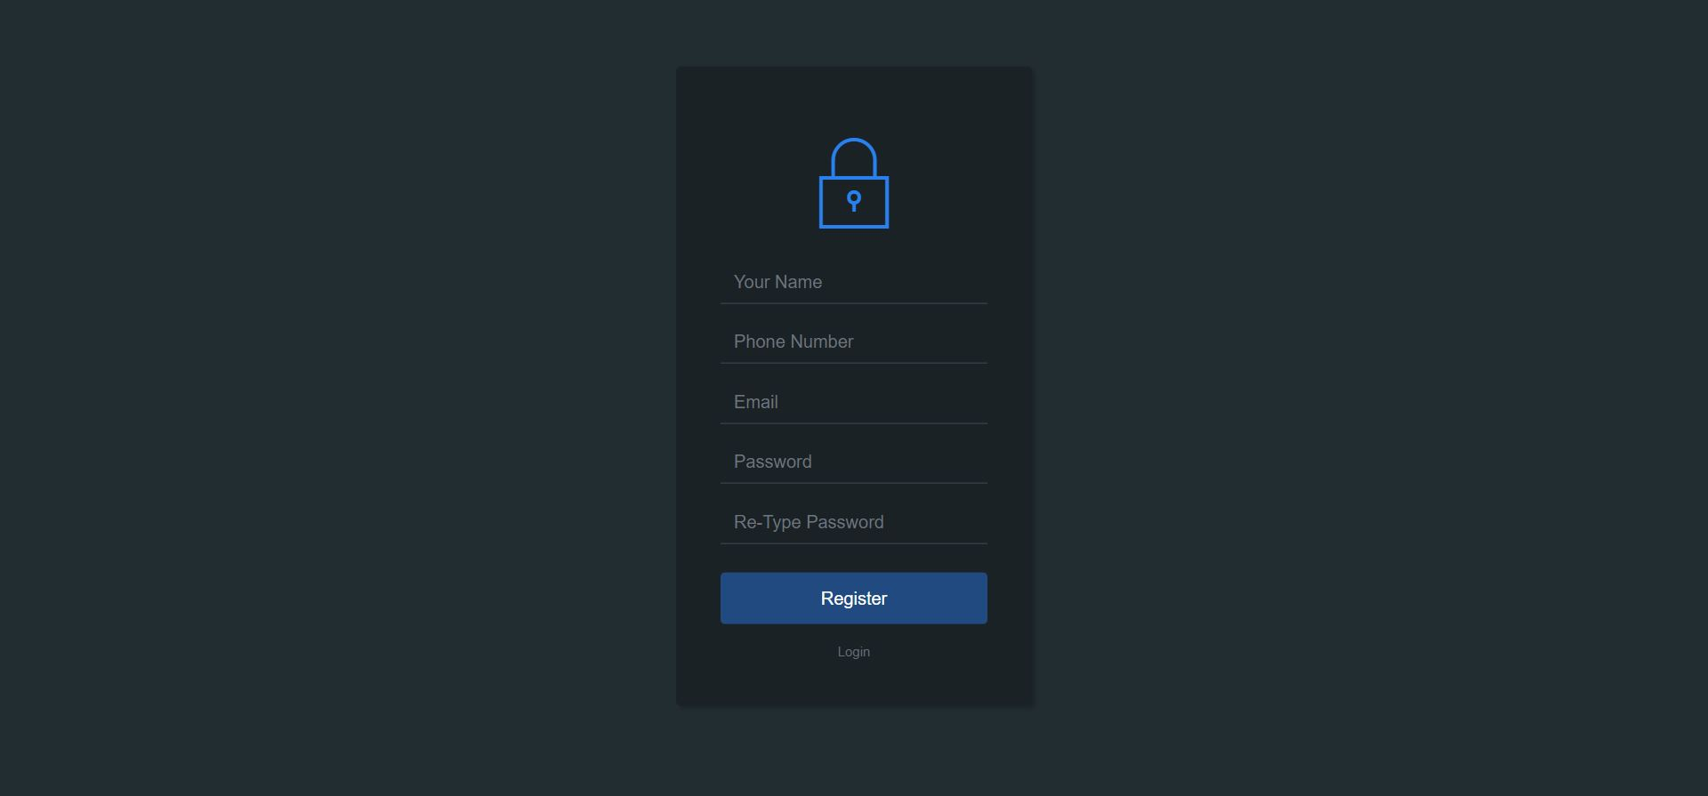

**Signup.php**

<html>

<head>

<meta charset="utf-8">

<meta name="viewport" content="width=device-width, initial-scale=1.0, shrink-to-fit=no">

<title>SQUAT</title>

<link rel="icon" href="image/logo.png" type="image">

<link rel="stylesheet" href="https://cdnjs.cloudflare.com/ajax/libs/twitter-bootstrap/4.5.2/css/bootstrap.min.css">

<link rel="stylesheet" href="https://cdnjs.cloudflare.com/ajax/libs/ionicons/2.0.1/css/ionicons.min.css">

<style>

**.login-dark** {

**height**: **1000px**;

**background**-**size**: cover;

**position**: **relative**;

}

body {

**background**: **#222D32**;

**font-family**: 'Roboto', **sans-serif**;

}

**.login-dark** form {

**max-width**: **320px**;

**width**: **90**%;

**background**: **#1A2226**;

**padding**: **40px**;

**border**-radius: **4px**;

transform: translate(**-50**%, **-50**%);

**position**: **absolute**;

**top**: **50**%;

**left**: **50**%;

**color**: **#fff**;

box-shadow: **3px** **3px** **4px** rgba(**0**, **0**, **0**, **0**.**2**);

}

**.login-dark** **.illustration** {

**text-align**: **center**;

**padding**: **15px** **0** **20px**;

**font-size**: **100px**;

**color**: **#2980ef**;

}

**.login-dark** form **.form-control** {

**background**: **none**;

**border**: **none**;

**border-bottom**: **1px** **solid** **#434a52**;

**border**-radius: **0**;

box-shadow: **none**;

**outline**: **none**;

**color**: **inherit**;

}

**.login-dark** form **.btn-primary** {

**background**: **#214a80**;

**border**: **none**;

**border**-radius: **4px**;

**padding**: **11px**;

box-shadow: **none**;

**margin-top**: **26px**;

**text-shadow**: **none**;

**outline**: **none**;

}

**.login-dark** form **.btn-primary:hover**,

**.login-dark** form **.btn-primary:active** {

**border-color**: **#0DB8DE**;

**color**: **#0DB8DE**;

**outline**: **none**;

}

**.login-dark** form **.forgot** {

**display**: **block**;

**text-align**: **center**;

**font-size**: **12px**;

**color**: **#6f7a85**;

**opacity**: **0**.**9**;

**text-decoration**: **none**;

}

**.login-dark** form **.forgot:hover**,

**.login-dark** form **.forgot:active** {

**opacity**: **1**;

**text-decoration**: **none**;

}

**.login-dark** form **.btn-primary:active** {

transform: translateY(**1px**);

}

</style>

<script>

/*JAVA SCRIPT CODING*/

**function** validate()

{

**if**(document.getElementById("name").value=="")

{

alert("Fill Your Name");

document.getElementById("name").focus();

**return** **false**;

}

**if**(document.getElementById("mobileNumber").value=="")

{

alert("Fill Your valid Mobile Number");

document.getElementById("mobileNumber").focus();

**return** **false**;

}

**if**(document.getElementById("email").value=="")

{

alert("Fill Your valid Email");

document.getElementById("email").focus();

**return** **false**;

}

**var** p1,p2;

p1=document.getElementById("pass").value;

p2=document.getElementById("conpass").value;

**if**(p1!=p2)

{

alert("Password Mismatch");

document.getElementById("conpass").focus();

**return** **false**;

}

**if**(document.getElementById("pass").value=="")

{

alert("Fill Your valid Password1");

document.getElementById("pass").focus();

**return** **false**;

}

**if**(document.getElementById("conpass").value=="")

{

alert("Fill Your valid Password");

document.getElementById("pass").focus();

**return** **false**;

}

}

</script>

</head>

<body>

<div class="login-dark" style="height: 695px;">

<form action="code.php" method="POST" onsubmit="return validate();" >

<h2 class="sr-only">Signup Form</h2>

<div class="illustration">

<i class="icon ion-ios-locked-outline"></i>

</div>

<div class="form-group">

<input class="form-control" id="name" type="name" name="unm" placeholder="Your Name">

</div>

<div class="form-group">

<input class="form-control" id="mobileNumber" type="text" name="mobile" placeholder="Phone Number">

</div>

<div class="form-group">

<input class="form-control" id="email" type="email" name="email" placeholder="Email">

</div>

<div class="form-group">

<input class="form-control" id="pass" type="password" name="pnm" placeholder="Password">

</div>

<div class="form-group">

<input class="form-control" id="conpass" type="password" name="repnm" placeholder="Re-Type Password">

</div>

<div class="form-group">

<button type="submit" onclick="validation()" class="btn btn-primary btn-block" name="signup_btn">Register</button>

</div>

<a class="forgot" href="login.php" >Login</a>

</form>

</div>

<script src="https://cdnjs.cloudflare.com/ajax/libs/jquery/3.5.1/jquery.min.js"></script>

<script src="https://cdnjs.cloudflare.com/ajax/libs/twitter-bootstrap/4.5.2/js/bootstrap.bundle.min.js"></script>

</body>

</html>

**Logincode.php**

<?php

session_start();

**include**('includes/connection.php');

**if**(isset($_POST['login_btn']))

{

$email=$_POST['email'];

$password=$_POST['password'];

$log_query="SELECT *FROM user_profile WHERE useremail='$email' AND userpassword='$password' LIMIT 1";

$log_query_run=mysqli_query($con,$log_query);

**if**(mysqli_num_rows($log_query_run) > **0**)

{

**foreach**($log_query_run **as** $row)

{

$user_id=$row['userid'];

$user_name=$row['username'];

$user_email=$row['useremail'];

$user_phone=$row['usermobile'];

$role_as=$row['role_as'];

}

$_SESSION['auth']="$role_as";

$_SESSION['auth_user']=[

'user_id'=>$user_id,

'user_name'=>$user_name,

'user_email'=>$user_email,

'user_phone'=>$user_phone

];

$_SESSION['status']="Logged in Successfully";

header('Location:index.php');

}

**else**

{

$_SESSION['status']="Invalid Email or Password";

header('Location:login.php');

}

}

**else**

{

$_SESSION['status']="Access Denied";

header('location:login.php');

}

?>

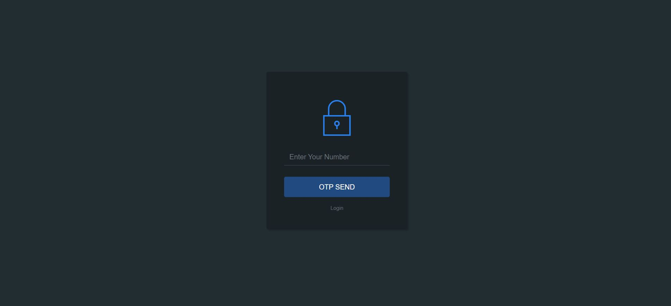

**Forgetpassword.php**

<html>

<head>

<meta charset="utf-8">

<meta name="viewport" content="width=device-width, initial-scale=1.0, shrink-to-fit=no">

<title>SQUAT</title>

<link rel="icon" href="image/logo.png" type="image">

<link rel="stylesheet" href="https://cdnjs.cloudflare.com/ajax/libs/twitter-bootstrap/4.5.2/css/bootstrap.min.css">

<link rel="stylesheet" href="https://cdnjs.cloudflare.com/ajax/libs/ionicons/2.0.1/css/ionicons.min.css">

<style>

**.login-dark** {

**height**: **1000px**;

**background**-**size**: cover;

**position**: **relative**;

}

body {

**background**: **#222D32**;

**font-family**: 'Roboto', **sans-serif**;

}

**.login-dark** form {

**max-width**: **320px**;

**width**: **90**%;

**background**: **#1A2226**;

**padding**: **40px**;

**border**-radius: **4px**;

transform: translate(**-50**%, **-50**%);

**position**: **absolute**;

**top**: **50**%;

**left**: **50**%;

**color**: **#fff**;

box-shadow: **3px** **3px** **4px** rgba(**0**, **0**, **0**, **0**.**2**);

}

**.login-dark** **.illustration** {

**text-align**: **center**;

**padding**: **15px** **0** **20px**;

**font-size**: **100px**;

**color**: **#2980ef**;

}

**.login-dark** form **.form-control** {

**background**: **none**;

**border**: **none**;

**border-bottom**: **1px** **solid** **#434a52**;

**border**-radius: **0**;

box-shadow: **none**;

**outline**: **none**;

**color**: **inherit**;

}

**.login-dark** form **.btn-primary** {

**background**: **#214a80**;

**border**: **none**;

**border**-radius: **4px**;

**padding**: **11px**;

box-shadow: **none**;

**margin-top**: **26px**;

**text-shadow**: **none**;

**outline**: **none**;

}

**.login-dark** form **.btn-primary:hover**,

**.login-dark** form **.btn-primary:active** {

**border-color**: **#0DB8DE**;

**color**: **#0DB8DE**;

**outline**: **none**;

}

**.login-dark** form **.forgot** {

**display**: **block**;

**text-align**: **center**;

**font-size**: **12px**;

**color**: **#6f7a85**;

**opacity**: **0**.**9**;

**text-decoration**: **none**;

}

**.login-dark** form **.forgot:hover**,

**.login-dark** form **.forgot:active** {

**opacity**: **1**;

**text-decoration**: **none**;

}

**.login-dark** form **.btn-primary:active** {

transform: translateY(**1px**);

}

</style>

</head>

<body>

<div class="login-dark" style="height: 695px;">

<form action="code.php" method="POST">

<h2 class="sr-only">Forget Password</h2>

<div class="illustration">

<i class="icon ion-ios-locked-outline"></i>

</div>

<div class="form-group">

<input class="form-control" type="text" name="phone" placeholder="Enter Your Number">

</div>

<div class="form-group">

<button class="btn btn-primary btn-block" name="sendotp">OTP SEND</button>

</div>

<a class="forgot" href="login.php">Login</a>

</form>

</div>

<script src="https://cdnjs.cloudflare.com/ajax/libs/jquery/3.5.1/jquery.min.js"></script>

<script src="https://cdnjs.cloudflare.com/ajax/libs/twitter-bootstrap/4.5.2/js/bootstrap.bundle.min.js"></script>

</body>

</html>

**Otp_verify.php**

<html>

<head>

<meta charset="utf-8">

<meta name="viewport" content="width=device-width, initial-scale=1.0, shrink-to-fit=no">

<title>SQUAT</title>

<link rel="icon" href="image/logo.png" type="image">

<link rel="stylesheet" href="https://cdnjs.cloudflare.com/ajax/libs/twitter-bootstrap/4.5.2/css/bootstrap.min.css">

<link rel="stylesheet" href="https://cdnjs.cloudflare.com/ajax/libs/ionicons/2.0.1/css/ionicons.min.css">

<style>

**.login-dark** {

**height**: **1000px**;

**background**-**size**: cover;

**position**: **relative**;

}

body {

**background**: **#222D32**;

**font-family**: 'Roboto', **sans-serif**;

}

**.login-dark** form {

**max-width**: **320px**;

**width**: **90**%;

**background**: **#1A2226**;

**padding**: **40px**;

**border**-radius: **4px**;

transform: translate(**-50**%, **-50**%);

**position**: **absolute**;

**top**: **50**%;

**left**: **50**%;

**color**: **#fff**;

box-shadow: **3px** **3px** **4px** rgba(**0**, **0**, **0**, **0**.**2**);

}

**.login-dark** **.illustration** {

**text-align**: **center**;

**padding**: **15px** **0** **20px**;

**font-size**: **100px**;

**color**: **#2980ef**;

}

**.login-dark** form **.form-control** {

**background**: **none**;

**border**: **none**;

**border-bottom**: **1px** **solid** **#434a52**;

**border**-radius: **0**;

box-shadow: **none**;

**outline**: **none**;

**color**: **inherit**;

}

**.login-dark** form **.btn-primary** {

**background**: **#214a80**;

**border**: **none**;

**border**-radius: **4px**;

**padding**: **11px**;

box-shadow: **none**;

**margin-top**: **26px**;

**text-shadow**: **none**;

**outline**: **none**;

}

**.login-dark** form **.btn-primary:hover**,

**.login-dark** form **.btn-primary:active** {

**border-color**: **#0DB8DE**;

**color**: **#0DB8DE**;

**outline**: **none**;

}

**.login-dark** form **.forgot** {

**display**: **block**;

**text-align**: **center**;

**font-size**: **12px**;

**color**: **#6f7a85**;

**opacity**: **0**.**9**;

**text-decoration**: **none**;

}

**.login-dark** form **.forgot:hover**,

**.login-dark** form **.forgot:active** {

**opacity**: **1**;

**text-decoration**: **none**;

}

**.login-dark** form **.btn-primary:active** {

transform: translateY(**1px**);

}

</style>

</head>

<body>

<div class="login-dark" style="height: 695px;">

<form>

<h2 class="sr-only">Forget Password</h2>

<div class="illustration">

<i class="icon ion-ios-locked-outline"></i>

</div>

<div class="form-group">

<input class="form-control" type="text" name="verifyotp" placeholder="Enter Your OTP">

</div>

<div class="form-group">

<button class="btn btn-primary btn-block" name="forget_password">Verify</button>

</div>

<!-- <a class="forgot" href="login.php">Login</a> -->

</form>

</div>

<script src="https://cdnjs.cloudflare.com/ajax/libs/jquery/3.5.1/jquery.min.js"></script>

<script src="https://cdnjs.cloudflare.com/ajax/libs/twitter-bootstrap/4.5.2/js/bootstrap.bundle.min.js"></script>

</body>

</html>

**Message.php**

<?php

**if**(isset($_SESSION['status']))

{

?>

echo"<script>alert('Hey !!<?php **echo** $_SESSION['status']; ?>')</script>";

<!-- <div class="alert alert-warning alert-dismissible fade show" role="alert">

<strong>Hey !</strong> <?php /* echo $_SESSION['status']; */ ?>

<button type="button" class="close" data-dismiss="alert" aria-label="Close">

<span aria-hidden="true">&times;</span>

</button>

</div> -->

<?php

unset($_SESSION['status']);

}

?>

**Code.php**

<?php

session_start();

**include**("includes/connection.php");

**if**(isset($_POST['logout_btn']))

{

unset($_SESSION['auth']);

unset($_SESSION['auth_user']);

$_SESSION['status']="Logged Out successfully";

header('location: login.php');

**exit**(**0**);

}

**if**(isset($_POST["contact_btn"]))

{

$name=$_POST["name"];

$email=$_POST["email"];

$subject=$_POST["subject"];

$website=$_POST["website"];

$message=$_POST["message"];

**echo**"<center><table border='2px'>";

**echo**"<tr><td>Name</td><td>".$name."</td></tr>";

**echo**"<tr><td>Email</td><td>".$email."</td></tr>";

**echo**"<tr><td>Subject</td><td>".$subject."</td></tr>";

**echo**"<tr><td>Website</td><td>".$website."</td></tr>";

**echo**"<tr><td>Message</td><td>".$message."</td></tr>";

**echo**"</center></table>";

**include**("includes/connection.php");

$sql="insert into contact(name,email,subject,website,message)values('".$name."','".$email."','".$subject."','".$website."','".$message."')";

mysqli_query($con,$sql);

**echo**"<script>alert('SUCCCESSFULLY SEND YOUR MESSAGE')</script>";

mysqli_close($con);

**echo**"<script>window.location='index.php'</script>";

}

**if**(isset($_POST["signup_btn"]))

{

$uname=$_POST["unm"];

$mobile=$_POST["mobile"]; //$pname=base64_encode($_POST["pnm"]);

$email=$_POST["email"];

$pname=$_POST["pnm"];

/* $pname=md5($_POST["pnm"]); *///it is also for password incripected form

$repname=$_POST["repnm"];

**if**(isset($_POST["btnsellform"]))

{

**include**("includes/connection.php");

$phone=$_POST["phone"];

$projectname=$_POST["projectname"];

$maintenance=$_POST["maintenance"];

$totalfloors=$_POST["totalfloors"];

$address=&$_POST['address'];

$type=&$_POST['type'];

$bedrooms=$_POST["bedrooms"];

$furnishing=$_POST["furnishing"];

$const_status=$_POST["const_status"];

$listedby=$_POST["listedby"];

$location="upload/";

$img1=$_FILES["exteriorimg"]["name"];

$img_tmp1=$_FILES["exteriorimg"]["tmp_name"];

$img2=$_FILES["livingroomimg"]["name"];

$img_tmp2=$_FILES["livingroomimg"]["tmp_name"];

$img3=$_FILES["kitchenimg"]["name"];

$img_tmp3=$_FILES["kitchenimg"]["tmp_name"];

$data=[];

$data=[$img1,$img2,$img3];

$image=implode(' ',$data);

$sql="INSERT INTO sellform(mobile,project,maintenance,total_floor,address,type,bedrooms,furnishing, const_status,listed_by,exterior,livingroom,kitchen)VALUES('$phone','$projectname','$maintenance','$totalfloors','$address','$type','$bedrooms','$furnishing','$const_status','$listedby','$img1','$img2','$img3')";

$fire=mysqli_query($con,$sql);

**if**($fire){

move_uploaded_file($img_tmp1,$location.$img1);

move_uploaded_file($img_tmp2,$location.$img2);

move_uploaded_file($img_tmp3,$location.$img3);

**echo**"<script>alert('Send data Successfully')</script>";

**echo**"<script>window.location='index.php'</script>";

}**else**{

**echo**"<script>alert('Failed data Successfully')</script>";

}

}

**if**(isset($_POST['emailagent_btn']))

{

**include**("includes/connection.php");

$name=$_POST["name"];

$email=$_POST["email"];

$password=$_POST["password"];

$message=$_POST["message"];

$sql="INSERT INTO email_agent(name,email,password,message)VALUES('$name','$email','$password','$message')";

mysqli_query($con,$sql);

**echo**"<script>alert('Send Successfully')</script>";

mysqli_close($con);

**echo**"<script>window.location='index.php'</script>";

}

**if**(isset($_POST['btn_inquery']))

{

$name=$_POST["name"];

$email=$_POST["email"];

$property_types=$_POST['property_types'];

$bedrooms=$_POST["bedrooms"];

$bathrooms=$_POST["bathrooms"];

$minprice=$_POST["minprice"];

$maxprice=$_POST["maxprice"];

$message=$_POST["message"];

$sql="INSERT INTO user_inquery(name,email,property_types,bedrooms,bathrooms,minprice,maxprice,message)VALUES('$name','$email','$property_types','$bedrooms','$bathrooms','$minprice','$maxprice','$message')";

mysqli_query($con,$sql);

**echo**"<script>alert('Send Inquery Successfully')</script>";

mysqli_close($con);

**echo**"<script>window.location='index.php'</script>";

}

?>

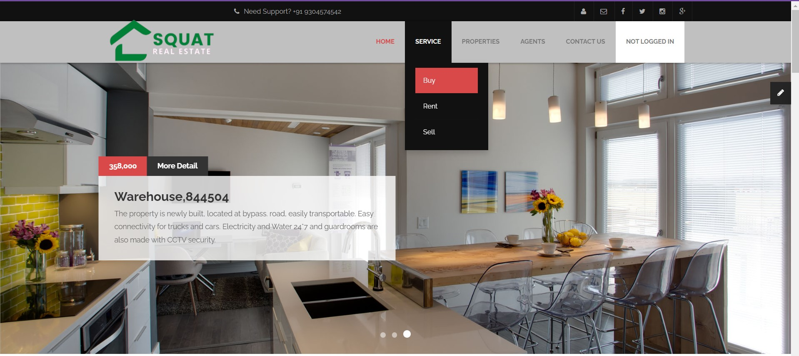

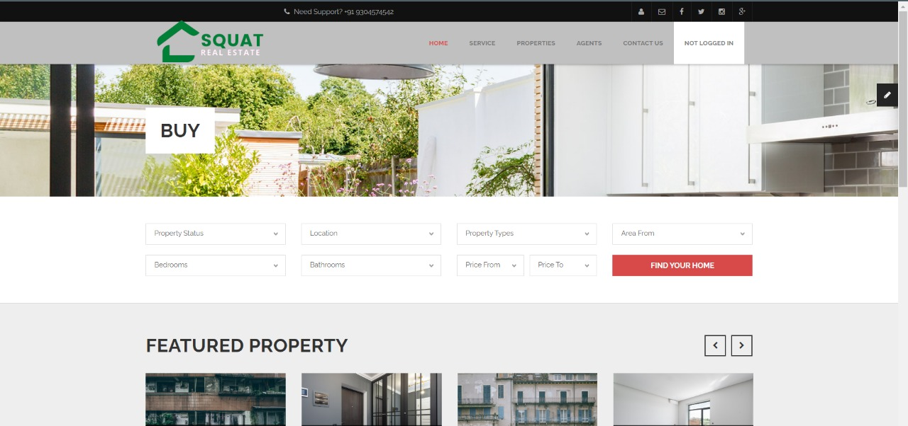

**Buy.php**

<?php **include**('authentication.php'); ?>

<?php **include**('includes/header.php'); ?>

<?php **include**('includes/connection.php'); ?>

<!-- Begin Main -->

<div role="main" class="main pgl-bg-grey">

<!-- Begin page top -->

<section class="page-top">

<div class="container">

<div class="page-top-in">

<h2><span>Buy </span></h2>

</div>

</div>

</section>

<!-- Begin Advanced Search -->

<section class="pgl-advanced-search pgl-bg-light">

<div class="container">

<form name="advancedsearch">

<div class="row">

<div class="col-xs-6 col-sm-3">

<div class="form-group">

<label class="sr-only" for="property-status">Property Status</label>

<select id="property-status" name="property-status" data-placeholder="Property Status"

class="chosen-select">

<option selected="selected" value="Property Status">Property Status</option>

<option value="sale">For Sale</option>

<option value="rent">For Rent</option>

</select>

</div>

</div>

<div class="col-xs-6 col-sm-3">

<div class="form-group">

<label class="sr-only" for="location">Location</label>

<select id="location" name="location" data-placeholder="Location" class="chosen-select">

<option selected="selected" value="Location">Location</option>

<option value="Bihar">Bihar</option>

<option value="Uttar Pardesh">Uttar Pardesh</option>

<option value="Noida">Noida</option>

<option value="Panjab">Panjab</option>

<option value="Karnataka">Karnataka</option>

<option value="Assam">Assam</option>

<option value="Patna">Patna</option>

<option value="Tamilnadu">Tamilnadu</option>

<option value="Kolkata">Kolkata</option>

<option value="Goa">Goa</option>

<option value="Maharashtra">Maharashtra</option>

<option value="West Bengal">West Bengal</option>

<option value="Gujarat">Gujarat</option>

<option value="Odisha">Odisha</option>

<option value="Tripura">Tripura</option>

<option value="Kerla">Kerla</option>

<option value="Sikkim">Sikkim</option>

<option value="Jharkhand">Jharkhand</option>

<option value="Nagaland">Nagaland</option>

<option value="Delhi">Delhi</option>

</select>

</div>

</div>

<div class="col-xs-6 col-sm-3">

<div class="form-group">

<label class="sr-only" for="property-types">Property Types</label>

<select id="property-types" name="property-types" data-placeholder="Property Types"

class="chosen-select">

<option selected="selected" value="Property Types">Property Types</option>

<option value="residential">Residential</option>

<option value="commercial">Commercial</option>

<option value="land">Land</option>

</select>

</div>

</div>

<div class="col-xs-6 col-sm-3">

<div class="form-group">

<label class="sr-only" for="area-from">Area From</label>

<select id="area-from" name="area-from" data-placeholder="Area From" class="chosen-select">

<option selected="selected" value="Area From">Area From</option>

<option value="450">450</option>

<option value="350">350</option>

<option value="250">250</option>

<option value="150">150</option>

<option value="100">100</option>

<option value="50">50</option>

</select>

</div>

</div>

</div>

<div class="row">

<div class="col-xs-6 col-sm-3">

<div class="form-group">

<label class="sr-only" for="search-bedrooms">Bedrooms</label>

<select id="search-bedrooms" name="search-bedrooms" data-placeholder="Bedrooms"

class="chosen-select">

<option selected="selected" value="Bedrooms">Bedrooms</option>

<option value="0">0</option>

<option value="1">1</option>

<option value="2">2</option>

<option value="3">3</option>

<option value="4">4</option>

<option value="5">5</option>

<option value="5plus">5+</option>

</select>

</div>

</div>

<div class="col-xs-6 col-sm-3">

<div class="form-group">

<label class="sr-only" for="search-bathrooms">Bathrooms</label>

<select id="search-bathrooms" name="search-bathrooms" data-placeholder="Bathrooms"

class="chosen-select">

<option selected="selected" value="Bathrooms">Bathrooms</option>

<option value="0">0</option>

<option value="1">1</option>

<option value="2">2</option>

<option value="3">3</option>

<option value="4">4</option>

<option value="4plus">4+</option>

</select>

</div>

</div>

<div class="col-xs-6 col-sm-3">

<div class="form-group">

<div class="row pgl-narrow-row">

<div class="col-xs-6">

<label class="sr-only" for="search-minprice">Price From</label>

<select id="search-minprice" name="search-minprice" data-placeholder="Price From"

class="chosen-select">

<option selected="selected" value="Price From">Price From</option>

<option value="0">0</option>

<option value="25000">25000</option>

<option value="50000">50000</option>

<option value="75000">75000</option>

<option value="100000">100000</option>

<option value="150000">150000</option>

<option value="200000">200000</option>

<option value="300000">300000</option>

<option value="500000">500000</option>

<option value="750000">750000</option>

<option value="1000000">1000000</option>

</select>

</div>

<div class="col-xs-6">

<label class="sr-only" for="search-maxprice">Price To</label>

<select id="search-maxprice" name="search-maxprice" data-placeholder="Price To"

class="chosen-select">

<option selected="selected" value="Price To">Price To</option>

<option value="25000">25000</option>

<option value="50000">50000</option>

<option value="75000">75000</option>

<option value="100000">100000</option>

<option value="150000">150000</option>

<option value="200000">200000</option>

<option value="300000">300000</option>

<option value="500000">500000</option>

<option value="750000">750000</option>

<option value="1000000">1000000</option>

<option value="1000000plus">>1000000</option>

</select>

</div>

</div>

</div>

</div>

<div class="col-xs-6 col-sm-3">

<div class="form-group">

<button type="submit" class="btn btn-block btn-primary">Find your home</button>

</div>

</div>

</div>

</form>

</div>

</section>

<!-- End Advanced Search -->

<section class="pgl-featured">

<div class="container">

<h2>Featured Property</h2>

<div class="row">

<div class="owl-carousel pgl-pro-slide"

data-plugin-options='{"items": 4, "singleItem": false, "autoPlay": false, "pagination": false}'>

<div class="col-sm-12 animation">

<div class="pgl-property featured-item">

<div class="property-thumb-info">

<div class="property-thumb-info-image">

<img alt="" class="img-responsive" src="images/agents/rent1.jpg">

</div>

<div class="property-thumb-info-content">

<h3><a href="property-details.php">3 BHK 2500 Sq.ft. Builder Floor for Rent</a></h3>

<p>Anand Niketan, Block D, Anand Niketan, Delhi</p>

</div>

</div>

</div>

</div>

<div class="col-sm-12 animation">

<div class="pgl-property featured-item">

<div class="property-thumb-info">

<div class="property-thumb-info-image">

<img alt="" class="img-responsive" src="images/agents/rent2.jpg">

</div>

<div class="property-thumb-info-content">

<h3><a href="property-details.php">2 BHK 900 Sq.ft. Builder Floor for Rent</a></h3>

<p>Mahavir Enclave Part 2, Mahavir Enclave, Delhi</p>

</div>

</div>

</div>

</div>

<div class="col-sm-12 animation">

<div class="pgl-property featured-item">

<div class="property-thumb-info">

<div class="property-thumb-info-image">

<img alt="" class="img-responsive" src="images/agents/rent3.jpg">

</div>

<div class="property-thumb-info-content">

<h3><a href="property-details.php">3 BHK 1320 Sq.ft. Builder Floor for Rent</a></h3>

<p>Rohini Sector 11, Rohini, Delhi .</p>

</div>

</div>

</div>

</div>

<div class="col-sm-12 animation">

<div class="pgl-property featured-item">

<div class="property-thumb-info">

<div class="property-thumb-info-image">

<img alt="" class="img-responsive" src="images/agents/rent4.jpg">

</div>

<div class="property-thumb-info-content">

<h3><a href="property-details.php">2 BHK 550 Sq.ft. Builder Floor for Rent</a></h3>

<p> Shastri Nagar Block E, Shastri Nagar, Delhi.</p>

</div>

</div>

</div>

</div>

<div class="col-sm-12 animation">

<div class="pgl-property featured-item">

<div class="property-thumb-info">

<div class="property-thumb-info-image">

<img alt="" class="img-responsive" src="images/properties/property-featured-3.jpg">

</div>

<div class="property-thumb-info-content">

<h3><a href="property-details.php">Spring Gate DrUNIT 4106</a></h3>

<p>Amet luctus nisl tempus.</p>

</div>

</div>

</div>

</div>

<div class="col-sm-12 animation">

<div class="pgl-property featured-item">

<div class="property-thumb-info">

<div class="property-thumb-info-image">

<img alt="" class="img-responsive" src="images/properties/property-featured-4.jpg">

</div>

<div class="property-thumb-info-content">

<h3><a href="property-details.php">Chatham St NW, Roanoke</a></h3>

<p>Amet luctus nisl tempus.</p>

</div>

</div>

</div>

</div>

</div>

</div>

<hr class="top-tall">

</div>

</section>

<!-- End Featured -->

<div class="container">

<h2>Recent Property</h2>

<div class="row">

<div class="col-md-12">

<div class="card">

<!-- <div class="card-header">

<h3 class="card-title">Sell Form Details</h3>

</div> -->

<!-- /.card-header -->

<div class="card-body">

<table id="example1" class="table table-bordered table-striped">

<thead>

<tr>

<th> SELL ID</th>

<th>PROJECT</th>

<th>MAINTENANCE</th>

<th>FLOORS</th>

<th>ADDRESS</th>

<th>BEDROOMS</th>

<th>FURNISHING</th>

<th>CONSTRACTIONS STATUS</th>

<th>EXTERIOR</th>

<!-- <th>DATE & TIME</th> -->

</tr>

</thead>

<tbody>

<?php

$query="SELECT * FROM sellform";

$query_run=mysqli_query($con,$query);

**if**(mysqli_num_rows($query_run) > **0**)

{

?>

<?php

**foreach**($query_run **as** $row)

{

/* echo $row['name']; */

?>

<tr>

<td>

<?php **echo** $row['id']; ?>

</td>

<td>

<a href="index.php"><?php **echo** $row['project']; ?></a>

</td>

<td>

<?php **echo** $row['maintenance']; ?>

</td>

<td>

<?php **echo** $row['total_floor']; ?>

</td>

<td>

<?php **echo** $row['address']; ?>

</td>

<td>

<?php **echo** $row['bedrooms']; ?>

</td>

<td>

<?php **echo** $row['furnishing']; ?>

</td>

<td>

<?php **echo** $row['const_status']; ?>

</td>

<td>

<?php **echo** '<img src="upload/'.$row['exterior'].' " width="100px" height="100px" alt="no image1">'?>

</td>

<td>

<a href="contact.php" class="btn btn-info">GET PHONE NO.</a>

</td>

<td>

<a href="property-details.php" class="btn btn-danger">PROPERTY DETAILS</a>

</td>

</tr>

<?php

}

}

**else**

{

?>

<tr>

<td>NO record found</td>

</tr>

<?php

}

?>

</tbody>

</table>

</div>

</div>

</div>

</div>

</div>

<?php **include**('includes/footer.php'); ?>

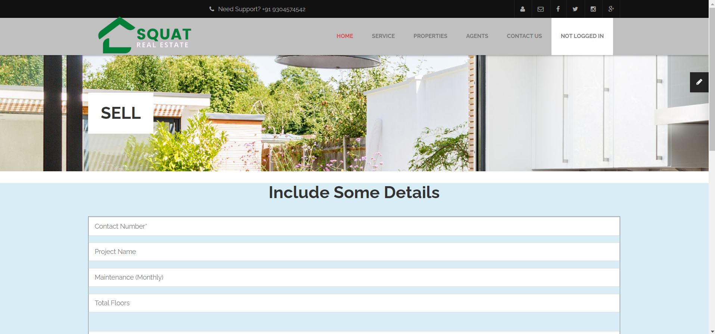

**Sell.php**

<?php **include**('authentication.php'); ?>

<?php **include**('includes/header.php') ?>

<!-- Begin Main -->

<div role="main" class="main pgl-bg-grey">

<!-- Begin page top -->

<section class="page-top">

<div class="container">

<div class="page-top-in">

<h2><span>Sell </span></h2>

</div>

</div>

</section>

</div>

<br>

<!-- End page top -->

<section class="bg-info">

<h1 class="text-center text-capitalize">Include Some Details</h1>

<div class="container">

<div class="row">

<div class="col-md-12">

<form action="code.php" method="POST" enctype="multipart/form-data" style="border:1px solid gray;">

<div class="form-group">

<input type="text" class="form-control" placeholder="Contact Number*" name="phone">

</div>

<div class="form-group">

<input type="text" class="form-control" placeholder="Project Name" name="projectname">

</div>

<div class="form-group">

<input type="text" class="form-control" placeholder="Maintenance (Monthly)" name="maintenance">

</div>

<div class="form-group">

<input type="text" class="form-control" placeholder="Total Floors" name="totalfloors">

</div>

<div class="form-group">

<label for="exampleFormControlTextarea1"></label>

<textarea class="form-control" id="exampleFormControlTextarea1" rows="3" name="address" placeholder="Your Address..."></textarea>

</div>

<div class="form-row">

<div class="form-group col-md-4">

<select class="form-control" name="type">

<option>Type*</option>

<option>Sell</option>

<option>Rent</option>

</select>

</div>

<div class="form-group col-md-4">

<select class="form-control" name="bedrooms">

<option>Bedrooms*</option>

<option>1</option>

<option>2</option>

<option>3</option>

<option>4</option>

<option>4+</option>

</select>

</div>

<div class="form-group col-md-4">

<select class="form-control" name="furnishing">

<option>Furnishing</option>

<option>Furnished</option>

<option>Semi-Furnished</option>

<option>Unfurnished</option>

</select>

</div>

</div>

<div class="form-row">

<div class="form-group col-md-6">

<select class="form-control" name="const_status">

<option>Constructions status</option>

<option>New Lunch</option>

<option>Ready to Move</option>

<option>Under Construction</option>

</select>

</div>

<div class="form-group col-md-6">

<select class="form-control" name="listedby">

<option>Listed by</option>

<option>Builder</option>

<option>Dealer</option>

<option>Owner</option>

</select>

</div>

</div>

<div class="col-md-4">

<div class="form-group">

<label for="exampleInputFile">Exterior</label>

<input type="file" id="exampleInputFile" name="exteriorimg">

</div>

</div>

<div class="col-md-4">

<div class="form-group">

<label for="exampleInputFile">Livingroom</label>

<input type="file" id="exampleInputFile" name="livingroomimg">

</div>

</div>

<div class="col-md-4">

<div class="form-group">

<label for="exampleInputFile">Kitchen</label>

<input type="file" id="exampleInputFile" name="kitchenimg">

</div>

</div>

<br><br><br>

<div class="form-group">

<button type="reset" class="btn btn-info" id="reset" name="btnsellform">Reset</button>

**&nbsp;&nbsp;&nbsp;&nbsp;&nbsp;&nbsp;**

<button type="submit" class="btn btn-primary" id="submit" name="btnsellform">submit</button>

</div>

</form>

<br><br><br><br>

</div>

</div>

</div>

</section>

<?php **include**('includes/footer.php') ?>

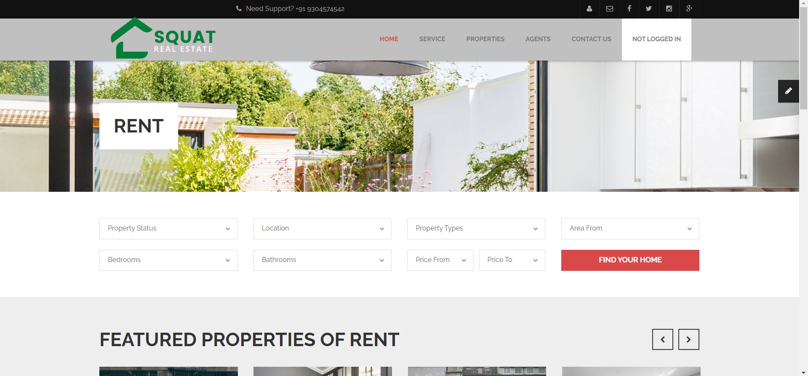

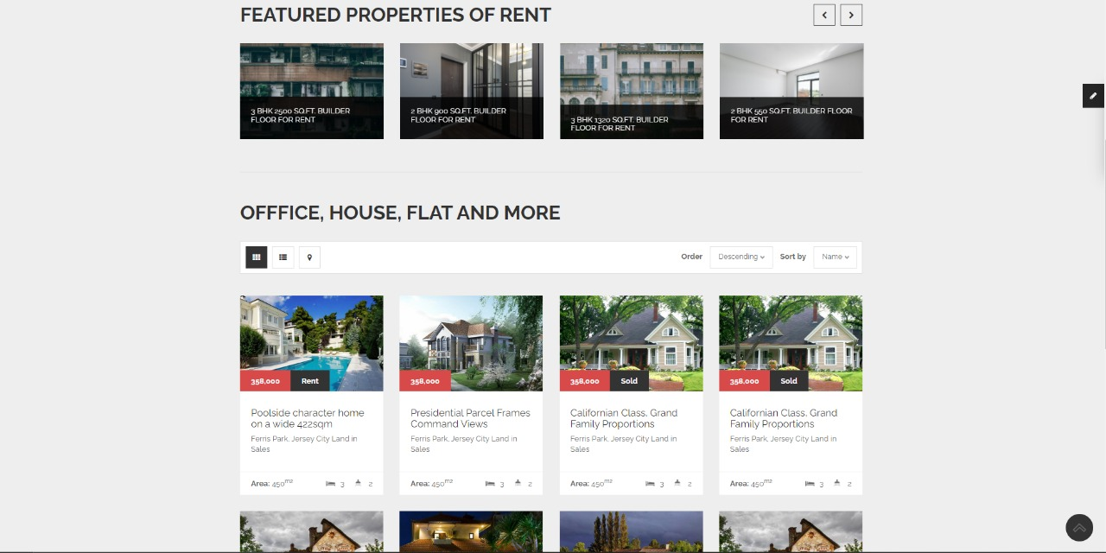

**Rent.php**

<?php **include**('authentication.php'); ?>

<?php **include**('includes/header.php') ?>

<!-- Begin Main -->

<div role="main" class="main pgl-bg-grey">

<!-- Begin page top -->

<section class="page-top">

<div class="container">

<div class="page-top-in">

<h2><span>Rent </span></h2>

</div>

</div>

</section>

<!-- Begin Advanced Search -->

<section class="pgl-advanced-search pgl-bg-light">

<div class="container">

<form name="advancedsearch">

<div class="row">

<div class="col-xs-6 col-sm-3">

<div class="form-group">

<label class="sr-only" for="property-status">Property Status</label>

<select id="property-status" name="property-status" data-placeholder="Property Status" class="chosen-select">

<option selected="selected" value="Property Status">Property Status</option>

<option value="sale">For Sale</option>

<option value="rent">For Rent</option>

</select>

</div>

</div>

<div class="col-xs-6 col-sm-3">

<div class="form-group">

<label class="sr-only" for="location">Location</label>

<select id="location" name="location" data-placeholder="Location" class="chosen-select">

<option selected="selected" value="Location">Location</option>

<option value="Bihar">Bihar</option>

<option value="Uttar Pardesh">Uttar Pardesh</option>

<option value="Noida">Noida</option>

<option value="Panjab">Panjab</option>

<option value="Karnataka">Karnataka</option>

<option value="Assam">Assam</option>

<option value="Patna">Patna</option>

<option value="Tamilnadu">Tamilnadu</option>

<option value="Kolkata">Kolkata</option>

<option value="Goa">Goa</option>

<option value="Maharashtra">Maharashtra</option>

<option value="West Bengal">West Bengal</option>

<option value="Gujarat">Gujarat</option>

<option value="Odisha">Odisha</option>

<option value="Tripura">Tripura</option>

<option value="Kerla">Kerla</option>

<option value="Sikkim">Sikkim</option>

<option value="Jharkhand">Jharkhand</option>

<option value="Nagaland">Nagaland</option>

<option value="Delhi">Delhi</option>

</select>

</div>

</div>

<div class="col-xs-6 col-sm-3">

<div class="form-group">

<label class="sr-only" for="property-types">Property Types</label>

<select id="property-types" name="property-types" data-placeholder="Property Types" class="chosen-select">

<option selected="selected" value="Property Types">Property Types</option>

<option value="residential">Residential</option>

<option value="commercial">Commercial</option>

<option value="land">Land</option>

</select>

</div>

</div>

<div class="col-xs-6 col-sm-3">

<div class="form-group">

<label class="sr-only" for="area-from">Area From</label>

<select id="area-from" name="area-from" data-placeholder="Area From" class="chosen-select">

<option selected="selected" value="Area From">Area From</option>

<option value="450">450</option>

<option value="350">350</option>

<option value="250">250</option>

<option value="150">150</option>

<option value="100">100</option>

<option value="50">50</option>

</select>

</div>

</div>

</div>

<div class="row">

<div class="col-xs-6 col-sm-3">

<div class="form-group">

<label class="sr-only" for="search-bedrooms">Bedrooms</label>

<select id="search-bedrooms" name="search-bedrooms" data-placeholder="Bedrooms" class="chosen-select">

<option selected="selected" value="Bedrooms">Bedrooms</option>

<option value="0">0</option>

<option value="1">1</option>

<option value="2">2</option>

<option value="3">3</option>

<option value="4">4</option>

<option value="5">5</option>

<option value="5plus">5+</option>

</select>

</div>

</div>

<div class="col-xs-6 col-sm-3">

<div class="form-group">

<label class="sr-only" for="search-bathrooms">Bathrooms</label>

<select id="search-bathrooms" name="search-bathrooms" data-placeholder="Bathrooms" class="chosen-select">

<option selected="selected" value="Bathrooms">Bathrooms</option>

<option value="0">0</option>

<option value="1">1</option>

<option value="2">2</option>

<option value="3">3</option>

<option value="4">4</option>

<option value="4plus">4+</option>

</select>

</div>

</div>

<div class="col-xs-6 col-sm-3">

<div class="form-group">

<div class="row pgl-narrow-row">

<div class="col-xs-6">

<label class="sr-only" for="search-minprice">Price From</label>

<select id="search-minprice" name="search-minprice" data-placeholder="Price From" class="chosen-select">

<option selected="selected" value="Price From">Price From</option>

<option value="0">0</option>

<option value="25000">25000</option>

<option value="50000">50000</option>

<option value="75000">75000</option>

<option value="100000">100000</option>

<option value="150000">150000</option>

<option value="200000">200000</option>

<option value="300000">300000</option>

<option value="500000">500000</option>

<option value="750000">750000</option>

<option value="1000000">1000000</option>

</select>

</div>

<div class="col-xs-6">

<label class="sr-only" for="search-maxprice">Price To</label>

<select id="search-maxprice" name="search-maxprice" data-placeholder="Price To" class="chosen-select">

<option selected="selected" value="Price To">Price To</option>

<option value="25000">25000</option>

<option value="50000">50000</option>

<option value="75000">75000</option>

<option value="100000">100000</option>

<option value="150000">150000</option>

<option value="200000">200000</option>

<option value="300000">300000</option>

<option value="500000">500000</option>

<option value="750000">750000</option>

<option value="1000000">1000000</option>

<option value="1000000plus">>1000000</option>

</select>

</div>

</div>

</div>

</div>

<div class="col-xs-6 col-sm-3">

<div class="form-group">

<button type="submit" class="btn btn-block btn-primary">Find your home</button>

</div>

</div>

</div>

</form>

</div>

</section>

<!-- End Advanced Search -->

<!-- Begin Featured -->

<section class="pgl-featured">

<div class="container">

<h2>Featured Properties of Rent</h2>

<div class="row">

<div class="owl-carousel pgl-pro-slide" data-plugin-options='{"items": 4, "singleItem": false, "autoPlay": false, "pagination": false}'>

<div class="col-sm-12 animation">

<div class="pgl-property featured-item">

<div class="property-thumb-info">

<div class="property-thumb-info-image">

<img alt="" class="img-responsive" src="images/agents/rent1.jpg">

</div>

<div class="property-thumb-info-content">

<h3><a href="property-details.php">3 BHK 2500 Sq.ft. Builder Floor for Rent</a></h3>

<p>Anand Niketan, Block D, Anand Niketan, Delhi</p>

</div>

</div>

</div>

</div>

<div class="col-sm-12 animation">

<div class="pgl-property featured-item">

<div class="property-thumb-info">

<div class="property-thumb-info-image">

<img alt="" class="img-responsive" src="images/agents/rent2.jpg">

</div>

<div class="property-thumb-info-content">

<h3><a href="property-details.php">2 BHK 900 Sq.ft. Builder Floor for Rent</a></h3>

<p>Mahavir Enclave Part 2, Mahavir Enclave, Delhi</p>

</div>

</div>

</div>

</div>

<div class="col-sm-12 animation">

<div class="pgl-property featured-item">

<div class="property-thumb-info">

<div class="property-thumb-info-image">

<img alt="" class="img-responsive" src="images/agents/rent3.jpg">

</div>

<div class="property-thumb-info-content">

<h3><a href="property-details.php">3 BHK 1320 Sq.ft. Builder Floor for Rent</a></h3>

<p>Rohini Sector 11, Rohini, Delhi .</p>

</div>

</div>

</div>

</div>

<div class="col-sm-12 animation">

<div class="pgl-property featured-item">

<div class="property-thumb-info">

<div class="property-thumb-info-image">

<img alt="" class="img-responsive" src="images/agents/rent4.jpg">

</div>

<div class="property-thumb-info-content">

<h3><a href="property-details.php">2 BHK 550 Sq.ft. Builder Floor for Rent</a></h3>

<p> Shastri Nagar Block E, Shastri Nagar, Delhi.</p>

</div>

</div>

</div>

</div>

<div class="col-sm-12 animation">

<div class="pgl-property featured-item">

<div class="property-thumb-info">

<div class="property-thumb-info-image">

<img alt="" class="img-responsive" src="images/properties/property-featured-3.jpg">

</div>

<div class="property-thumb-info-content">

<h3><a href="property-details.php">Spring Gate DrUNIT 4106</a></h3>

<p>Amet luctus nisl tempus.</p>

</div>

</div>

</div>

</div>

<div class="col-sm-12 animation">

<div class="pgl-property featured-item">

<div class="property-thumb-info">

<div class="property-thumb-info-image">

<img alt="" class="img-responsive" src="images/properties/property-featured-4.jpg">

</div>

<div class="property-thumb-info-content">

<h3><a href="property-details.php">Chatham St NW, Roanoke</a></h3>

<p>Amet luctus nisl tempus.</p>

</div>

</div>

</div>

</div>

</div>

</div>

<hr class="top-tall">

</div>

</section>

<!-- End Featured -->

<!-- Begin Properties -->

<section class="pgl-properties pgl-bg-grey">

<div class="container">

<h2>Offfice, House, Flat and More</h2>

<div class="properties-full">

<div class="listing-header clearfix">

<ul class="list-inline list-icons pull-left">

<li class="active"><a href="grid-fullwidth-4-column.html"><i class="fa fa-th"></i></a></li>

<li><a href="list-fullwidth.html"><i class="fa fa-th-list"></i></a></li>

<li><a href="list-map.html"><i class="fa fa-map-marker"></i></a></li>

</ul>

<ul class="list-inline list-sort pull-right">

<li><label for="order-status">Order</label></li>

<li>

<select id="order-status" name="order-status" data-placeholder="Order" class="chosen-select">

<option value="Descending">Descending</option>

<option value="Ascending">Ascending</option>

</select>

</li>

<li><label for="sortby-status">Sort by</label></li>

<li>

<select id="sortby-status" name="sortby-status" data-placeholder="Sort by" class="chosen-select">

<option value="Name">Name</option>

<option value="Area">Area</option>

<option value="Date">Date</option>

</select>

</li>

</ul>

</div>

<div class="row">

<div class="col-xs-6 col-md-3 animation">

<div class="pgl-property">

<div class="property-thumb-info">

<div class="property-thumb-info-image">

<img alt="" class="img-responsive" src="images/properties/property-1.jpg">

<span class="property-thumb-info-label">

<span class="label price">358,000</span>

<span class="label forrent">Rent</span>

</span>

</div>

<div class="property-thumb-info-content">

<h3><a href="property-details.php">Poolside character home on a wide 422sqm</a></h3>

<address>Ferris Park, Jersey City Land in Sales</address>

</div>

<div class="amenities clearfix">

<ul class="pull-left">

<li><strong>Area:</strong> 450<sup>m2</sup></li>

</ul>

<ul class="pull-right">

<li><i class="icons icon-bedroom"></i> 3</li>

<li><i class="icons icon-bathroom"></i> 2</li>

</ul>

</div>

</div>

</div>

</div>

<div class="col-xs-6 col-md-3 animation">

<div class="pgl-property">

<div class="property-thumb-info">

<div class="property-thumb-info-image">

<img alt="" class="img-responsive" src="images/properties/property-2.jpg">

<span class="property-thumb-info-label">

<span class="label price">358,000</span>

</span>

</div>

<div class="property-thumb-info-content">

<h3><a href="property-details.php">Presidential Parcel Frames Command Views</a></h3>

<address>Ferris Park, Jersey City Land in Sales</address>

</div>

<div class="amenities clearfix">

<ul class="pull-left">

<li><strong>Area:</strong> 450<sup>m2</sup></li>

</ul>

<ul class="pull-right">

<li><i class="icons icon-bedroom"></i> 3</li>

<li><i class="icons icon-bathroom"></i> 2</li>

</ul>

</div>

</div>

</div>

</div>

<div class="col-xs-6 col-md-3 animation">

<div class="pgl-property">

<div class="property-thumb-info">

<div class="property-thumb-info-image">

<img alt="" class="img-responsive" src="images/properties/property-3.jpg">

<span class="property-thumb-info-label">

<span class="label price">358,000</span>

<span class="label forsold">Sold</span>

</span>

</div>

<div class="property-thumb-info-content">

<h3><a href="property-details.php">Californian Class, Grand Family Proportions</a></h3>

<address>Ferris Park, Jersey City Land in Sales</address>

</div>

<div class="amenities clearfix">

<ul class="pull-left">

<li><strong>Area:</strong> 450<sup>m2</sup></li>

</ul>

<ul class="pull-right">

<li><i class="icons icon-bedroom"></i> 3</li>

<li><i class="icons icon-bathroom"></i> 2</li>

</ul>

</div>

</div>

</div>

</div>

<div class="col-xs-6 col-md-3 animation">

<div class="pgl-property">

<div class="property-thumb-info">

<div class="property-thumb-info-image">

<img alt="" class="img-responsive" src="images/properties/property-3.jpg">

<span class="property-thumb-info-label">

<span class="label price">358,000</span>

<span class="label forsold">Sold</span>

</span>

</div>

<div class="property-thumb-info-content">

<h3><a href="property-details.php">Californian Class, Grand Family Proportions</a></h3>

<address>Ferris Park, Jersey City Land in Sales</address>

</div>

<div class="amenities clearfix">

<ul class="pull-left">

<li><strong>Area:</strong> 450<sup>m2</sup></li>

</ul>

<ul class="pull-right">

<li><i class="icons icon-bedroom"></i> 3</li>

<li><i class="icons icon-bathroom"></i> 2</li>

</ul>

</div>

</div>

</div>

</div>

</div>

<div class="row">

<div class="col-xs-6 col-md-3 animation">

<div class="pgl-property">

<div class="property-thumb-info">

<div class="property-thumb-info-image">

<img alt="" class="img-responsive" src="images/properties/property-4.jpg">

<span class="property-thumb-info-label">

<span class="label price">358,000</span>

<span class="label forrent">Rent</span>

</span>

</div>

<div class="property-thumb-info-content">

<h3><a href="property-details.php">Chatham St NW, Roanoke, VA 24012</a></h3>

<address>Ferris Park, Jersey City Land in Sales</address>

</div>

<div class="amenities clearfix">

<ul class="pull-left">

<li><strong>Area:</strong> 450<sup>m2</sup></li>

</ul>

<ul class="pull-right">

<li><i class="icons icon-bedroom"></i> 3</li>

<li><i class="icons icon-bathroom"></i> 2</li>

</ul>

</div>

</div>

</div>

</div>

<div class="col-xs-6 col-md-3 animation">

<div class="pgl-property">

<div class="property-thumb-info">

<div class="property-thumb-info-image">

<img alt="" class="img-responsive" src="images/properties/property-5.jpg">

<span class="property-thumb-info-label">

<span class="label price">358,000</span>

</span>

</div>

<div class="property-thumb-info-content">

<h3><a href="property-details.php">Chatham St NW, Roanoke, VA 24012</a></h3>

<address>Ferris Park, Jersey City Land in Sales</address>

</div>

<div class="amenities clearfix">

<ul class="pull-left">

<li><strong>Area:</strong> 450<sup>m2</sup></li>

</ul>

<ul class="pull-right">

<li><i class="icons icon-bedroom"></i> 3</li>

<li><i class="icons icon-bathroom"></i> 2</li>

</ul>

</div>

</div>

</div>

</div>

<div class="col-xs-6 col-md-3 animation">

<div class="pgl-property">

<div class="property-thumb-info">

<div class="property-thumb-info-image">

<img alt="" class="img-responsive" src="images/properties/property-6.jpg">

<span class="property-thumb-info-label">

<span class="label price">358,000</span>

</span>

</div>

<div class="property-thumb-info-content">

<h3><a href="property-details.php">Chatham St NW, Roanoke, VA 24012</a></h3>

<address>Ferris Park, Jersey City Land in Sales</address>

</div>

<div class="amenities clearfix">

<ul class="pull-left">

<li><strong>Area:</strong> 450<sup>m2</sup></li>

</ul>

<ul class="pull-right">

<li><i class="icons icon-bedroom"></i> 3</li>

<li><i class="icons icon-bathroom"></i> 2</li>

</ul>

</div>

</div>

</div>

</div>

<div class="col-xs-6 col-md-3 animation">

<div class="pgl-property">

<div class="property-thumb-info">

<div class="property-thumb-info-image">

<img alt="" class="img-responsive" src="images/properties/property-4.jpg">

<span class="property-thumb-info-label">

<span class="label price">358,000</span>

<span class="label forrent">Rent</span>

</span>

</div>

<div class="property-thumb-info-content">

<h3><a href="property-details.php">Chatham St NW, Roanoke, VA 24012</a></h3>

<address>Ferris Park, Jersey City Land in Sales</address>

</div>

<div class="amenities clearfix">

<ul class="pull-left">

<li><strong>Area:</strong> 450<sup>m2</sup></li>

</ul>

<ul class="pull-right">

<li><i class="icons icon-bedroom"></i> 3</li>

<li><i class="icons icon-bathroom"></i> 2</li>

</ul>

</div>

</div>

</div>

</div>

</div>

<ul class="pagination">

<li class="active"><a href="#">1 <span class="sr-only">(current)</span></a></li>

<li><a href="#">2</a></li>

<li><a href="#">3</a></li>

<li><a href="#">Next</a></li>

</ul>

</div>

</div>

</section>

<!-- End Properties -->

<!-- End Main -->

<?php **include**('includes/footer.php') ?>

**Properties**

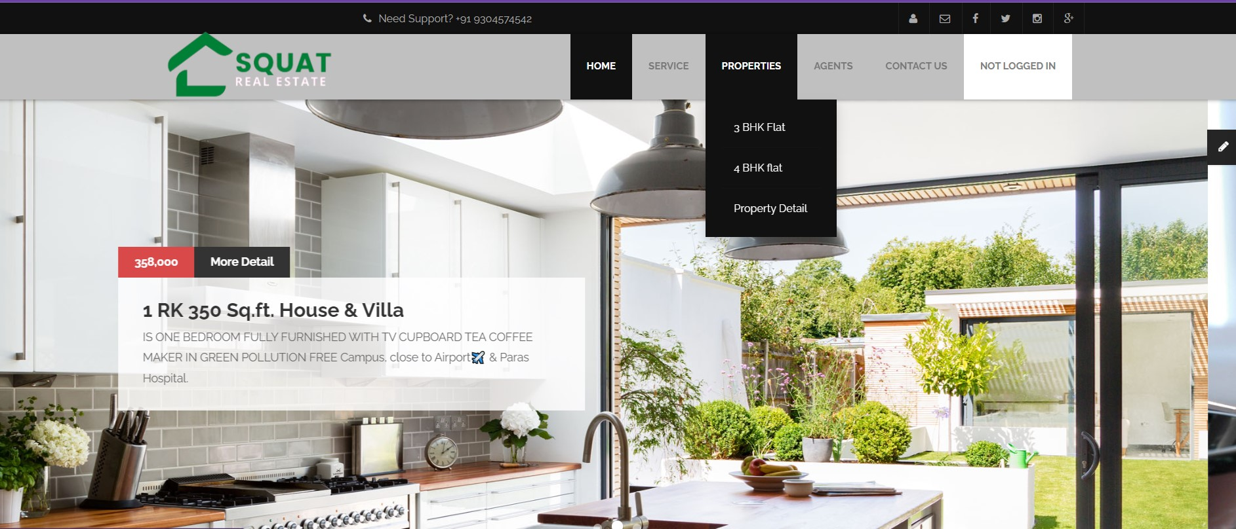

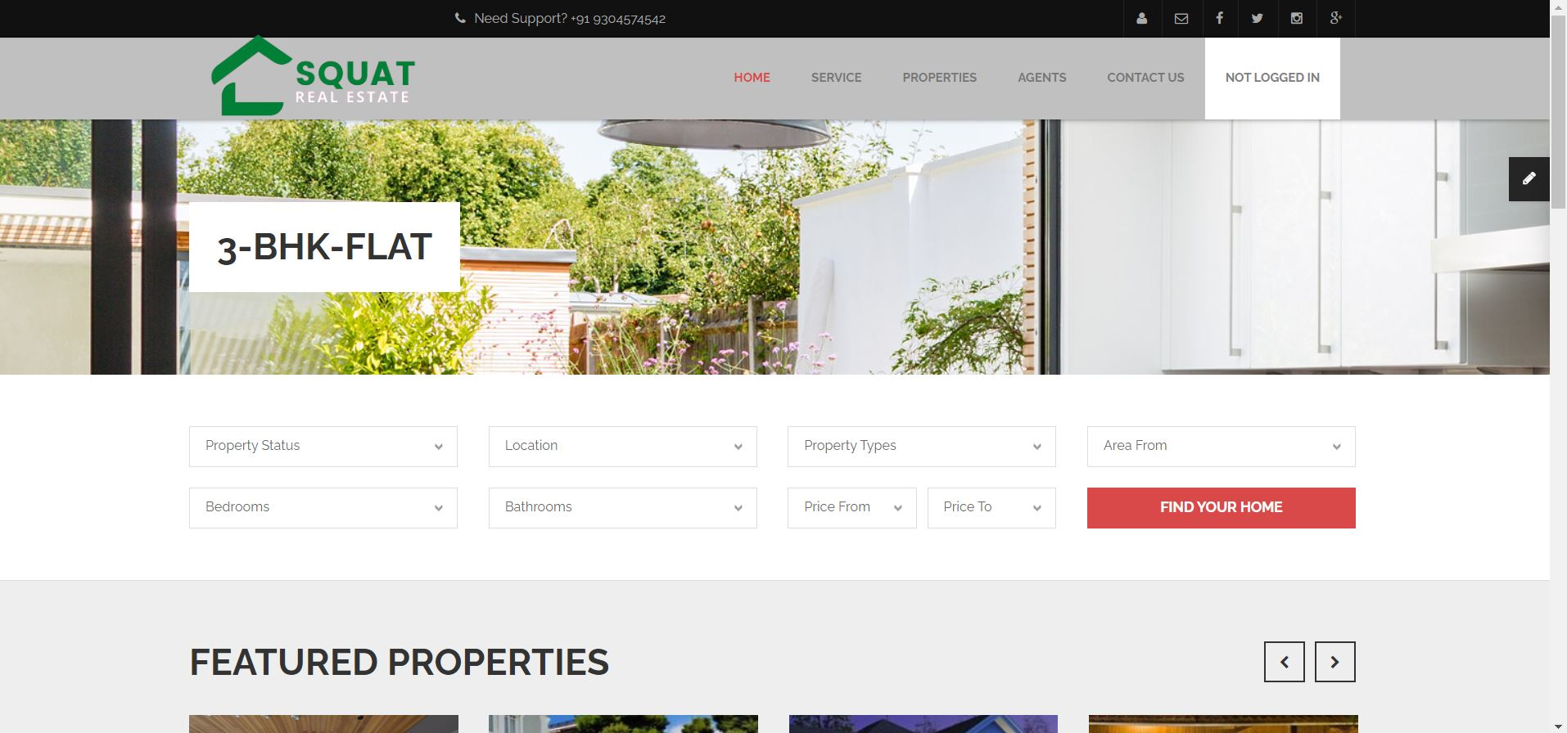

**3-bhk-flat.php**

<?php **include**('includes/header.php') ?>

<!-- Begin Main -->

<div role="main" class="main pgl-bg-grey">

<!-- Begin page top -->

<section class="page-top">

<div class="container">

<div class="page-top-in">

<h2><span>3-BHK-Flat</span></h2>

</div>

</div>

</section>

<!-- End page top -->

<!-- Begin Advanced Search -->

<section class="pgl-advanced-search pgl-bg-light">

<div class="container">

<form name="advancedsearch">

<div class="row">

<div class="col-xs-6 col-sm-3">

<div class="form-group">

<label class="sr-only" for="property-status">Property Status</label>

<select id="property-status" name="property-status" data-placeholder="Property Status" class="chosen-select">

<option selected="selected" value="Property Status">Property Status</option>

<option value="sale">For Sale</option>

<option value="rent">For Rent</option>

</select>

</div>

</div>

<div class="col-xs-6 col-sm-3">

<div class="form-group">

<label class="sr-only" for="location">Location</label>

<select id="location" name="location" data-placeholder="Location" class="chosen-select">

<option selected="selected" value="Location">Location</option>

<option value="Bihar">Bihar</option>

<option value="Uttar Pardesh">Uttar Pardesh</option>

<option value="Noida">Noida</option>

<option value="Panjab">Panjab</option>

<option value="Karnataka">Karnataka</option>

<option value="Assam">Assam</option>

<option value="Patna">Patna</option>

<option value="Tamilnadu">Tamilnadu</option>

<option value="Kolkata">Kolkata</option>

<option value="Goa">Goa</option>

<option value="Maharashtra">Maharashtra</option>

<option value="West Bengal">West Bengal</option>

<option value="Gujarat">Gujarat</option>

<option value="Odisha">Odisha</option>

<option value="Tripura">Tripura</option>

<option value="Kerla">Kerla</option>

<option value="Sikkim">Sikkim</option>

<option value="Jharkhand">Jharkhand</option>

<option value="Nagaland">Nagaland</option>

<option value="Delhi">Delhi</option>

</select>

</div>

</div>

<div class="col-xs-6 col-sm-3">

<div class="form-group">

<label class="sr-only" for="property-types">Property Types</label>

<select id="property-types" name="property-types" data-placeholder="Property Types" class="chosen-select">

<option selected="selected" value="Property Types">Property Types</option>

<option value="residential">Residential</option>

<option value="commercial">Commercial</option>

<option value="land">Land</option>

</select>

</div>

</div>

<div class="col-xs-6 col-sm-3">

<div class="form-group">

<label class="sr-only" for="area-from">Area From</label>

<select id="area-from" name="area-from" data-placeholder="Area From" class="chosen-select">

<option selected="selected" value="Area From">Area From</option>

<option value="450">450</option>

<option value="350">350</option>

<option value="250">250</option>

<option value="150">150</option>

<option value="100">100</option>

<option value="50">50</option>

</select>

</div>

</div>

</div>

<div class="row">

<div class="col-xs-6 col-sm-3">

<div class="form-group">

<label class="sr-only" for="search-bedrooms">Bedrooms</label>

<select id="search-bedrooms" name="search-bedrooms" data-placeholder="Bedrooms" class="chosen-select">

<option selected="selected" value="Bedrooms">Bedrooms</option>

<option value="0">0</option>

<option value="1">1</option>

<option value="2">2</option>

<option value="3">3</option>

<option value="4">4</option>

<option value="5">5</option>

<option value="5plus">5+</option>

</select>

</div>

</div>

<div class="col-xs-6 col-sm-3">

<div class="form-group">

<label class="sr-only" for="search-bathrooms">Bathrooms</label>

<select id="search-bathrooms" name="search-bathrooms" data-placeholder="Bathrooms" class="chosen-select">

<option selected="selected" value="Bathrooms">Bathrooms</option>

<option value="0">0</option>

<option value="1">1</option>

<option value="2">2</option>

<option value="3">3</option>

<option value="4">4</option>

<option value="4plus">4+</option>

</select>

</div>

</div>

<div class="col-xs-6 col-sm-3">

<div class="form-group">

<div class="row pgl-narrow-row">

<div class="col-xs-6">

<label class="sr-only" for="search-minprice">Price From</label>

<select id="search-minprice" name="search-minprice" data-placeholder="Price From" class="chosen-select">

<option selected="selected" value="Price From">Price From</option>

<option value="0">0</option>

<option value="25000">25000</option>

<option value="50000">50000</option>

<option value="75000">75000</option>

<option value="100000">100000</option>

<option value="150000">150000</option>

<option value="200000">200000</option>

<option value="300000">300000</option>

<option value="500000">500000</option>

<option value="750000">750000</option>

<option value="1000000">1000000</option>

</select>

</div>

<div class="col-xs-6">

<label class="sr-only" for="search-maxprice">Price To</label>

<select id="search-maxprice" name="search-maxprice" data-placeholder="Price To" class="chosen-select">

<option selected="selected" value="Price To">Price To</option>

<option value="25000">25000</option>

<option value="50000">50000</option>

<option value="75000">75000</option>

<option value="100000">100000</option>

<option value="150000">150000</option>

<option value="200000">200000</option>

<option value="300000">300000</option>

<option value="500000">500000</option>

<option value="750000">750000</option>

<option value="1000000">1000000</option>

<option value="1000000plus">>1000000</option>

</select>

</div>

</div>

</div>

</div>

<div class="col-xs-6 col-sm-3">

<div class="form-group">

<button type="submit" class="btn btn-block btn-primary">Find your home</button>

</div>

</div>

</div>

</form>

</div>

</section>

<!-- End Advanced Search -->

<!-- Begin Featured -->

<section class="pgl-featured">

<div class="container">

<h2>Featured Properties</h2>

<div class="row">

<div class="owl-carousel pgl-pro-slide" data-plugin-options='{"items": 4, "singleItem": false, "autoPlay": false, "pagination": false}'>

<div class="col-md-12 animation">

<div class="pgl-property featured-item">

<div class="property-thumb-info">

<div class="property-thumb-info-image">

<img alt="" class="img-responsive" src="images/properties/property-featured-2.jpg">

</div>

<div class="property-thumb-info-content">

<h3><a href="property-details.php">J St, Modesto, CA 95351</a></h3>

<p>Amet luctus nisl tempus.</p>

</div>

</div>

</div>

</div>

<div class="col-md-12 animation">

<div class="pgl-property featured-item">

<div class="property-thumb-info">

<div class="property-thumb-info-image">

<img alt="" class="img-responsive" src="images/properties/property-featured-3.jpg">

</div>

<div class="property-thumb-info-content">

<h3><a href="property-details.php">Spring Gate DrUNIT 4106</a></h3>

<p>Amet luctus nisl tempus.</p>

</div>

</div>

</div>

</div>

<div class="col-md-12 animation">

<div class="pgl-property featured-item">

<div class="property-thumb-info">

<div class="property-thumb-info-image">

<img alt="" class="img-responsive" src="images/properties/property-featured-4.jpg">

</div>

<div class="property-thumb-info-content">

<h3><a href="property-details.php">Chatham St NW, Roanoke</a></h3>

<p>Amet luctus nisl tempus.</p>

</div>

</div>

</div>

</div>

<div class="col-md-12 animation">

<div class="pgl-property featured-item">

<div class="property-thumb-info">

<div class="property-thumb-info-image">

<img alt="" class="img-responsive" src="images/properties/property-featured-5.jpg">

</div>

<div class="property-thumb-info-content">

<h3><a href="property-details.php">Stockton, CA 95215</a></h3>

<p>Amet luctus nisl tempus.</p>

</div>

</div>

</div>

</div>

<div class="col-md-12 animation">

<div class="pgl-property featured-item">

<div class="property-thumb-info">

<div class="property-thumb-info-image">

<img alt="" class="img-responsive" src="images/properties/property-featured-3.jpg">

</div>

<div class="property-thumb-info-content">

<h3><a href="property-details.php">Spring Gate DrUNIT 4106</a></h3>

<p>Amet luctus nisl tempus.</p>

</div>

</div>

</div>

</div>

<div class="col-md-12 animation">

<div class="pgl-property featured-item">

<div class="property-thumb-info">

<div class="property-thumb-info-image">

<img alt="" class="img-responsive" src="images/properties/property-featured-4.jpg">

</div>

<div class="property-thumb-info-content">

<h3><a href="property-details.php">Chatham St NW, Roanoke</a></h3>

<p>Amet luctus nisl tempus.</p>

</div>

</div>

</div>

</div>

</div>

</div>

<hr class="top-tall">

</div>

</section>

<!-- End Featured -->

<!-- Begin Properties -->

<section class="pgl-properties pgl-bg-grey">

<div class="container">

<h2>Offfice house</h2>

<div class="properties-full">

<div class="listing-header clearfix">

<ul class="list-inline list-icons pull-left">

<li class="active"><a href="grid-fullwidth-4-column.html"><i class="fa fa-th"></i></a></li>

<li><a href="list-fullwidth.html"><i class="fa fa-th-list"></i></a></li>

<li><a href="list-map.html"><i class="fa fa-map-marker"></i></a></li>

</ul>

<ul class="list-inline list-sort pull-right">

<li><label for="order-status">Order</label></li>

<li>

<select id="order-status" name="order-status" data-placeholder="Order" class="chosen-select">

<option value="Descending">Descending</option>

<option value="Ascending">Ascending</option>

</select>

</li>

<li><label for="sortby-status">Sort by</label></li>

<li>

<select id="sortby-status" name="sortby-status" data-placeholder="Sort by" class="chosen-select">

<option value="Name">Name</option>

<option value="Area">Area</option>

<option value="Date">Date</option>

</select>

</li>

</ul>

</div>

<div class="row">

<div class="col-xs-4 animation">

<div class="pgl-property">

<div class="property-thumb-info">

<div class="property-thumb-info-image">

<img alt="" class="img-responsive" src="images/properties/property-1.jpg">

<span class="property-thumb-info-label">

<span class="label price">358,000</span>

<span class="label forrent">Rent</span>

</span>

</div>

<div class="property-thumb-info-content">

<h3><a href="property-details.php">Poolside character home on a wide 422sqm</a></h3>

<address>Ferris Park, Jersey City Land in Sales</address>

</div>

<div class="amenities clearfix">

<ul class="pull-left">

<li><strong>Area:</strong> 450<sup>m2</sup></li>

</ul>

<ul class="pull-right">

<li><i class="icons icon-bedroom"></i> 3</li>

<li><i class="icons icon-bathroom"></i> 2</li>

</ul>

</div>

</div>

</div>

</div>

<div class="col-xs-4 animation">

<div class="pgl-property">

<div class="property-thumb-info">

<div class="property-thumb-info-image">

<img alt="" class="img-responsive" src="images/properties/property-2.jpg">

<span class="property-thumb-info-label">

<span class="label price">358,000</span>

</span>

</div>

<div class="property-thumb-info-content">

<h3><a href="property-details.php">Presidential Parcel Frames Command Views of Mt. Rushmore</a></h3>

<address>Ferris Park, Jersey City Land in Sales</address>

</div>

<div class="amenities clearfix">

<ul class="pull-left">

<li><strong>Area:</strong> 450<sup>m2</sup></li>

</ul>

<ul class="pull-right">

<li><i class="icons icon-bedroom"></i> 3</li>

<li><i class="icons icon-bathroom"></i> 2</li>

</ul>

</div>

</div>

</div>

</div>

<div class="col-xs-4 animation">

<div class="pgl-property">

<div class="property-thumb-info">

<div class="property-thumb-info-image">

<img alt="" class="img-responsive" src="images/properties/property-3.jpg">

<span class="property-thumb-info-label">

<span class="label price">358,000</span>

<span class="label forsold">Sold</span>

</span>

</div>

<div class="property-thumb-info-content">

<h3><a href="property-details.php">Californian Class, Grand Family Proportions</a></h3>

<address>Ferris Park, Jersey City Land in Sales</address>

</div>

<div class="amenities clearfix">

<ul class="pull-left">

<li><strong>Area:</strong> 450<sup>m2</sup></li>

</ul>

<ul class="pull-right">

<li><i class="icons icon-bedroom"></i> 3</li>

<li><i class="icons icon-bathroom"></i> 2</li>

</ul>

</div>

</div>

</div>

</div>

</div>

<div class="row">

<div class="col-xs-4 animation">

<div class="pgl-property">

<div class="property-thumb-info">

<div class="property-thumb-info-image">

<img alt="" class="img-responsive" src="images/properties/property-4.jpg">

<span class="property-thumb-info-label">

<span class="label price">358,000</span>

<span class="label forrent">Rent</span>

</span>

</div>

<div class="property-thumb-info-content">

<h3><a href="property-details.php">Chatham St NW, Roanoke, VA 24012</a></h3>

<address>Ferris Park, Jersey City Land in Sales</address>

</div>

<div class="amenities clearfix">

<ul class="pull-left">

<li><strong>Area:</strong> 450<sup>m2</sup></li>

</ul>

<ul class="pull-right">

<li><i class="icons icon-bedroom"></i> 3</li>

<li><i class="icons icon-bathroom"></i> 2</li>

</ul>

</div>

</div>

</div>

</div>

<div class="col-xs-4 animation">

<div class="pgl-property">

<div class="property-thumb-info">

<div class="property-thumb-info-image">

<img alt="" class="img-responsive" src="images/properties/property-5.jpg">

<span class="property-thumb-info-label">

<span class="label price">358,000</span>

</span>

</div>

<div class="property-thumb-info-content">

<h3><a href="property-details.php">Chatham St NW, Roanoke, VA 24012</a></h3>

<address>Ferris Park, Jersey City Land in Sales</address>

</div>

<div class="amenities clearfix">

<ul class="pull-left">

<li><strong>Area:</strong> 450<sup>m2</sup></li>

</ul>

<ul class="pull-right">

<li><i class="icons icon-bedroom"></i> 3</li>

<li><i class="icons icon-bathroom"></i> 2</li>

</ul>

</div>

</div>

</div>

</div>

<div class="col-xs-4 animation">

<div class="pgl-property">

<div class="property-thumb-info">

<div class="property-thumb-info-image">

<img alt="" class="img-responsive" src="images/properties/property-6.jpg">

<span class="property-thumb-info-label">

<span class="label price">358,000</span>

</span>

</div>

<div class="property-thumb-info-content">

<h3><a href="property-details.php">Chatham St NW, Roanoke, VA 24012</a></h3>

<address>Ferris Park, Jersey City Land in Sales</address>

</div>

<div class="amenities clearfix">

<ul class="pull-left">

<li><strong>Area:</strong> 450<sup>m2</sup></li>

</ul>

<ul class="pull-right">

<li><i class="icons icon-bedroom"></i> 3</li>

<li><i class="icons icon-bathroom"></i> 2</li>

</ul>

</div>

</div>

</div>

</div>

</div>

<ul class="pagination">

<li class="active"><a href="#">1 <span class="sr-only">(current)</span></a></li>

<li><a href="#">2</a></li>

<li><a href="#">3</a></li>

<li><a href="#">Next</a></li>

</ul>

</div>

</div>

</section>

<!-- End Properties -->

</div>

<!-- End Main -->

<?php **include**('includes/footer.php') ?>

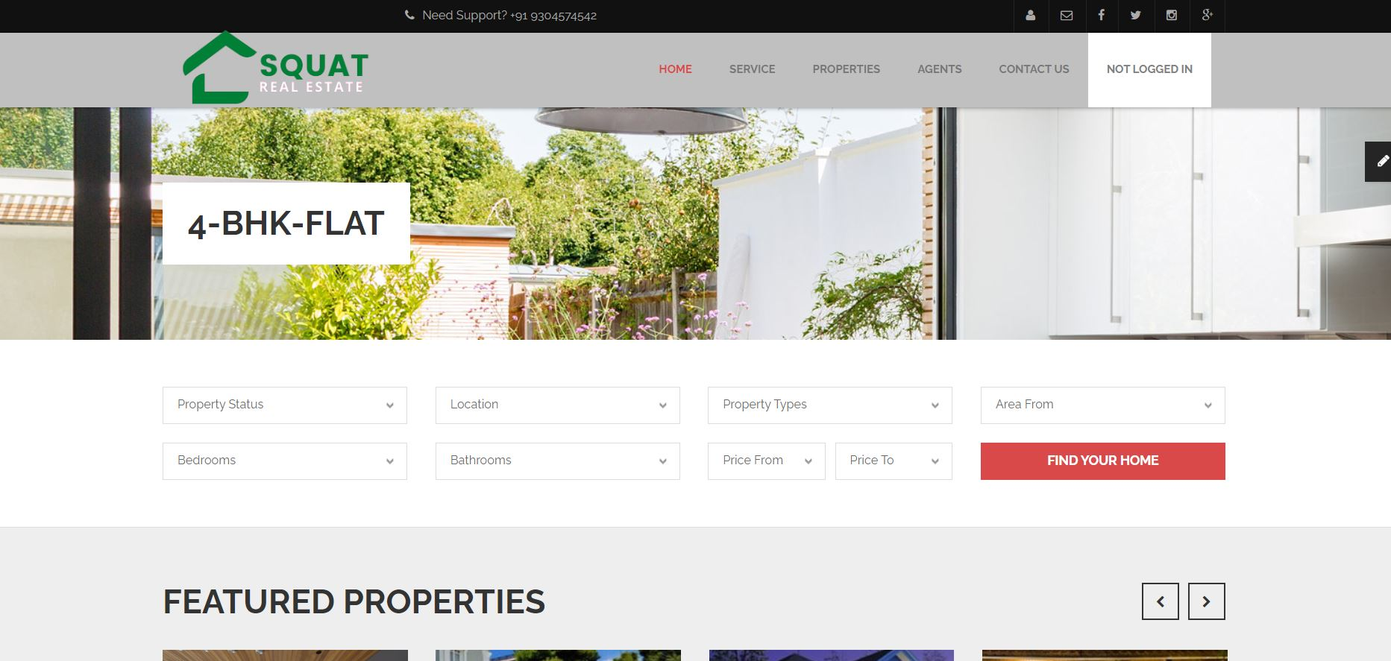4-bhk-flat.php

<?php **include**('includes/header.php') ?>

<!-- Begin Main -->

<div role="main" class="main pgl-bg-grey">

<!-- Begin page top -->

<section class="page-top">

<div class="container">

<div class="page-top-in">

<h2><span>4-BHK-Flat</span></h2>

</div>

</div>

</section>

<!-- End page top -->

<!-- Begin Advanced Search -->

<section class="pgl-advanced-search pgl-bg-light">

<div class="container">

<form name="advancedsearch">

<div class="row">

<div class="col-xs-6 col-sm-3">

<div class="form-group">

<label class="sr-only" for="property-status">Property Status</label>

<select id="property-status" name="property-status" data-placeholder="Property Status" class="chosen-select">

<option selected="selected" value="Property Status">Property Status</option>

<option value="sale">For Sale</option>

<option value="rent">For Rent</option>

</select>

</div>

</div>

<div class="col-xs-6 col-sm-3">

<div class="form-group">

<label class="sr-only" for="location">Location</label>

<select id="location" name="location" data-placeholder="Location" class="chosen-select">

<option selected="selected" value="Location">Location</option>

<option value="Bihar">Bihar</option>

<option value="Uttar Pardesh">Uttar Pardesh</option>

<option value="Noida">Noida</option>

<option value="Panjab">Panjab</option>

<option value="Karnataka">Karnataka</option>

<option value="Assam">Assam</option>

<option value="Patna">Patna</option>

<option value="Tamilnadu">Tamilnadu</option>

<option value="Kolkata">Kolkata</option>

<option value="Goa">Goa</option>

<option value="Maharashtra">Maharashtra</option>

<option value="West Bengal">West Bengal</option>

<option value="Gujarat">Gujarat</option>

<option value="Odisha">Odisha</option>

<option value="Tripura">Tripura</option>

<option value="Kerla">Kerla</option>

<option value="Sikkim">Sikkim</option>

<option value="Jharkhand">Jharkhand</option>

<option value="Nagaland">Nagaland</option>

<option value="Delhi">Delhi</option>

</select>

</div>

</div>

<div class="col-xs-6 col-sm-3">

<div class="form-group">

<label class="sr-only" for="property-types">Property Types</label>

<select id="property-types" name="property-types" data-placeholder="Property Types" class="chosen-select">

<option selected="selected" value="Property Types">Property Types</option>

<option value="residential">Residential</option>

<option value="commercial">Commercial</option>

<option value="land">Land</option>

</select>

</div>

</div>

<div class="col-xs-6 col-sm-3">

<div class="form-group">

<label class="sr-only" for="area-from">Area From</label>

<select id="area-from" name="area-from" data-placeholder="Area From" class="chosen-select">

<option selected="selected" value="Area From">Area From</option>

<option value="450">450</option>

<option value="350">350</option>

<option value="250">250</option>

<option value="150">150</option>

<option value="100">100</option>

<option value="50">50</option>

</select>

</div>

</div>

</div>

<div class="row">

<div class="col-xs-6 col-sm-3">

<div class="form-group">

<label class="sr-only" for="search-bedrooms">Bedrooms</label>

<select id="search-bedrooms" name="search-bedrooms" data-placeholder="Bedrooms" class="chosen-select">

<option selected="selected" value="Bedrooms">Bedrooms</option>

<option value="0">0</option>

<option value="1">1</option>

<option value="2">2</option>

<option value="3">3</option>

<option value="4">4</option>

<option value="5">5</option>

<option value="5plus">5+</option>

</select>

</div>

</div>

<div class="col-xs-6 col-sm-3">

<div class="form-group">

<label class="sr-only" for="search-bathrooms">Bathrooms</label>

<select id="search-bathrooms" name="search-bathrooms" data-placeholder="Bathrooms" class="chosen-select">

<option selected="selected" value="Bathrooms">Bathrooms</option>

<option value="0">0</option>

<option value="1">1</option>

<option value="2">2</option>

<option value="3">3</option>

<option value="4">4</option>

<option value="4plus">4+</option>

</select>

</div>

</div>

<div class="col-xs-6 col-sm-3">

<div class="form-group">

<div class="row pgl-narrow-row">

<div class="col-xs-6">

<label class="sr-only" for="search-minprice">Price From</label>

<select id="search-minprice" name="search-minprice" data-placeholder="Price From" class="chosen-select">

<option selected="selected" value="Price From">Price From</option>

<option value="0">0</option>

<option value="25000">25000</option>

<option value="50000">50000</option>

<option value="75000">75000</option>

<option value="100000">100000</option>

<option value="150000">150000</option>

<option value="200000">200000</option>

<option value="300000">300000</option>

<option value="500000">500000</option>

<option value="750000">750000</option>

<option value="1000000">1000000</option>

</select>

</div>

<div class="col-xs-6">

<label class="sr-only" for="search-maxprice">Price To</label>

<select id="search-maxprice" name="search-maxprice" data-placeholder="Price To" class="chosen-select">

<option selected="selected" value="Price To">Price To</option>

<option value="25000">25000</option>

<option value="50000">50000</option>

<option value="75000">75000</option>

<option value="100000">100000</option>

<option value="150000">150000</option>

<option value="200000">200000</option>

<option value="300000">300000</option>

<option value="500000">500000</option>

<option value="750000">750000</option>

<option value="1000000">1000000</option>

<option value="1000000plus">>1000000</option>

</select>

</div>

</div>

</div>

</div>

<div class="col-xs-6 col-sm-3">

<div class="form-group">

<button type="submit" class="btn btn-block btn-primary">Find your home</button>

</div>

</div>

</div>

</form>

</div>

</section>

<!-- End Advanced Search -->

<!-- Begin Featured -->

<section class="pgl-featured">

<div class="container">

<h2>Featured Properties</h2>

<div class="row">

<div class="owl-carousel pgl-pro-slide" data-plugin-options='{"items": 4, "singleItem": false, "autoPlay": false, "pagination": false}'>

<div class="col-sm-12 animation">

<div class="pgl-property featured-item">

<div class="property-thumb-info">

<div class="property-thumb-info-image">

<img alt="" class="img-responsive" src="images/properties/property-featured-2.jpg">

</div>

<div class="property-thumb-info-content">

<h3><a href="property-detail.html">J St, Modesto, CA 95351</a></h3>

<p>Amet luctus nisl tempus.</p>

</div>

</div>

</div>

</div>

<div class="col-sm-12 animation">

<div class="pgl-property featured-item">

<div class="property-thumb-info">

<div class="property-thumb-info-image">

<img alt="" class="img-responsive" src="images/properties/property-featured-3.jpg">

</div>

<div class="property-thumb-info-content">

<h3><a href="property-detail.html">Spring Gate DrUNIT 4106</a></h3>

<p>Amet luctus nisl tempus.</p>

</div>

</div>

</div>

</div>

<div class="col-sm-12 animation">

<div class="pgl-property featured-item">

<div class="property-thumb-info">

<div class="property-thumb-info-image">

<img alt="" class="img-responsive" src="images/properties/property-featured-4.jpg">

</div>

<div class="property-thumb-info-content">

<h3><a href="property-detail.html">Chatham St NW, Roanoke</a></h3>

<p>Amet luctus nisl tempus.</p>

</div>

</div>

</div>

</div>

<div class="col-sm-12 animation">

<div class="pgl-property featured-item">

<div class="property-thumb-info">

<div class="property-thumb-info-image">

<img alt="" class="img-responsive" src="images/properties/property-featured-5.jpg">

</div>

<div class="property-thumb-info-content">

<h3><a href="property-detail.html">Stockton, CA 95215</a></h3>

<p>Amet luctus nisl tempus.</p>

</div>

</div>

</div>

</div>

<div class="col-sm-12 animation">

<div class="pgl-property featured-item">

<div class="property-thumb-info">

<div class="property-thumb-info-image">

<img alt="" class="img-responsive" src="images/properties/property-featured-3.jpg">

</div>

<div class="property-thumb-info-content">

<h3><a href="property-detail.html">Spring Gate DrUNIT 4106</a></h3>

<p>Amet luctus nisl tempus.</p>

</div>

</div>

</div>

</div>

<div class="col-sm-12 animation">

<div class="pgl-property featured-item">

<div class="property-thumb-info">

<div class="property-thumb-info-image">

<img alt="" class="img-responsive" src="images/properties/property-featured-4.jpg">

</div>

<div class="property-thumb-info-content">

<h3><a href="property-detail.html">Chatham St NW, Roanoke</a></h3>

<p>Amet luctus nisl tempus.</p>

</div>

</div>

</div>

</div>

</div>

</div>

<hr class="top-tall">

</div>

</section>

<!-- End Featured -->

<!-- Begin Properties -->

<section class="pgl-properties pgl-bg-grey">

<div class="container">

<h2>Offfice house</h2>

<div class="properties-full">

<div class="listing-header clearfix">

<ul class="list-inline list-icons pull-left">

<li class="active"><a href="grid-fullwidth-4-column.html"><i class="fa fa-th"></i></a></li>

<li><a href="list-fullwidth.html"><i class="fa fa-th-list"></i></a></li>

<li><a href="list-map.html"><i class="fa fa-map-marker"></i></a></li>

</ul>

<ul class="list-inline list-sort pull-right">

<li><label for="order-status">Order</label></li>

<li>

<select id="order-status" name="order-status" data-placeholder="Order" class="chosen-select">

<option value="Descending">Descending</option>

<option value="Ascending">Ascending</option>

</select>

</li>

<li><label for="sortby-status">Sort by</label></li>

<li>

<select id="sortby-status" name="sortby-status" data-placeholder="Sort by" class="chosen-select">

<option value="Name">Name</option>

<option value="Area">Area</option>

<option value="Date">Date</option>

</select>

</li>

</ul>

</div>

<div class="row">

<div class="col-xs-6 col-md-3 animation">

<div class="pgl-property">

<div class="property-thumb-info">

<div class="property-thumb-info-image">

<img alt="" class="img-responsive" src="images/properties/property-1.jpg">

<span class="property-thumb-info-label">

<span class="label price">358,000</span>

<span class="label forrent">Rent</span>

</span>

</div>

<div class="property-thumb-info-content">

<h3><a href="property-detail.html">Poolside character home on a wide 422sqm</a></h3>

<address>Ferris Park, Jersey City Land in Sales</address>

</div>

<div class="amenities clearfix">

<ul class="pull-left">

<li><strong>Area:</strong> 450<sup>m2</sup></li>

</ul>

<ul class="pull-right">

<li><i class="icons icon-bedroom"></i> 3</li>

<li><i class="icons icon-bathroom"></i> 2</li>

</ul>

</div>

</div>

</div>

</div>

<div class="col-xs-6 col-md-3 animation">

<div class="pgl-property">

<div class="property-thumb-info">

<div class="property-thumb-info-image">

<img alt="" class="img-responsive" src="images/properties/property-2.jpg">

<span class="property-thumb-info-label">

<span class="label price">358,000</span>

</span>

</div>

<div class="property-thumb-info-content">

<h3><a href="property-detail.html">Presidential Parcel Frames Command Views</a></h3>

<address>Ferris Park, Jersey City Land in Sales</address>

</div>

<div class="amenities clearfix">

<ul class="pull-left">

<li><strong>Area:</strong> 450<sup>m2</sup></li>

</ul>

<ul class="pull-right">

<li><i class="icons icon-bedroom"></i> 3</li>

<li><i class="icons icon-bathroom"></i> 2</li>

</ul>

</div>

</div>

</div>

</div>

<div class="col-xs-6 col-md-3 animation">

<div class="pgl-property">

<div class="property-thumb-info">

<div class="property-thumb-info-image">

<img alt="" class="img-responsive" src="images/properties/property-3.jpg">

<span class="property-thumb-info-label">

<span class="label price">358,000</span>

<span class="label forsold">Sold</span>

</span>

</div>

<div class="property-thumb-info-content">

<h3><a href="property-detail.html">Californian Class, Grand Family Proportions</a></h3>

<address>Ferris Park, Jersey City Land in Sales</address>

</div>

<div class="amenities clearfix">

<ul class="pull-left">

<li><strong>Area:</strong> 450<sup>m2</sup></li>

</ul>

<ul class="pull-right">

<li><i class="icons icon-bedroom"></i> 3</li>

<li><i class="icons icon-bathroom"></i> 2</li>

</ul>

</div>

</div>

</div>

</div>

<div class="col-xs-6 col-md-3 animation">

<div class="pgl-property">

<div class="property-thumb-info">

<div class="property-thumb-info-image">

<img alt="" class="img-responsive" src="images/properties/property-3.jpg">

<span class="property-thumb-info-label">

<span class="label price">358,000</span>

<span class="label forsold">Sold</span>

</span>

</div>

<div class="property-thumb-info-content">

<h3><a href="property-detail.html">Californian Class, Grand Family Proportions</a></h3>

<address>Ferris Park, Jersey City Land in Sales</address>

</div>

<div class="amenities clearfix">

<ul class="pull-left">

<li><strong>Area:</strong> 450<sup>m2</sup></li>

</ul>

<ul class="pull-right">

<li><i class="icons icon-bedroom"></i> 3</li>

<li><i class="icons icon-bathroom"></i> 2</li>

</ul>

</div>

</div>

</div>

</div>

</div>

<div class="row">

<div class="col-xs-6 col-md-3 animation">

<div class="pgl-property">

<div class="property-thumb-info">

<div class="property-thumb-info-image">

<img alt="" class="img-responsive" src="images/properties/property-4.jpg">

<span class="property-thumb-info-label">

<span class="label price">358,000</span>

<span class="label forrent">Rent</span>

</span>

</div>

<div class="property-thumb-info-content">

<h3><a href="property-detail.html">Chatham St NW, Roanoke, VA 24012</a></h3>

<address>Ferris Park, Jersey City Land in Sales</address>

</div>

<div class="amenities clearfix">

<ul class="pull-left">

<li><strong>Area:</strong> 450<sup>m2</sup></li>

</ul>

<ul class="pull-right">

<li><i class="icons icon-bedroom"></i> 3</li>

<li><i class="icons icon-bathroom"></i> 2</li>

</ul>

</div>

</div>

</div>

</div>

<div class="col-xs-6 col-md-3 animation">

<div class="pgl-property">

<div class="property-thumb-info">

<div class="property-thumb-info-image">

<img alt="" class="img-responsive" src="images/properties/property-5.jpg">

<span class="property-thumb-info-label">

<span class="label price">358,000</span>

</span>

</div>

<div class="property-thumb-info-content">

<h3><a href="property-detail.html">Chatham St NW, Roanoke, VA 24012</a></h3>

<address>Ferris Park, Jersey City Land in Sales</address>

</div>

<div class="amenities clearfix">

<ul class="pull-left">

<li><strong>Area:</strong> 450<sup>m2</sup></li>

</ul>

<ul class="pull-right">

<li><i class="icons icon-bedroom"></i> 3</li>

<li><i class="icons icon-bathroom"></i> 2</li>

</ul>

</div>

</div>

</div>

</div>

<div class="col-xs-6 col-md-3 animation">

<div class="pgl-property">

<div class="property-thumb-info">

<div class="property-thumb-info-image">

<img alt="" class="img-responsive" src="images/properties/property-6.jpg">

<span class="property-thumb-info-label">

<span class="label price">358,000</span>

</span>

</div>

<div class="property-thumb-info-content">

<h3><a href="property-detail.html">Chatham St NW, Roanoke, VA 24012</a></h3>

<address>Ferris Park, Jersey City Land in Sales</address>

</div>

<div class="amenities clearfix">

<ul class="pull-left">

<li><strong>Area:</strong> 450<sup>m2</sup></li>

</ul>

<ul class="pull-right">

<li><i class="icons icon-bedroom"></i> 3</li>

<li><i class="icons icon-bathroom"></i> 2</li>

</ul>

</div>

</div>

</div>

</div>

<div class="col-xs-6 col-md-3 animation">

<div class="pgl-property">

<div class="property-thumb-info">

<div class="property-thumb-info-image">

<img alt="" class="img-responsive" src="images/properties/property-4.jpg">

<span class="property-thumb-info-label">

<span class="label price">358,000</span>

<span class="label forrent">Rent</span>

</span>

</div>

<div class="property-thumb-info-content">

<h3><a href="property-detail.html">Chatham St NW, Roanoke, VA 24012</a></h3>

<address>Ferris Park, Jersey City Land in Sales</address>

</div>

<div class="amenities clearfix">

<ul class="pull-left">

<li><strong>Area:</strong> 450<sup>m2</sup></li>

</ul>

<ul class="pull-right">

<li><i class="icons icon-bedroom"></i> 3</li>

<li><i class="icons icon-bathroom"></i> 2</li>

</ul>

</div>

</div>

</div>

</div>

</div>

<ul class="pagination">

<li class="active"><a href="#">1 <span class="sr-only">(current)</span></a></li>

<li><a href="#">2</a></li>

<li><a href="#">3</a></li>

<li><a href="#">Next</a></li>

</ul>

</div>

</div>

</section>

<!-- End Properties -->

</div>

<!-- End Main -->

<?php **include**('includes/footer.php') ?>

**Property-details.php**

<?php **include**('authentication.php'); ?>

<?php **include**('includes/header.php') ?>

<!-- Begin Main -->

<div role="main" class="main pgl-bg-grey">

<!-- Begin page top -->

<section class="page-top">

<div class="container">

<div class="page-top-in">

<h2><span>Property Detail</span></h2>

</div>

</div>

</section>

<!-- End page top -->

<!-- Begin content with sidebar -->

<div class="container">

<div class="row">

<div class="col-md-9 content">

<section class="pgl-pro-detail pgl-bg-light">

<div id="slider" class="flexslider">

<ul class="slides">

<li>

<img src="images/properties/property-detail-1.jpg" alt="">

<span class="property-thumb-info-label">

<span class="label price">358,000</span>

<span class="label forrent">Rent</span>

</span>

</li>

<li>

<img src="images/properties/property-detail-2.jpg" alt="">

<span class="property-thumb-info-label">

<span class="label price">358,000</span>

</span>

</li>

<li>

<img src="images/properties/property-detail-3.jpg" alt="">

<span class="property-thumb-info-label">

<span class="label price">358,000</span>

<span class="label forrent">Rent</span>

</span>

</li>

<li>

<img src="images/properties/property-detail-4.jpg" alt="">

<span class="property-thumb-info-label">

<span class="label price">358,000</span>

</span>

</li>

<li>

<img src="images/properties/property-detail-5.jpg" alt="">

<span class="property-thumb-info-label">

<span class="label price">358,000</span>

</span>

</li>

<li>

<img src="images/properties/property-detail-1.jpg" alt="">

<span class="property-thumb-info-label">

<span class="label price">358,000</span>

<span class="label forrent">Rent</span>

</span>

</li>

<li>

<img src="images/properties/property-detail-2.jpg" alt="">

<span class="property-thumb-info-label">

<span class="label price">358,000</span>

</span>

</li>

<li>

<img src="images/properties/property-detail-3.jpg" alt="">

<span class="property-thumb-info-label">

<span class="label price">358,000</span>

<span class="label forrent">Rent</span>

</span>

</li>

</ul>

</div>

<div id="carousel" class="flexslider">

<ul class="slides">

<li> <img src="images/properties/property-detail-s-1.jpg" alt=""></li>

<li> <img src="images/properties/property-detail-s-2.jpg" alt=""></li>

<li> <img src="images/properties/property-detail-s-3.jpg" alt=""></li>

<li> <img src="images/properties/property-detail-s-4.jpg" alt=""></li>

<li> <img src="images/properties/property-detail-s-5.jpg" alt=""></li>

<li> <img src="images/properties/property-detail-s-1.jpg" alt=""></li>

<li> <img src="images/properties/property-detail-s-2.jpg" alt=""></li>

<li> <img src="images/properties/property-detail-s-3.jpg" alt=""></li>

</ul>

</div>

<div class="pgl-detail">

<div class="row">

<div class="col-sm-4">

<ul class="list-unstyled amenities amenities-detail">

<li><strong>Type:</strong> Apartment</li>

<li><strong>Area:</strong> 450<sup>m2</sup></li>

<li><address><i class="icons icon-location"></i> Palo Alto, SA</address></li>

<li><i class="icons icon-bedroom"></i> 3 Bedrooms</li>

<li><i class="icons icon-bathroom"></i> 2 Bathrooms</li>

</ul>

</div>

<div class="col-sm-8">

<h2>Building: 123 for family 844504</h2>

<p><strong>Welcome home to this adorable totally renovated move-in ready home. The large front porch is great for morning coffee and would be perfect for a porch swing. Once in side, you will find tasteful updates through out this stunning home. The first floor features a living room that opens into the dining room with classic French doors and the open totally new kitchen with brand new appliances. The second floor features 3 bedrooms, all with ceiling fans, a totally new bath and more. NEW NEW NEW!!! Recent Renovations include: NEW Roof, all NEW WINDOWS, NEW 2-zone HVAC, NEW plumbing, NEW insulation in crawl space and attic, NEW main Bath, NEW half Bath, NEW light fixtures, NEW Kitchen with NEW appliances, and More. This home is better than new and no waiting on builder delays!! Note the garage conveys as is</strong></p>

<p></p>

<p> </p>

</div>

</div>

<div class="tab-detail">

<h3>More Infomation</h3>

<div class="panel-group" id="accordion">

<div class="panel panel-default pgl-panel">

<div class="panel-heading">

<h4 class="panel-title"> <a data-toggle="collapse" data-parent="#accordion" href="#collapseOne">Additional Details</a> </h4>

</div>

<div id="collapseOne" class="panel-collapse collapse in">

<div class="panel-body">

<ul>

<li><strong>AC:</strong> Ceiling Fan(s), Central</li>

<li><strong>Acres Source:</strong> Assessor</li>

<li><strong>Bathrooms Description:</strong> Stall Shower</li>

<li><strong>Bathrooms Features:</strong> Main Floor Master Bedroom</li>

<li><strong>Dining Area:</strong> Family Kitchen</li>

<li><strong>Lot Description:</strong> Curbs-Walks</li>

<li><strong>Mot Dimensions:</strong> 70x100</li>

<li><strong>Lot Size Source:</strong> Assessor</li>

<li><strong>Parking Type:</strong> Direct Garage Access, Driveway, Garage Door Opener</li>

</ul>

</div>

</div>

</div>

<div class="panel panel-default pgl-panel">

<div class="panel-heading">

<h4 class="panel-title"> <a data-toggle="collapse" data-parent="#accordion" href="#collapseTwo" class="collapsed">Video</a> </h4>

</div>

<div id="collapseTwo" class="panel-collapse collapse">

<div class="panel-body"> <p><a href="https://www.youtube.com/watch?v=DFHWmUPz8Ds">Play Now----1</a></p>

<p><a href="https://www.youtube.com/watch?v=bpPHvqkluiU">Play Now----2</a></p> </div>

</div>

</div>

<div class="panel panel-default pgl-panel">

<div class="panel-heading">

<h4 class="panel-title"> <a data-toggle="collapse" data-parent="#accordion" href="#collapseThree" class="collapsed">Map</a> </h4>

</div>

<div id="collapseThree" class="panel-collapse collapse">

<div class="panel-body">

<p><iframe src="https://www.google.com/maps/embed?pb=!1m18!1m12!1m3!1d115133.01016839834!2d85.0730025887359!3d25.608020764550556!2m3!1f0!2f0!3f0!3m2!1i1024!2i768!4f13.1!3m3!1m2!1s0x39f29937c52d4f05%3A0x831a0e05f607b270!2sPatna%2C%20Bihar!5e0!3m2!1sen!2sin!4v1657878139127!5m2!1sen!2sin" width="600" height="450" style="border:0;" allowfullscreen="" loading="lazy" referrerpolicy="no-referrer-when-downgrade"></iframe></p>

<div id="contact-map" class="pgl-bg-light"></div>

</div>

</div>

</div>

<div class="panel panel-default pgl-panel">

<div class="panel-heading">

<h4 class="panel-title"> <a data-toggle="collapse" data-parent="#accordion" href="#collapseFouth" class="collapsed">Agent</a> </h4>

</div>

<div id="collapseFouth" class="panel-collapse collapse">

<div class="panel-body">

<div class="pgl-agent-item pgl-bg-light">

<div class="row pgl-midnarrow-row">

<div class="col-xs-4">

<div class="img-thumbnail-medium">

<a href="agentprofile.html"><img alt="" class="img-responsive" src="images/agents/temp-agent1.jpg"></a>

</div>

</div>

<div class="col-xs-8">

<div class="pgl-agent-info">

<small>NO.1</small>

<h4><a href="agentprofile.html">Surya Nestbuild Ltd.</a></h4>

<address>

<i class="fa fa-map-marker"></i> Office : 91 9304574542<br>

<i class="fa fa-phone"></i> Mobile : 9304574542<br>

<i class="fa fa-fax"></i> Fax : 1-800-666-8888<br>

<i class="fa fa-envelope-o"></i> Mail: <a href="mailto:squat931@gmail.com">squat931@gmail.com</a>

</address>

</div>

</div>

</div>

</div>

</div>

</div>

</div>

<div class="panel panel-default pgl-panel">

<div class="panel-heading">

<h4 class="panel-title"> <a data-toggle="collapse" data-parent="#accordion" href="#collapseFive" class="collapsed">Contact us</a> </h4>

</div>

<div id="collapseFive" class="panel-collapse collapse">

<div class="panel-body">

<p><a href="contact.php">Click for connect with us</a></p>

</div>

</div>

</div>

</div>

</div>

</div>

</section>

<!-- Begin Related properties -->

<section class="pgl-properties">

<h2>Related Properties</h2>

<div class="row">

<div class="owl-carousel pgl-pro-slide" data-plugin-options='{"items": 3, "itemsDesktop": 3, "singleItem": false, "autoPlay": false, "pagination": false}'>

<div class="col-md-12 animation">

<div class="pgl-property">

<div class="property-thumb-info">

<div class="property-thumb-info-image">

<img alt="" class="img-responsive" src="images/properties/property-1.jpg">

<span class="property-thumb-info-label">

<span class="label price">358,000</span>

<span class="label forrent">Rent</span>

</span>

</div>

<div class="property-thumb-info-content">

<h3><a href="property-detail.html">Poolside character home on a wide 422sqm</a></h3>

<address>Ferris Park, Jersey City Land in Sales</address>

</div>

<div class="amenities clearfix">

<ul class="pull-left">

<li><strong>Area:</strong> 450<sup>m2</sup></li>

</ul>

<ul class="pull-right">

<li><i class="icons icon-bedroom"></i> 3</li>

<li><i class="icons icon-bathroom"></i> 2</li>

</ul>

</div>

</div>

</div>

</div>

<div class="col-md-12 animation">

<div class="pgl-property">

<div class="property-thumb-info">

<div class="property-thumb-info-image">

<img alt="" class="img-responsive" src="images/properties/property-2.jpg">

<span class="property-thumb-info-label">

<span class="label price">358,000</span>

<span class="label forrent">Rent</span>

</span>

</div>

<div class="property-thumb-info-content">

<h3><a href="property-detail.html">Poolside character home on a wide 422sqm</a></h3>

<address>Ferris Park, Jersey City Land in Sales</address>

</div>

<div class="amenities clearfix">

<ul class="pull-left">

<li><strong>Area:</strong> 450<sup>m2</sup></li>

</ul>

<ul class="pull-right">

<li><i class="icons icon-bedroom"></i> 3</li>

<li><i class="icons icon-bathroom"></i> 2</li>

</ul>

</div>

</div>

</div>

</div>

<div class="col-md-12 animation">

<div class="pgl-property">

<div class="property-thumb-info">

<div class="property-thumb-info-image">

<img alt="" class="img-responsive" src="images/properties/property-3.jpg">

<span class="property-thumb-info-label">

<span class="label price">358,000</span>

<span class="label forrent">Rent</span>

</span>

</div>

<div class="property-thumb-info-content">

<h3><a href="property-detail.html">Poolside character home on a wide 422sqm</a></h3>

<address>Ferris Park, Jersey City Land in Sales</address>

</div>

<div class="amenities clearfix">

<ul class="pull-left">

<li><strong>Area:</strong> 450<sup>m2</sup></li>

</ul>

<ul class="pull-right">

<li><i class="icons icon-bedroom"></i> 3</li>

<li><i class="icons icon-bathroom"></i> 2</li>

</ul>

</div>

</div>

</div>

</div>

<div class="col-md-12 animation">

<div class="pgl-property">

<div class="property-thumb-info">

<div class="property-thumb-info-image">

<img alt="" class="img-responsive" src="images/properties/property-4.jpg">

<span class="property-thumb-info-label">

<span class="label price">358,000</span>

<span class="label forrent">Rent</span>

</span>

</div>

<div class="property-thumb-info-content">

<h3><a href="property-detail.html">Poolside character home on a wide 422sqm</a></h3>

<address>Ferris Park, Jersey City Land in Sales</address>

</div>

<div class="amenities clearfix">

<ul class="pull-left">

<li><strong>Area:</strong> 450<sup>m2</sup></li>

</ul>

<ul class="pull-right">

<li><i class="icons icon-bedroom"></i> 3</li>

<li><i class="icons icon-bathroom"></i> 2</li>

</ul>

</div>

</div>

</div>

</div>

</div>

</div>

</section>

<!-- End Related properties -->

</div>

<div class="col-md-3 sidebar">

<!-- Begin Inquery Search -->

<aside class="block pgl-advanced-search pgl-bg-light">

<h3>Inquery Proerty</h3>

<form name="advancedsearch" action="code.php" method="POST">

<div class="form-group">

<input type="text" class="form-control" name="name" placeholder="Your Name..."/>

</div>

<div class="form-group">

<input type="email" class="form-control" name="email" placeholder="Your Email..."/>

</div>

<div class="form-group">

<label class="sr-only" for="property-types">Property Types</label>

<select id="property-types" name="property_types" data-placeholder="Property Types" class="chosen-select">

<option selected="selected" value="Property Types">Property Types</option>

<option value="residential">Residential</option>

<option value="commercial">Commercial</option>

<option value="land">Land</option>

</select>

</div>

<div class="form-group">

<label class="sr-only" for="search-bedrooms">Bedrooms</label>

<select id="search-bedrooms" name="bedrooms" data-placeholder="Bedrooms" class="chosen-select">

<option selected="selected" value="Bedrooms">Bedrooms</option>

<option value="0">0</option>

<option value="1">1</option>

<option value="2">2</option>

<option value="3">3</option>

<option value="4">4</option>

<option value="5">5</option>

<option value="5plus">5+</option>

</select>

</div>

<div class="form-group">

<label class="sr-only" for="search-bathrooms">Bathrooms</label>

<select id="search-bathrooms" name="bathrooms" data-placeholder="Bathrooms" class="chosen-select">

<option selected="selected" value="Bathrooms">Bathrooms</option>

<option value="0">0</option>

<option value="1">1</option>

<option value="2">2</option>

<option value="3">3</option>

<option value="4">4</option>

<option value="4plus">4+</option>

</select>

</div>

<div class="form-group">

<div class="row pgl-narrow-row">

<div class="col-xs-6">

<label class="sr-only" for="search-minprice">Price From</label>

<select id="search-minprice" name="minprice" data-placeholder="Price From" class="chosen-select">

<option selected="selected" value="Price From">Price From</option>

<option value="0">0</option>

<option value="25000">25000</option>

<option value="50000">50000</option>

<option value="75000">75000</option>

<option value="100000">100000</option>

<option value="150000">150000</option>

<option value="200000">200000</option>

<option value="300000">300000</option>

<option value="500000">500000</option>

<option value="750000">750000</option>

<option value="1000000">1000000</option>

</select>

</div>

<div class="col-xs-6">

<label class="sr-only" for="search-maxprice">Price To</label>

<select id="search-maxprice" name="maxprice" data-placeholder="Price To" class="chosen-select">

<option selected="selected" value="Price To">Price To</option>

<option value="25000">25000</option>

<option value="50000">50000</option>

<option value="75000">75000</option>

<option value="100000">100000</option>

<option value="150000">150000</option>

<option value="200000">200000</option>

<option value="300000">300000</option>

<option value="500000">500000</option>

<option value="750000">750000</option>

<option value="1000000">1000000</option>

<option value="1000000plus">>1000000</option>

</select>

</div>

</div>

</div>

<div class="form-group">

<input type="text" class="form-control" name="message" placeholder="Your Message..."/>

</div>

<div class="form-group">

<button type="submit" class="btn btn-block btn-primary" name="btn_inquery">Send</button>

</div>

</form>

</aside>

<!-- End Inquery Search -->

<!-- Begin Our Agents -->

<aside class="block pgl-agents pgl-bg-light">

<h3>Our Agents</h3>

<div class="owl-carousel pgl-pro-slide pgl-agent-item" data-plugin-options='{"items": 1, "pagination": false, "autoHeight": true}'>

<div class="pgl-agent-item">

<div class="img-thumbnail-medium">

<a href="agentprofile.html"><img src="images/agents/temp-agent1.jpg" class="img-responsive" alt=""></a>

</div>

<div class="pgl-agent-info">

<small>NO.1</small>

<h4><a href="agentprofile.html">Surya Nestbuild Ltd.</a></h4>

<address>

<i class="fa fa-map-marker"></i> Office : 91 9304574542<br>

<i class="fa fa-phone"></i> Mobile : 9304574542<br>

<i class="fa fa-fax"></i> Fax : 1-800-666-8888<br>

<i class="fa fa-envelope-o"></i> Mail: <a href="mailto:squat931@gmail.com">squat931@gmail.com</a>

</address>

</div>

</div>

<div class="pgl-agent-item">

<div class="img-thumbnail-medium">

<a href="agentprofile.html"><img src="images/agents/temp-agent2.jpg" class="img-responsive" alt=""></a>

</div>

<div class="pgl-agent-info">

<small>NO.2.1</small>

<h4><a href="agentprofile.html">Rahul Builder</a></h4>

<address>

<i class="fa fa-map-marker"></i> Office : 91 9973007530<br>

<i class="fa fa-phone"></i> Mobile : 91 8712369878<br>

<i class="fa fa-fax"></i> Fax : 1-800-666-8888<br>

<i class="fa fa-envelope-o"></i> Mail: <a href="mailto:squat931@gmail.com">squat931@gmail.com</a>

</address>

</div>

</div>

</div>

</aside>

<!-- End Our Agents -->

<!-- Begin agent agent -->

<aside class="block pgl-bg-dark pgl-testimonials">

<div class="owl-carousel pgl-testimonial" data-plugin-options='{"items": 1, "pagination": false, "autoHeight": true}'>

<div class="col-md-12">

<div class="testimonial-author">

<div class="img-thumbnail-small img-circle">

<img src="images/agents/agent1.jpg" height="100px" class="img-circle" alt="Andrew MCCarthy">

</div>

<h4>Rohan verma</h4>

<p><strong>Selller</strong></p>

</div>

<div class="divider-quote-sign"><span>“</span></div>

<blockquote class="testimonial">

<p>I posses one of my father's properties and wanted to get it revamped by a builder. I contacted this builder around five months back. The builder is extremely reliable and suggests the best plans. Thanks!</p>

</blockquote>

</div>

<div class="col-md-12">

<div class="testimonial-author">

<div class="img-thumbnail-small img-circle">

<img src="images/agents/agent-1.jpg" class="img-circle" alt="John Smith">

</div>

<h4>Saloni raghav</h4>

<p><strong>Selller</strong></p>

</div>

<div class="divider-quote-sign"><span>“</span></div>

<blockquote class="testimonial">

<p>This builder has helped me in getting my building constructed within the promised time frame and as per the modern trends. This builder was very supportive and always provided appropriate suggestion to me considering my requirements.</p>

</blockquote>

</div>

</div>

</aside>

<!-- End Advanced Search -->

</div>

</div>

</div>

<!-- End content with sidebar -->

</div>

<!-- End Main -->

</div>

<?php **include**('includes/footer.php') ?>

Agents

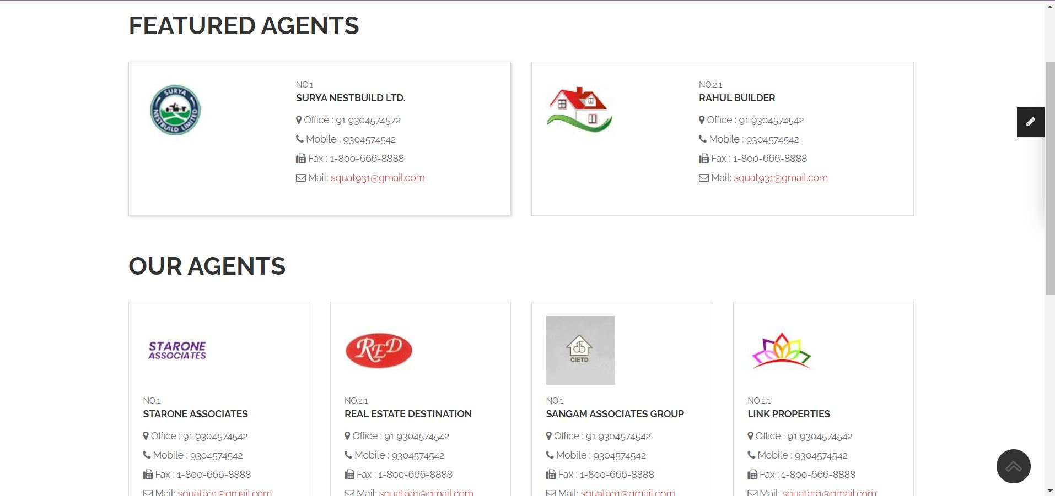

**Agentprofile1.php**

<?php **include**('includes/header.php') ?>

<!-- Begin Main -->

<div role="main" class="main pgl-bg-grey">

<!-- Begin page top -->

<section class="page-top">

<div class="container">

<div class="page-top-in">

<h2><span>Agent Profile</span></h2>

</div>

</div>

</section>

<!-- End page top -->

<!-- Begin Featured Agents -->

<section class="pgl-agents">

<div class="container">

<h2>Agent Profile</h2>

<div class="agent-profile">

<div class="row">

<div class="col-md-12">

<div class="pgl-agent-item pgl-bg-light">

<div class="row pgl-midnarrow-row">

<div class="col-xs-3">

<div class="img-thumbnail-medium">

<a href="agentprofile1.php"><img src="images/agents/temp-agent1.jpg" class="img-responsive" alt=""></a>

</div>

</div>

<div class="col-xs-9">

<div class="pgl-agent-info">

<small>NO.1</small>

<h4><a href="agentprofile1.php">Surya Nestbuild Ltd.</a></h4>

<address>

<i class="fa fa-map-marker"></i> Office : 91 9304574542<br>

<i class="fa fa-phone"></i> Mobile : 9304574542<br>

<i class="fa fa-fax"></i> Fax : 1-800-666-8888<br>

<i class="fa fa-envelope-o"></i> Mail: <a href="mailto:squat931@gmail.com">squat931@gmail.com</a>

</address>

<p>We are Dealing in all kinds of Properties. Flats/Apartments,Builders, Real Estate Agents</p>

</div>

</div>

</div>

</div>

</div>

</div>

</div>

<!-- End Featured Agents -->

<!-- Begin Our Agents -->

<section class="pgl-properties">

<h2>Agent's Properties</h2>

<div class="properties-full">

<div class="row">

<div class="col-xs-6 col-md-3 animation">

<div class="pgl-property">

<div class="property-thumb-info">

<div class="property-thumb-info-image">

<img alt="" class="img-responsive" src="images/properties/property-1.jpg">

<span class="property-thumb-info-label">

<span class="label price">358,000</span>

<span class="label forrent">Rent</span>

</span>

</div>

<div class="property-thumb-info-content">

<h3><a href="property-detail.html">3 BHK Flats for Sale</a></h3>

<address>Dwarka Sector 23, Delhi Land in Sales</address>

</div>

<div class="amenities clearfix">

<ul class="pull-left">

<li><strong>Area:</strong> 450<sup>m2</sup></li>

</ul>

<ul class="pull-right">

<li><i class="icons icon-bedroom"></i> 3</li>

<li><i class="icons icon-bathroom"></i> 2</li>

</ul>

</div>

</div>

</div>

</div>

<div class="col-xs-6 col-md-3 animation">

<div class="pgl-property">

<div class="property-thumb-info">

<div class="property-thumb-info-image">

<img alt="" class="img-responsive" src="images/properties/property-2.jpg">

<span class="property-thumb-info-label">

<span class="label price">358,000</span>

</span>

</div>

<div class="property-thumb-info-content">

<h3><a href="property-detail.html">3 BHK Flats for Sale</a></h3>

<address>Dwarka Sector 3, Delhi City Land in Sales</address>

</div>

<div class="amenities clearfix">

<ul class="pull-left">

<li><strong>Area:</strong> 450<sup>m2</sup></li>

</ul>

<ul class="pull-right">

<li><i class="icons icon-bedroom"></i> 3</li>

<li><i class="icons icon-bathroom"></i> 2</li>

</ul>

</div>

</div>

</div>

</div>

<div class="col-xs-6 col-md-3 animation">

<div class="pgl-property">

<div class="property-thumb-info">

<div class="property-thumb-info-image">

<img alt="" class="img-responsive" src="images/properties/property-3.jpg">

<span class="property-thumb-info-label">

<span class="label price">358,000</span>

<span class="label forsold">Sold</span>

</span>

</div>

<div class="property-thumb-info-content">

<h3><a href="property-detail.html">Californian Class, Grand Family Proportions</a></h3>

<address>Ferris Park, Jersey City Land in Sales</address>

</div>

<div class="amenities clearfix">

<ul class="pull-left">

<li><strong>Area:</strong> 450<sup>m2</sup></li>

</ul>

<ul class="pull-right">

<li><i class="icons icon-bedroom"></i> 3</li>

<li><i class="icons icon-bathroom"></i> 2</li>

</ul>

</div>

</div>

</div>

</div>

<div class="col-xs-6 col-md-3 animation">

<div class="pgl-property">

<div class="property-thumb-info">

<div class="property-thumb-info-image">

<img alt="" class="img-responsive" src="images/properties/property-3.jpg">

<span class="property-thumb-info-label">

<span class="label price">358,000</span>

<span class="label forsold">Sold</span>

</span>

</div>

<div class="property-thumb-info-content">

<h3><a href="property-detail.html">Californian Class, Grand Family Proportions</a></h3>

<address>Ferris Park, Jersey City Land in Sales</address>

</div>

<div class="amenities clearfix">

<ul class="pull-left">

<li><strong>Area:</strong> 450<sup>m2</sup></li>

</ul>

<ul class="pull-right">

<li><i class="icons icon-bedroom"></i> 3</li>

<li><i class="icons icon-bathroom"></i> 2</li>

</ul>

</div>

</div>

</div>

</div>

</div>

<div class="row">

<div class="col-xs-6 col-md-3 animation">

<div class="pgl-property">

<div class="property-thumb-info">

<div class="property-thumb-info-image">

<img alt="" class="img-responsive" src="images/properties/property-4.jpg">

<span class="property-thumb-info-label">

<span class="label price">358,000</span>

<span class="label forrent">Rent</span>

</span>

</div>

<div class="property-thumb-info-content">

<h3><a href="property-detail.html">Chatham St NW, Roanoke, VA 24012</a></h3>

<address>Ferris Park, Jersey City Land in Sales</address>

</div>

<div class="amenities clearfix">

<ul class="pull-left">

<li><strong>Area:</strong> 450<sup>m2</sup></li>

</ul>

<ul class="pull-right">

<li><i class="icons icon-bedroom"></i> 3</li>

<li><i class="icons icon-bathroom"></i> 2</li>

</ul>

</div>

</div>

</div>

</div>

<div class="col-xs-6 col-md-3 animation">

<div class="pgl-property">

<div class="property-thumb-info">

<div class="property-thumb-info-image">

<img alt="" class="img-responsive" src="images/properties/property-5.jpg">

<span class="property-thumb-info-label">

<span class="label price">358,000</span>

</span>

</div>

<div class="property-thumb-info-content">

<h3><a href="property-detail.html">Chatham St NW, Roanoke, VA 24012</a></h3>

<address>Ferris Park, Jersey City Land in Sales</address>

</div>

<div class="amenities clearfix">

<ul class="pull-left">

<li><strong>Area:</strong> 450<sup>m2</sup></li>

</ul>

<ul class="pull-right">

<li><i class="icons icon-bedroom"></i> 3</li>

<li><i class="icons icon-bathroom"></i> 2</li>

</ul>

</div>

</div>

</div>

</div>

<div class="col-xs-6 col-md-3 animation">

<div class="pgl-property">

<div class="property-thumb-info">

<div class="property-thumb-info-image">

<img alt="" class="img-responsive" src="images/properties/property-6.jpg">

<span class="property-thumb-info-label">

<span class="label price">358,000</span>

</span>

</div>

<div class="property-thumb-info-content">

<h3><a href="property-detail.html">Chatham St NW, Roanoke, VA 24012</a></h3>

<address>Ferris Park, Jersey City Land in Sales</address>

</div>

<div class="amenities clearfix">

<ul class="pull-left">

<li><strong>Area:</strong> 450<sup>m2</sup></li>

</ul>

<ul class="pull-right">

<li><i class="icons icon-bedroom"></i> 3</li>

<li><i class="icons icon-bathroom"></i> 2</li>

</ul>

</div>

</div>

</div>

</div>

<div class="col-xs-6 col-md-3 animation">

<div class="pgl-property">

<div class="property-thumb-info">

<div class="property-thumb-info-image">

<img alt="" class="img-responsive" src="images/properties/property-4.jpg">

<span class="property-thumb-info-label">

<span class="label price">358,000</span>

<span class="label forrent">Rent</span>

</span>

</div>

<div class="property-thumb-info-content">

<h3><a href="property-detail.html">Chatham St NW, Roanoke, VA 24012</a></h3>

<address>Ferris Park, Jersey City Land in Sales</address>

</div>

<div class="amenities clearfix">

<ul class="pull-left">

<li><strong>Area:</strong> 450<sup>m2</sup></li>

</ul>

<ul class="pull-right">

<li><i class="icons icon-bedroom"></i> 3</li>

<li><i class="icons icon-bathroom"></i> 2</li>

</ul>

</div>

</div>

</div>

</div>

</div>

<ul class="pagination">

<li class="active"><a href="#">1 <span class="sr-only">(current)</span></a></li>

<li><a href="#">2</a></li>

<li><a href="#">3</a></li>

<li><a href="#">Next</a></li>

</ul>

</div>

</div>

</div>

</section>

<!-- End Our Agents -->

</div>

<!-- End Main -->

<?php **include**('includes/footer.php') ?><?php **include**('includes/header.php') ?>

<!-- Begin Main -->

<div role="main" class="main pgl-bg-grey">

<!-- Begin page top -->

<section class="page-top">

<div class="container">

<div class="page-top-in">

<h2><span>Agent Profile</span></h2>

</div>

</div>

</section>

<!-- End page top -->

<!-- Begin Featured Agents -->

<section class="pgl-agents">

<div class="container">

<h2>Agent Profile</h2>

<div class="agent-profile">

<div class="row">

<div class="col-md-12">

<div class="pgl-agent-item pgl-bg-light">

<div class="row pgl-midnarrow-row">

<div class="col-xs-3">

<div class="img-thumbnail-medium">

<a href="agentprofile1.php"><img src="images/agents/temp-agent1.jpg" class="img-responsive" alt=""></a>

</div>

</div>

<div class="col-xs-9">

<div class="pgl-agent-info">

<small>NO.1</small>

<h4><a href="agentprofile1.php">Surya Nestbuild Ltd.</a></h4>

<address>

<i class="fa fa-map-marker"></i> Office : 91 9304574542<br>

<i class="fa fa-phone"></i> Mobile : 9304574542<br>

<i class="fa fa-fax"></i> Fax : 1-800-666-8888<br>

<i class="fa fa-envelope-o"></i> Mail: <a href="mailto:squat931@gmail.com">squat931@gmail.com</a>

</address>

<p>We are Dealing in all kinds of Properties. Flats/Apartments,Builders, Real Estate Agents</p>

</div>

</div>

</div>

</div>

</div>

</div>

</div>

<!-- End Featured Agents -->

<!-- Begin Our Agents -->

<section class="pgl-properties">

<h2>Agent's Properties</h2>

<div class="properties-full">

<div class="row">

<div class="col-xs-6 col-md-3 animation">

<div class="pgl-property">

<div class="property-thumb-info">

<div class="property-thumb-info-image">

<img alt="" class="img-responsive" src="images/properties/property-1.jpg">

<span class="property-thumb-info-label">

<span class="label price">358,000</span>

<span class="label forrent">Rent</span>

</span>

</div>

<div class="property-thumb-info-content">

<h3><a href="property-detail.html">3 BHK Flats for Sale</a></h3>

<address>Dwarka Sector 23, Delhi Land in Sales</address>

</div>

<div class="amenities clearfix">

<ul class="pull-left">

<li><strong>Area:</strong> 450<sup>m2</sup></li>

</ul>

<ul class="pull-right">

<li><i class="icons icon-bedroom"></i> 3</li>

<li><i class="icons icon-bathroom"></i> 2</li>

</ul>

</div>

</div>

</div>

</div>

<div class="col-xs-6 col-md-3 animation">

<div class="pgl-property">

<div class="property-thumb-info">

<div class="property-thumb-info-image">

<img alt="" class="img-responsive" src="images/properties/property-2.jpg">

<span class="property-thumb-info-label">

<span class="label price">358,000</span>

</span>

</div>

<div class="property-thumb-info-content">

<h3><a href="property-detail.html">3 BHK Flats for Sale</a></h3>

<address>Dwarka Sector 3, Delhi City Land in Sales</address>

</div>

<div class="amenities clearfix">

<ul class="pull-left">

<li><strong>Area:</strong> 450<sup>m2</sup></li>

</ul>

<ul class="pull-right">

<li><i class="icons icon-bedroom"></i> 3</li>

<li><i class="icons icon-bathroom"></i> 2</li>

</ul>

</div>

</div>

</div>

</div>

<div class="col-xs-6 col-md-3 animation">

<div class="pgl-property">

<div class="property-thumb-info">

<div class="property-thumb-info-image">

<img alt="" class="img-responsive" src="images/properties/property-3.jpg">

<span class="property-thumb-info-label">

<span class="label price">358,000</span>

<span class="label forsold">Sold</span>

</span>

</div>

<div class="property-thumb-info-content">

<h3><a href="property-detail.html">Californian Class, Grand Family Proportions</a></h3>

<address>Ferris Park, Jersey City Land in Sales</address>

</div>

<div class="amenities clearfix">

<ul class="pull-left">

<li><strong>Area:</strong> 450<sup>m2</sup></li>

</ul>

<ul class="pull-right">

<li><i class="icons icon-bedroom"></i> 3</li>

<li><i class="icons icon-bathroom"></i> 2</li>

</ul>

</div>

</div>

</div>

</div>

<div class="col-xs-6 col-md-3 animation">

<div class="pgl-property">

<div class="property-thumb-info">

<div class="property-thumb-info-image">

<img alt="" class="img-responsive" src="images/properties/property-3.jpg">

<span class="property-thumb-info-label">

<span class="label price">358,000</span>

<span class="label forsold">Sold</span>

</span>

</div>

<div class="property-thumb-info-content">

<h3><a href="property-detail.html">Californian Class, Grand Family Proportions</a></h3>

<address>Ferris Park, Jersey City Land in Sales</address>

</div>

<div class="amenities clearfix">

<ul class="pull-left">

<li><strong>Area:</strong> 450<sup>m2</sup></li>

</ul>

<ul class="pull-right">

<li><i class="icons icon-bedroom"></i> 3</li>

<li><i class="icons icon-bathroom"></i> 2</li>

</ul>

</div>

</div>

</div>

</div>

</div>

<div class="row">

<div class="col-xs-6 col-md-3 animation">

<div class="pgl-property">

<div class="property-thumb-info">

<div class="property-thumb-info-image">

<img alt="" class="img-responsive" src="images/properties/property-4.jpg">

<span class="property-thumb-info-label">

<span class="label price">358,000</span>

<span class="label forrent">Rent</span>

</span>

</div>

<div class="property-thumb-info-content">

<h3><a href="property-detail.html">Chatham St NW, Roanoke, VA 24012</a></h3>

<address>Ferris Park, Jersey City Land in Sales</address>

</div>

<div class="amenities clearfix">

<ul class="pull-left">

<li><strong>Area:</strong> 450<sup>m2</sup></li>

</ul>

<ul class="pull-right">

<li><i class="icons icon-bedroom"></i> 3</li>

<li><i class="icons icon-bathroom"></i> 2</li>

</ul>

</div>

</div>

</div>

</div>

<div class="col-xs-6 col-md-3 animation">

<div class="pgl-property">

<div class="property-thumb-info">

<div class="property-thumb-info-image">

<img alt="" class="img-responsive" src="images/properties/property-5.jpg">

<span class="property-thumb-info-label">

<span class="label price">358,000</span>

</span>

</div>

<div class="property-thumb-info-content">

<h3><a href="property-detail.html">Chatham St NW, Roanoke, VA 24012</a></h3>

<address>Ferris Park, Jersey City Land in Sales</address>

</div>

<div class="amenities clearfix">

<ul class="pull-left">

<li><strong>Area:</strong> 450<sup>m2</sup></li>

</ul>

<ul class="pull-right">

<li><i class="icons icon-bedroom"></i> 3</li>

<li><i class="icons icon-bathroom"></i> 2</li>

</ul>

</div>

</div>

</div>

</div>

<div class="col-xs-6 col-md-3 animation">

<div class="pgl-property">

<div class="property-thumb-info">

<div class="property-thumb-info-image">

<img alt="" class="img-responsive" src="images/properties/property-6.jpg">

<span class="property-thumb-info-label">

<span class="label price">358,000</span>

</span>

</div>

<div class="property-thumb-info-content">

<h3><a href="property-detail.html">Chatham St NW, Roanoke, VA 24012</a></h3>

<address>Ferris Park, Jersey City Land in Sales</address>

</div>

<div class="amenities clearfix">

<ul class="pull-left">

<li><strong>Area:</strong> 450<sup>m2</sup></li>

</ul>

<ul class="pull-right">

<li><i class="icons icon-bedroom"></i> 3</li>

<li><i class="icons icon-bathroom"></i> 2</li>

</ul>

</div>

</div>

</div>

</div>

<div class="col-xs-6 col-md-3 animation">

<div class="pgl-property">

<div class="property-thumb-info">

<div class="property-thumb-info-image">

<img alt="" class="img-responsive" src="images/properties/property-4.jpg">

<span class="property-thumb-info-label">

<span class="label price">358,000</span>

<span class="label forrent">Rent</span>

</span>

</div>

<div class="property-thumb-info-content">

<h3><a href="property-detail.html">Chatham St NW, Roanoke, VA 24012</a></h3>

<address>Ferris Park, Jersey City Land in Sales</address>

</div>

<div class="amenities clearfix">

<ul class="pull-left">

<li><strong>Area:</strong> 450<sup>m2</sup></li>

</ul>

<ul class="pull-right">

<li><i class="icons icon-bedroom"></i> 3</li>

<li><i class="icons icon-bathroom"></i> 2</li>

</ul>

</div>

</div>

</div>

</div>

</div>

<ul class="pagination">

<li class="active"><a href="#">1 <span class="sr-only">(current)</span></a></li>

<li><a href="#">2</a></li>

<li><a href="#">3</a></li>

<li><a href="#">Next</a></li>

</ul>

</div>

</div>

</div>

</section>

<!-- End Our Agents -->

</div>

<!-- End Main -->

<?php **include**('includes/footer.php') ?>

**Ouragents.php**

<?php **include**('authentication.php'); ?>

<?php **include**('includes/header.php') ?>

<!-- Begin Featured Agents -->

<section class="pgl-agents">

<div class="container">

<h2>Featured Agents</h2>

<div class="featured-agent">

<div class="row">

<div class="col-md-6">

<div class="pgl-agent-item pgl-bg-light">

<div class="row pgl-midnarrow-row">

<div class="col-xs-5">

<div class="img-thumbnail-medium">

<a href="agentprofile1.php"><img class="img-responsive" alt="" src="images/agents/temp-agent1.jpg"></a>

</div>

</div>

<div class="col-xs-7">

<div class="pgl-agent-info">

<small>NO.1</small>

<h4><a href="agentprofile1.php">Surya Nestbuild Ltd.</a></h4>

<address>

<i class="fa fa-map-marker"></i> Office : 91 9304574572<br>

<i class="fa fa-phone"></i> Mobile : 9304574542<br>

<i class="fa fa-fax"></i> Fax : 1-800-666-8888<br>

<i class="fa fa-envelope-o"></i> Mail: <a href="mailto:squat931@gmail.com">squat931@gmail.com</a>

</address>

</div>

</div>

</div>

</div>

</div>

<div class="col-md-6">

<div class="pgl-agent-item pgl-bg-light">

<div class="row pgl-midnarrow-row">

<div class="col-xs-5">

<div class="img-thumbnail-medium">

<a href="agentprofile2.php"><img class="img-responsive" alt="" src="images/agents/temp-agent2.jpg"></a>

</div>

</div>

<div class="col-xs-7">

<div class="pgl-agent-info">

<small>NO.2.1</small>

<h4><a href="agentprofile2.php">Rahul Builder</a></h4>

<address>

<i class="fa fa-map-marker"></i> Office : 91 9304574542<br>

<i class="fa fa-phone"></i> Mobile : 9304574542<br>

<i class="fa fa-fax"></i> Fax : 1-800-666-8888<br>

<i class="fa fa-envelope-o"></i> Mail: <a href="mailto:MCsquat931@gmail.com">squat931@gmail.com</a>

</address>

</div>

</div>

</div>

</div>

</div>

</div>

</div>

<!-- End Featured Agents -->

<!-- Begin Our Agents -->

<div class="grid-agents">

<h2>Our Agents</h2>

<div class="row">

<div class="col-xs-6 col-md-3">

<div class="pgl-agent-item pgl-bg-light">

<div class="img-thumbnail-medium">

<a href="agentprofile1.php"><img class="img-responsive" alt="" src="images/agents/temp-agent3.jpg"></a>

</div>

<div class="pgl-agent-info">

<small>NO.1</small>

<h4><a href="agentprofile1.php">Starone Associates</a></h4>

<address>

<i class="fa fa-map-marker"></i> Office : 91 9304574542<br>

<i class="fa fa-phone"></i> Mobile : 9304574542<br>

<i class="fa fa-fax"></i> Fax : 1-800-666-8888<br>

<i class="fa fa-envelope-o"></i> Mail: <a href="mailto:MCsquat931@gmail.com">squat931@gmail.com</a>

</address>

</div>

</div>

</div>

<div class="col-xs-6 col-md-3">

<div class="pgl-agent-item pgl-bg-light">

<div class="img-thumbnail-medium">

<a href="agentprofile2.php"><img class="img-responsive" alt="" src="images/agents/temp-agent4.jpg"></a>

</div>

<div class="pgl-agent-info">

<small>NO.2.1</small>

<h4><a href="agentprofile1.php">Real Estate Destination</a></h4>

<address>

<i class="fa fa-map-marker"></i> Office : 91 9304574542<br>

<i class="fa fa-phone"></i> Mobile : 9304574542<br>

<i class="fa fa-fax"></i> Fax : 1-800-666-8888<br>

<i class="fa fa-envelope-o"></i> Mail: <a href="mailto:MCsquat931@gmail.com">squat931@gmail.com</a>

</address>

</div>

</div>

</div>

<div class="col-xs-6 col-md-3">

<div class="pgl-agent-item pgl-bg-light">

<div class="img-thumbnail-medium">

<a href="agentprofile2.php"><img class="img-responsive" alt="" src="images/agents/temp-agent5.jpg"></a>

</div>

<div class="pgl-agent-info">

<small>NO.1</small>

<h4><a href="agentprofile1.php">Sangam Associates Group</a></h4>

<address>

<i class="fa fa-map-marker"></i> Office : 91 9304574542<br>

<i class="fa fa-phone"></i> Mobile : 9304574542<br>

<i class="fa fa-fax"></i> Fax : 1-800-666-8888<br>

<i class="fa fa-envelope-o"></i> Mail: <a href="mailto:MCsquat931@gmail.com">squat931@gmail.com</a>

</address>

</div>

</div>

</div>

<div class="col-xs-6 col-md-3">

<div class="pgl-agent-item pgl-bg-light">

<div class="img-thumbnail-medium">

<a href="agentprofile1.php"><img class="img-responsive" alt="" src="images/agents/temp-agent6.jpg"></a>

</div>

<div class="pgl-agent-info">

<small>NO.2.1</small>

<h4><a href="agentprofile1.php">Link Properties</a></h4>

<address>

<i class="fa fa-map-marker"></i> Office : 91 9304574542<br>

<i class="fa fa-phone"></i> Mobile : 9304574542<br>

<i class="fa fa-fax"></i> Fax : 1-800-666-8888<br>

<i class="fa fa-envelope-o"></i> Mail: <a href="mailto:MCsquat931@gmail.com">squat931@gmail.com</a>

</address>

</div>

</div>

</div>

</div>

</div>

</div>

</section>

<!-- End Our Agents -->

</div>

<!-- End Main -->

<?php **include**('includes/footer.php') ?>

**Contact us**

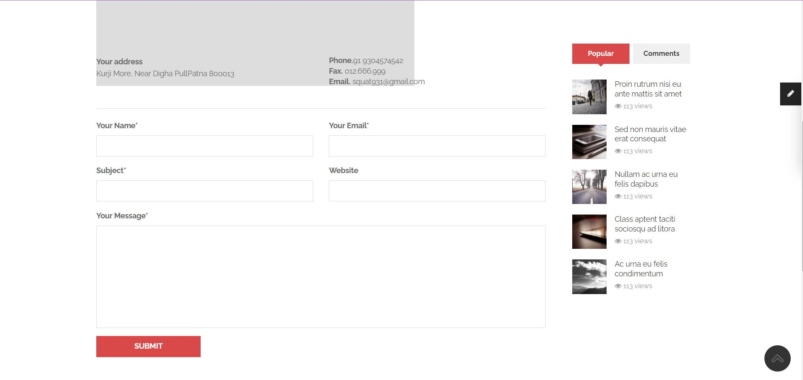

Contact.php

<?php **include**('includes/header.php') ?>

<!-- Begin content with sidebar -->

<div class="container">

<div class="row">

<div class="col-md-9 content">

<div class="contact">

<p>Having Questions? Tell us about your Business, Our experts will check all the aspects and call you back to explain how RealEstateIndia.com would help you to get quotes for your Business.</p>

<div id="contact-map" class="pgl-bg-light">

<iframe src="https://www.google.com/maps/embed?pb=!1m18!1m12!1m3!1d7194.180351726923!2d85.10598212507702!3d25.63513248477736!2m3!1f0!2f0!3f0!3m2!1i1024!2i768!4f13.1!3m3!1m2!1s0x39ed59d13a4b560b%3A0xb7950e8e8cc670e7!2sKurji%2C%20Patna%2C%20Bihar!5e0!3m2!1sen!2sin!4v1657869506106!5m2!1sen!2sin" width="600" height="450" style="border:0;" allowfullscreen="" loading="lazy" referrerpolicy="no-referrer-when-downgrade"></iframe>

</div>

<br><br>

<div class="row">

<div class="col-sm-6">

<strong>Your address</strong>

<address>Kurji More, Near Digha PullPatna 800013</address>

</div>

<div class="col-sm-6">

<address>

<strong>Phone.</strong>91 9304574542 <br>

<strong>Fax.</strong> 012.666.999<br>

<strong>Email.</strong> squat931@gmail.com

</address>

</div>

</div>

<hr>

<form id="contact-form" name="form1" method="post" action="code.php">

<div class="form-group">

<div class="row">

<div class="col-sm-6">

<label for="name">Your Name*</label>

<input type="text" name="name" id="name" class="form-control" data-msg-required="Please enter your name." required>

</div>

<div class="col-sm-6">

<label for="customer_mail">Your Email*</label>

<input type="email" name="email" id="customer_mail" class="form-control" data-msg-required="Please enter your email address." data-msg-email="Please enter a valid email address." required>

</div>

</div>

</div>

<div class="form-group">

<div class="row">

<div class="col-sm-6">

<label for="subject">Subject*</label>

<input type="text" name="subject" id="subject" class="form-control" data-msg-required="Please enter the subject." required>

</div>

<div class="col-sm-6">

<label for="website">Website</label>

<input type="text" name="website" id="website" class="form-control">

</div>

</div>

</div>

<div class="form-group">

<label for="comments">Your Message*</label>

<textarea rows="9" name="message" id="comments" class="form-control" data-msg-required="Please enter your message." required></textarea>

</div>

<div class="form-group">

<input type="submit" value="Submit" class="btn btn-primary min-wide" name="contact_btn" data-loading-text="Loading...">

</div>

</form>

</div>

</div>

<div class="col-md-3 sidebar">

<!-- Begin Our Agents -->

<aside class="block pgl-agents pgl-bg-light">

<h3>Our Agents</h3>

<div class="owl-carousel pgl-pro-slide pgl-agent-item" data-plugin-options='{"items": 1, "pagination": false, "autoHeight": true}'>

<div class="pgl-agent-item">

<div class="img-thumbnail-medium">

<a href="agentprofile.html"><img src="images/agents/temp-agent1.jpg" class="img-responsive" alt=""></a>

</div>

<div class="pgl-agent-info">

<small>NO.1</small>

<h4><a href="agentprofile.html">Surya Nestbuild Ltd.</a></h4>

<address>

<i class="fa fa-map-marker"></i> Office : 91 9304574542<br>

<i class="fa fa-phone"></i> Mobile : 9304574542<br>

<i class="fa fa-fax"></i> Fax : 1-800-666-8888<br>

<i class="fa fa-envelope-o"></i> Mail: <a href="mailto:squat931@gmail.com">squat931@gmail.com</a>

</address>

</div>

</div>

<div class="pgl-agent-item">

<div class="img-thumbnail-medium">

<a href="agentprofile.html"><img src="images/agents/temp-agent2.jpg" class="img-responsive" alt=""></a>

</div>

<div class="pgl-agent-info">

<small>NO.2.1</small>

<h4><a href="agentprofile.html">Rahul Builder</a></h4>

<address>

<i class="fa fa-map-marker"></i> Office : 91 9973007530<br>

<i class="fa fa-phone"></i> Mobile : 91 8712369878<br>

<i class="fa fa-fax"></i> Fax : 1-800-666-8888<br>

<i class="fa fa-envelope-o"></i> Mail: <a href="mailto:squat931@gmail.com">squat931@gmail.com</a>

</address>

</div>

</div>

</div>

</aside>

<!-- End Our Agents -->

<!-- Begin Tabs -->

<aside class="block tabs pgl-bg-light">

<ul class="nav nav-tabs second-tabs">

<li class="active"><a href="#popularPosts" data-toggle="tab"><i class="icon icon-star"></i> Popular</a></li>

<li><a href="#latestComments" data-toggle="tab">Comments</a></li>

</ul>

<div class="tab-content">

<div class="tab-pane active" id="popularPosts">

<ul class="list-unstyled simple-post-list">

<li>

<div class="post-image">

<a href="blog-single.html"><img class="img-responsive" src="images/blog/demo-thumb-7.jpg" alt="Blog"></a>

</div>

<div class="post-info">

<a href="blog-single.html">Proin rutrum nisi eu ante mattis sit amet</a>

<div class="post-meta">

<i class="fa fa-eye"></i> 113 views

</div>

</div>

</li>

<li>

<div class="post-image">

<a href="blog-single.html"><img class="img-responsive" src="images/blog/demo-thumb-6.jpg" alt="Blog"></a>

</div>

<div class="post-info">

<a href="blog-single.html">Sed non mauris vitae erat consequat</a>

<div class="post-meta">

<i class="fa fa-eye"></i> 113 views

</div>

</div>

</li>

<li>

<div class="post-image">

<a href="blog-single.html"><img class="img-responsive" src="images/blog/demo-thumb-5.jpg" alt="Blog"></a>

</div>

<div class="post-info">

<a href="blog-single.html">Nullam ac urna eu felis dapibus</a>

<div class="post-meta">

<i class="fa fa-eye"></i> 113 views

</div>

</div>

</li>

<li>

<div class="post-image">

<a href="blog-single.html"><img class="img-responsive" src="images/blog/demo-thumb-4.jpg" alt="Blog"></a>

</div>

<div class="post-info">

<a href="blog-single.html">Class aptent taciti sociosqu ad litora</a>

<div class="post-meta">

<i class="fa fa-eye"></i> 113 views

</div>

</div>

</li>

<li>

<div class="post-image">

<a href="blog-single.html"><img class="img-responsive" src="images/blog/demo-thumb-3.jpg" alt="Blog"></a>

</div>

<div class="post-info">

<a href="blog-single.html">Ac urna eu felis condimentum</a>

<div class="post-meta">

<i class="fa fa-eye"></i> 113 views

</div>

</div>

</li>

</ul>

</div>

<div class="tab-pane" id="latestComments">

<ul class="list-unstyled simple-post-list">

<li>

<div class="post-image">

<a href="blog-single.html"><img class="img-responsive" src="images/blog/demo-thumb-2.jpg" alt="Blog"></a>

</div>

<div class="post-info">

<a href="blog-single.html">Proin rutrum nisi eu ante mattis sit amet</a>

<div class="post-meta">

<i class="fa fa-eye"></i> 117 views

</div>

</div>

</li>

<li>

<div class="post-image">

<a href="blog-single.html"><img class="img-responsive" src="images/blog/demo-thumb-3.jpg" alt="Blog"></a>

</div>

<div class="post-info">

<a href="blog-single.html">Nullam ac urna eu felis dapibus</a>

<div class="post-meta">

<i class="fa fa-eye"></i> 19 views

</div>

</div>

</li>

<li>

<div class="post-image">

<a href="blog-single.html"><img class="img-responsive" src="images/blog/demo-thumb-4.jpg" alt="Blog"></a>

</div>

<div class="post-info">

<a href="blog-single.html">Class aptent taciti sociosqu ad litora</a>

<div class="post-meta">

<i class="fa fa-eye"></i> 113 views

</div>

</div>

</li>

<li>

<div class="post-image">

<a href="blog-single.html"><img class="img-responsive" src="images/blog/demo-thumb-3.jpg" alt="Blog"></a>

</div>

<div class="post-info">

<a href="blog-single.html">Ac urna eu felis condimentum</a>

<div class="post-meta">

<i class="fa fa-eye"></i> 113 views

</div>

</div>

</li>

</ul>

</div>

</div>

</aside>

<!-- End Tabs -->

</div>

</div>

</div>

<!-- End content with sidebar -->

</div>

<!-- End Main -->

<?php **include**('includes/footer.php') ?>

**Map-with-property.php**

<?php **include**('includes/header.php') ?>

<!-- Begin Main -->

<div role="main" class="main pgl-bg-grey">

<!-- Begin page top -->

<section class="page-top">

<div class="container">

<div class="page-top-in">

<h2><span>Map with property</span></h2>

</div>

</div>

</section>

<!-- End page top -->

<!-- Begin Properties -->

<section class="pgl-properties-map pgl-bg-grey">

<div class="container">

<h2>Offfice house</h2>

<div class="properties-full">

<div class="listing-header clearfix">

<ul class="list-inline list-icons pull-left">

<li><a href="grid-fullwidth-4-column.html"><i class="fa fa-th"></i></a></li>

<li><a href="list-fullwidth.html"><i class="fa fa-th-list"></i></a></li>

<li class="active"><a href="list-map.html"><i class="fa fa-map-marker"></i></a></li>

</ul>

<ul class="list-inline list-sort pull-right">

<li><label for="order-status">Order</label></li>

<li>

<select id="order-status" name="order-status" data-placeholder="Order" class="chosen-select">

<option value="Descending">Descending</option>

<option value="Ascending">Ascending</option>

</select>

</li>

<li><label for="sortby-status">Sort by</label></li>

<li>

<select id="sortby-status" name="sortby-status" data-placeholder="Sort by" class="chosen-select">

<option value="Name">Name</option>

<option value="Area">Area</option>

<option value="Date">Date</option>

</select>

</li>

</ul>

</div>

<div id="properties_map" class="map pgl-bg-dark">

</div>

</div>

</div>

</section>

<!-- End Properties -->

<!-- Begin Featured -->

<section class="pgl-featured pgl-featured-bottom">

<div class="container">

<h2>Featured Properties</h2>

<div class="row">

<div class="owl-carousel pgl-pro-slide" data-plugin-options='{"items": 4, "singleItem": false, "autoPlay": false, "pagination": false}'>

<div class="col-md-12 animation">

<div class="pgl-property featured-item">

<div class="property-thumb-info">

<div class="property-thumb-info-image">

<img alt="" class="img-responsive" src="images/properties/property-featured-2.jpg">

</div>

<div class="property-thumb-info-content">

<h3><a href="property-detail.html">J St, Modesto, CA 95351</a></h3>

<p>Amet luctus nisl tempus.</p>

</div>

</div>

</div>

</div>

<div class="col-md-12 animation">

<div class="pgl-property featured-item">

<div class="property-thumb-info">

<div class="property-thumb-info-image">

<img alt="" class="img-responsive" src="images/properties/property-featured-3.jpg">

</div>

<div class="property-thumb-info-content">

<h3><a href="property-detail.html">Spring Gate DrUNIT 4106</a></h3>

<p>Amet luctus nisl tempus.</p>

</div>

</div>

</div>

</div>

<div class="col-md-12 animation">

<div class="pgl-property featured-item">

<div class="property-thumb-info">

<div class="property-thumb-info-image">

<img alt="" class="img-responsive" src="images/properties/property-featured-4.jpg">

</div>

<div class="property-thumb-info-content">

<h3><a href="property-detail.html">Chatham St NW, Roanoke</a></h3>

<p>Amet luctus nisl tempus.</p>

</div>

</div>

</div>

</div>

<div class="col-md-12 animation">

<div class="pgl-property featured-item">

<div class="property-thumb-info">

<div class="property-thumb-info-image">

<img alt="" class="img-responsive" src="images/properties/property-featured-5.jpg">

</div>

<div class="property-thumb-info-content">

<h3><a href="property-detail.html">Stockton, CA 95215</a></h3>

<p>Amet luctus nisl tempus.</p>

</div>

</div>

</div>

</div>

<div class="col-md-12 animation">

<div class="pgl-property featured-item">

<div class="property-thumb-info">

<div class="property-thumb-info-image">

<img alt="" class="img-responsive" src="images/properties/property-featured-3.jpg">

</div>

<div class="property-thumb-info-content">

<h3><a href="property-detail.html">Spring Gate DrUNIT 4106</a></h3>

<p>Amet luctus nisl tempus.</p>

</div>

</div>

</div>

</div>

<div class="col-md-12 animation">

<div class="pgl-property featured-item">

<div class="property-thumb-info">

<div class="property-thumb-info-image">

<img alt="" class="img-responsive" src="images/properties/property-featured-4.jpg">

</div>

<div class="property-thumb-info-content">

<h3><a href="property-detail.html">Chatham St NW, Roanoke</a></h3>

<p>Amet luctus nisl tempus.</p>

</div>

</div>

</div>

</div>

</div>

</div>

</div>

</section>

<!-- End Featured -->

</div>

<!-- End Main -->

<?php **include**('includes/footer.php') ?>

**About-us.php**

<?php **include**('includes/header.php') ?>

<!-- Begin Main -->

<div role="main" class="main pgl-bg-grey">

<section class="pgl-intro">

<div class="container">

<h2>Welcome to RealEstast</h2>

<div class="owl-carousel pgl-pro-slide pgl-img-slide" data-plugin-options='{"items": 1, "pagination": false, "autoHeight": true}'>

<div class="item-wrap">

<img src="images/slides/slider1.jpg" alt="Photo" class="img-responsive">

<div class="item-caption"><p>Sarvodya Om Nikunj View</p></div>

</div>

<div class="item-wrap">

<img src="images/slides/slider2.jpg" alt="Photo" class="img-responsive">

<div class="item-caption"><p>Sarvodya Om Nikunj View</p></div>

</div>

<div class="item-wrap">

<img src="images/slides/slider3.jpg" alt="Photo" class="img-responsive">

<div class="item-caption"><p>Sarvodya Om Nikunj View</p></div>

</div>

</div>

<div class="lead pgl-bg-light text-center">

<p>Om Nikunj View is a name which reflects elegance in itself. Residents can enjoy themselves to the fullest as the structure is dotted with all the basic infrastructures within close vicinity. The beauty of the surrounding environs will no doubt make the dwellers feel like enjoying their holiday. After a hectic day you can relax and rejuvenate yourself in the green surroundings. The balconies of the apartments overlook the scenic beauty of the surrounding area. Moreover, the complex is bedecked with all the modern amenities and facilities at their best.</p>

</div>

</div>

</section>

<!-- Begin About -->

<section class="pgl-offer">

<div class="container">

<h2>We offer</h2>

<div class="row">

<div class="col-md-4 animation">

<div class="offer-item pgl-bg-light">

<div class="offer-item-inner">

<p><i class="icons icon-hand"></i></p>

<h3>Brokerage Services</h3>

<p>A brokerage firm or brokerage company is a middleman who connects buyers and sellers to complete a transaction for stock shares, bonds, options, and other financial instruments. Brokers are compensated in commissions or fees that are charged once the transaction has been completed.

</p>

</div>

</div>

</div>

<div class="col-md-4 animation">

<div class="offer-item pgl-bg-light">

<div class="offer-item-inner">

<p><i class="icons icon-home"></i></p>

<h3>Real Estate Management</h3>

<p>Making profits for prospective estate owners is one of the important aims of estate management. This is particularly true for private owners where the owner is usually satisfied with for the rent he will receive.They also comply with the local landlord and real estate board laws and maintain the property.</p>

</div>

</div>

</div>

<div class="col-md-4 animation">

<div class="offer-item pgl-bg-light">

<div class="offer-item-inner">

<p><i class="icons icon-chart"></i></p>

<h3>Construction **&amp;** Development</h3>

<p>Development, in terms of land, property or real estate, is a complex process of coordinating various activities to transform ideas and plans into physical reality. As a business process, it involves the financing, construction, renovation or refurbishment of buildings and land in order to make a profit.</p>

</div>

</div>

</div>

</div>

</div>

</section>

<!-- End About -->

<!-- Begin testimonial -->

<section class="pgl-testimonials pgl-testimonials-full">

<div class="container">

<h2>Happy Clients</h2>

<div class="owl-carousel pgl-bg-dark pgl-testimonial" data-plugin-options='{"items": 1, "pagination": false, "autoHeight": true}'>

<div class="row">

<div class="col-sm-4">

<div class="testimonial-author">

<div class="img-thumbnail-small img-circle">

<img src="images/agents/agent1.jpg" height="80px" class="img-circle" alt="Andrew MCCarthy">

</div>

<h4>Rajan singh</h4>

<p><strong>Selller</strong></p>

</div>

</div>

<div class="col-sm-8">

<blockquote class="testimonial">

<p>I posses one of my father's properties and wanted to get it revamped by a builder. I contacted this builder around five months back. The builder is extremely reliable and suggests the best plans. Thanks!</p>

</blockquote>

</div>

</div>

<div class="row">

<div class="col-sm-4">

<div class="testimonial-author">

<div class="img-thumbnail-small img-circle">

<img src="images/agents/agent-1.jpg" class="img-circle" alt="Andrew MCCarthy">

</div>

<h4>riya raj</h4>

<p><strong>Selller</strong></p>

</div>

</div>

<div class="col-sm-8">

<blockquote class="testimonial">

<p>This builder has helped me in getting my building constructed within the promised time frame and as per the modern trends. This builder was very supportive and always provided appropriate suggestion to me considering my requirements.</p>

</blockquote>

</div>

</div>

</div>

</div>

</section>

<!-- End testimonial -->

<!-- Begin testimonial -->

<section class="pgl-teams">

<div class="container">

<h2>Our Team</h2>

<p>To be the first choice for our consumers and partners in their journey of discovering, renting, buying, selling and financing a home. We do that with data, design, technology, and above all the passion of our people, while delivering value to our shareholders.</p>

<div class="row">

<div class="col-xs-6 col-md-3">

<div class="pgl-team-item pgl-bg-light">

<div class="img-thumbnail-medium">

<a href="#"><img src="images/agents/team1.jpg" class="img-responsive" alt=""></a>

<ul class="social-links">

<li><a href="https://www.facebook.com/profile.php?id=100011799281391"><i class="fa fa-facebook"></i></a></li>

<li><a href="https://twitter.com/_prince__singh_"><i class="fa fa-twitter"></i></a></li>

<li><a href="#"><i class="fa fa-instagram"></i></a></li>

</ul>

</div>

<div class="pgl-team-info">

<h4>Prince kumar</h4>

<!-- <p class="text-muted">Sale Director</p>

<p>Eiusmod tempor incididunt ut labore et dolore magna aliqua. Ut enim ad minim veniam, quis nostrudexercitation</p>

<a href="#">View profile</a> -->

</div>

</div>

</div>

<div class="col-xs-6 col-md-3">

<div class="pgl-team-item pgl-bg-light">

<div class="img-thumbnail-medium">

<a href="#"><img src="images/agents/team-1.jpg" class="img-responsive" alt=""></a>

<ul class="social-links">

<li><a href="https://www.facebook.com/profile.php?id=100006169276634"><i class="fa fa-facebook"></i></a></li>

<li><a href="https://mobile.twitter.com/PriyranjanRaj"><i class="fa fa-twitter"></i></a></li>

<li><a href="https://www.instagram.com/therajwanshirajveer"><i class="fa fa-instagram"></i></a></li>

</ul>

</div>

<div class="pgl-team-info">

<h4>Priyaranjan raj</h4>

<!-- <p class="text-muted">Sale Director</p>

<p>Eiusmod tempor incididunt ut labore et dolore magna aliqua. Ut enim ad minim veniam, quis nostrudexercitation</p>

<a href="#">View profile</a> -->

</div>

</div>

</div>

<div class="col-xs-6 col-md-3">

<div class="pgl-team-item pgl-bg-light">

<div class="img-thumbnail-medium">

<a href="#"><img src="images/agents/team-1.jpg" class="img-responsive" alt=""></a>

<ul class="social-links">

<li><a href="#"><i class="fa fa-facebook"></i></a></li>

<li><a href="#"><i class="fa fa-twitter"></i></a></li>

<li><a href="#"><i class="fa fa-instagram"></i></a></li>

</ul>

</div>

<div class="pgl-team-info">

<h4>Saif iqabal</h4>

<!-- <p class="text-muted">Sale Director</p>

<p>Eiusmod tempor incididunt ut labore et dolore magna aliqua. Ut enim ad minim veniam, quis nostrudexercitation</p>

<a href="#">View profile</a> -->

</div>

</div>

</div>

<div class="col-xs-6 col-md-3">

<div class="pgl-team-item pgl-bg-light">

<div class="img-thumbnail-medium">

<a href="#"><img src="images/agents/team-1.jpg" class="img-responsive" alt=""></a>

<ul class="social-links">

<li><a href="#"><i class="fa fa-facebook"></i></a></li>

<li><a href="#"><i class="fa fa-twitter"></i></a></li>

<li><a href="#"><i class="fa fa-instagram"></i></a></li>

</ul>

</div>

<div class="pgl-team-info">

<h4>Prince prakash</h4>

<!-- <p class="text-muted">Sale Director</p>

<p>Eiusmod tempor incididunt ut labore et dolore magna aliqua. Ut enim ad minim veniam, quis nostrudexercitation</p>

<a href="#">View profile</a> -->

</div>

</div>

</div>

</div>

<div class="row">

<div class="col-xs-6 col-md-3">

<div class="pgl-team-item pgl-bg-light">

<div class="img-thumbnail-medium">

<a href="#"><img src="images/agents/team-1.jpg" class="img-responsive" alt=""></a>

<ul class="social-links">

<li><a href="#"><i class="fa fa-facebook"></i></a></li>

<li><a href="#"><i class="fa fa-twitter"></i></a></li>

<li><a href="#"><i class="fa fa-instagram"></i></a></li>

</ul>

</div>

<div class="pgl-team-info">

<h4>abhishek chatrvedi</h4>

<!-- <p class="text-muted">Sale Director</p>

<p>Eiusmod tempor incididunt ut labore et dolore magna aliqua. Ut enim ad minim veniam, quis nostrudexercitation</p>

<a href="#">View profile</a> -->

</div>

</div>

</div>

</div>

</div>

</section>

<!-- End testimonial -->

</div>

<!-- End Main -->

<?php **include**('includes/footer.php') ?>

**JS files**

**Contact.js**

(function($) {

'use strict';

/*

Contact Form: Basic

*/

$('#contact-form').validate({

submitHandler: function(form) {

var $form = $(form),

$submitButton = $(this.submitButton);

$form.submit();

}

});

**theme.js**

(function() {

"use strict";

var Core = {

initialized: false,

initialize: function() {

if (this.initialized) return;

this.initialized = true;

this.build();

},

build: function() {

// Scroll to Top Button.

$.scrollToTop();

// Owl Carousel

this.owlCarousel();

// dropdown menu

this.dropdownhover();

// Dropdown Menu mobile

this.editDropdown();

//flexslider

this.flexslider();

//choosenselect

this.choosenselect();

//masonrygrid

this.masonrygrid();

},

owlCarousel: function(options) {

var total = $("div.owl-carousel:not(.manual)").length,

count = 0;

$("div.owl-carousel:not(.manual)").each(function() {

var slider = $(this);

var defaults = {

// Most important owl features

items : 4,

itemsCustom : false,

itemsDesktop : [1199,2],

itemsDesktopSmall : [979,1],

itemsTablet: [768,2],

itemsTabletSmall: false,

itemsMobile : [479,1],

singleItem : true,

itemsScaleUp : false,

//Basic Speeds

slideSpeed : 200,

paginationSpeed : 800,

rewindSpeed : 1000,

//Autoplay

autoPlay : false,

stopOnHover : false,

// Navigation

navigation : true,

navigationText : ["<i class=\"icons icon-left\"></i>","<i class=\"icons icon-right\"></i>"],

rewindNav : true,

scrollPerPage : false,

//Pagination

pagination : true,

paginationNumbers: false,

// Responsive

responsive: true,

responsiveRefreshRate : 200,

responsiveBaseWidth: window,

// CSS Styles

baseClass : "owl-carousel",

theme : "owl-theme",

//Lazy load

lazyLoad : false,

lazyFollow : true,

lazyEffect : "fade",

//Auto height

autoHeight : false,

//JSON

jsonPath : false,

jsonSuccess : false,

//Mouse Events

dragBeforeAnimFinish : true,

mouseDrag : true,

touchDrag : true,

//Transitions

transitionStyle : false,

// Other

addClassActive : false,

//Callbacks

beforeUpdate : false,

afterUpdate : false,

beforeInit: false,

afterInit: false,

beforeMove: false,

afterMove: false,

afterAction: false,

startDragging : false,

afterLazyLoad : false

}

var config = $.extend({}, defaults, options, slider.data("plugin-options"));

// Initialize Slider

slider.owlCarousel(config).addClass("owl-carousel-init");

});

},

dropdownhover: function(options) {

/** Extra script for smoother navigation effect **/

if ($(window).width() > 992) {

$('.pgl-navbar-main .dropdown-toggle').addClass('disabled');

$('.navbar .dropdown').hover(function () {

"use strict";

$(this).addClass('open').find('.dropdown-menu').first().stop(true, true).delay(250).slideDown();

}, function () {

"use strict";

var na = $(this);

na.find('.dropdown-menu').first().stop(true, true).delay(100).slideUp('fast', function () {

na.removeClass('open');

});

});

} else return;

},

editDropdown: function() {

if($(window).width() < 1024) {

$('.navbar-nav .dropdown').click(function() {

$(this).addClass('open').find('.dropdown-menu').first().stop(true, true).show();

}, function() {

$(this).removeClass('open').find('.dropdown-menu').first().stop(true, true).hide();

$('.navbar-nav .dropdown > a').click(function(){

location.href = this.href;

});

});

}

},

flexslider: function(options) {

// The slider being synced must be initialized first

$('#carousel').flexslider({

animation: "slide",

controlNav: false,

animationLoop: false,

slideshow: false,

itemWidth: 148,

itemMargin: 10,

asNavFor: '#slider'

});

$('#slider').flexslider({

animation: "slide",

controlNav: false,

animationLoop: false,

slideshow: false,

sync: "#carousel"

});

},

choosenselect: function(options) {

var config = {

'.chosen-select' : {},

'.chosen-select-deselect' : {allow_single_deselect:true},

'.chosen-select-no-single' : {disable_search_threshold:10},

'.chosen-select-no-results': {no_results_text:'Oops, nothing found!'},

'.chosen-select-width' : {width:"95%"}

}

for (var selector in config) {

$(selector).chosen(config[selector]);

}

},

masonrygrid: function(options) {

// Masonry for desktop

if($(window).width() < 361) return;

var $container = $('.masonry-desk');

// initialize

$container.imagesLoaded( function() {

$container.masonry();

});

var $items = document.querySelectorAll('.masonry-item');

imagesLoaded( $items, function() {

$container.masonry({

itemSelector: '.masonry-item'

});

});

}

};

Core.initialize();

$(window).load(function () {

});

})();

**Theme.plugin.js**

(function($) { $.extend({

scrollToTop: function() {

var _isScrolling = false;

// Append Button

$("body").append($("<a />")

.addClass("scroll-to-top")

.attr({

"href": "#",

"id": "scrollToTop"

})

.append(

$("<i />")

.addClass("icons icon-up")

));

$("#scrollToTop").click(function(e) {

e.preventDefault();

$("body, html").animate({scrollTop : 0}, 500);

return false;

});

// Show/Hide Button on Window Scroll event.

$(window).scroll(function() {

if(!_isScrolling) {

_isScrolling = true;

if($(window).scrollTop() > 150) {

$("#scrollToTop").stop(true, true).addClass("visible");

_isScrolling = false;

} else {

$("#scrollToTop").stop(true, true).removeClass("visible");

_isScrolling = false;

}

}

});

}

});

})(jQuery);

**Adminstration panel:-**

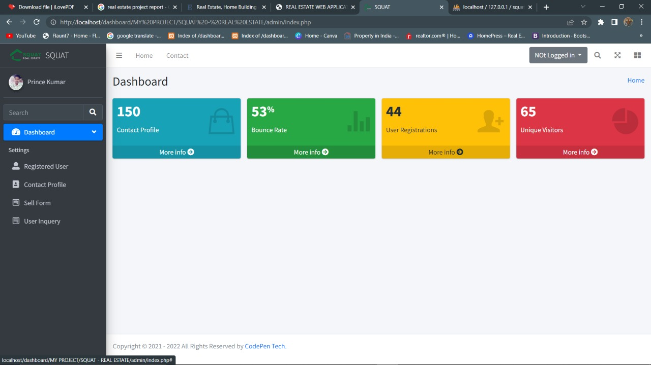

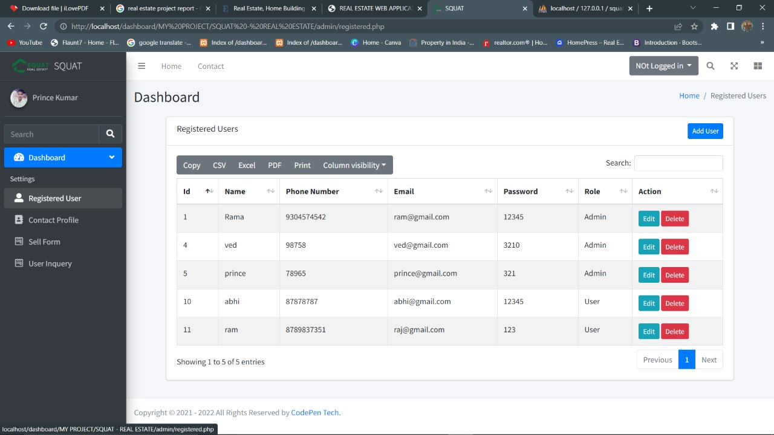

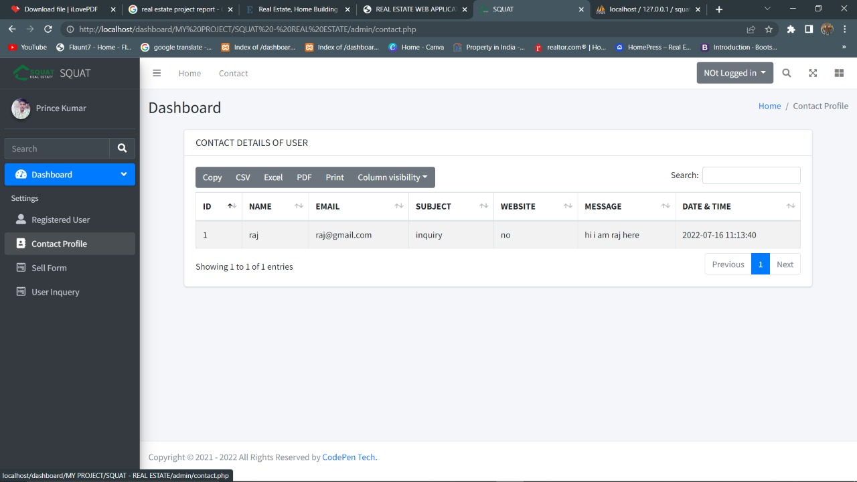



**Authentication.php**

<?php

session_start();

**if**(!isset($_SESSION['auth']))

{

$_SESSION['auth_status']="Loggin to access dashboard";

header('Location:login.php');

**exit**(**0**);

}

**else**

{

**if**($_SESSION['auth'] == "1")

{

//auto access

}

**else**

{

$_SESSION['status']="You are not authirized as admin";

header('Location: ../index.php');

**exit**(**0**);

}

}

?>

**Authentication_copy.php**

<?php

session_start();

**if**(!isset($_SESSION['auth']))

{

$_SESSION['auth_status']="Loggin to access dashboard";

header('Location:login.php');

**exit**(**0**);

}

**else**

{

**if**($_SESSION['auth'] == "1")

{

//auto access

}

**else**

{

$_SESSION['status']="You are not authirized as admin";

header('Location: ../index.php');

**exit**(**0**);

}

}

?>

<?php

session_start();

**include**('authentication.php');

**include**('config/dbcon.php');

**if**(isset($_POST['logout_btn']))

{

/* session_destroy(); */

unset($_SESSION['auth']);

unset($_SESSION['auth_user']);

$_SESSION['status']="Logged Out successfully";

header('location: login.php');

**exit**(**0**);

}

**if**(isset($_POST['addUser']))

{

$name=$_POST['name'];

$phone=$_POST['phone'];

$email=$_POST['email'];

$password=$_POST['password'];

$confirmpassword=$_POST['confirmpassword'];

**if**($password==$confirmpassword)

{

$checkemail="SELECT useremail FROM user_profile WHERE useremail='$email' ";

$checkemail_run=mysqli_query($con,$checkemail);

**if**(mysqli_num_rows($checkemail_run) > **0**)

{

//taken already exist

$_SESSION['status']="Email Id is already taken";

header("Location:registered.php");

**exit**;

}

**else**

{

//Available----Record not found

$user_query="INSERT INTO user_profile(username,usermobile,useremail,userpassword) values ('$name','$phone','$email','$password')";

$user_query_run=mysqli_query($con,$user_query);

**if**($user_query_run)

{

$_SESSION['status']="User added Successfully";

header("Location:registered.php");

}

**else**

{

$_SESSION['status']="User Registration failed";

header("Location:registered.php");

}

}

}

**else**

{

$_SESSION['status']="Password and ConfirmPassword does't match";

header("Location:registered.php");

}

}

**if**(isset($_POST['updateUser']))

{

$user_id=$_POST['user_id'];

$name=$_POST['name'];

$phone=$_POST['phone'];

$email=$_POST['email'];

$password=$_POST['password'];

$role_as=$_POST['role_as'];

$query="UPDATE user_profile SET username='$name', usermobile='$phone', useremail='$email', userpassword='$password',role_as='$role_as' WHERE userid='$user_id' ";

$query_run=mysqli_query($con,$query);

**if**($query_run)

{

$_SESSION['status']="User updated Successfully";

header("Location:registered.php");

}

**else**

{

$_SESSION['status']="User updating failed";

header("Location:registered.php");

}

}

**if**(isset($_POST['DeleteUserbtn']))

{

$userid=$_POST['delete_id'];

**Code.php**

$query="DELETE FROM user_profile WHERE userid='$userid' ";

$query_run=mysqli_query($con,$query);

**if**($query_run)

{

$_SESSION['status']="User deleted Successfully";

header("Location:registered.php");

}

**else**

{

$_SESSION['status']="User deleting failed";

header("Location:registered.php");

}

}

**if**(isset($_POST['check_Emailbtn']))

{

$email=$_POST['email'];

$checkemail="SELECT useremail FROM user_profile WHERE useremail='$email' ";

$checkemail_run=mysqli_query($con,$checkemail);

**if**(mysqli_num_rows($checkemail_run) > **0**)

{

**echo**"Email id already taken..!";

}

**else**

{

**echo**"it's Available";

}

}

?>

**Contact.php**

<?php

/* include('authentication.php'); */

**include**('includes/header.php');

**include**('includes/topbar.php');

**include**('includes/sidebar.php');

**include**('config/dbcon.php');

?>

<!-- Content Wrapper. Contains page content -->

<div class="content-wrapper">

<!-- Content Header (Page header) -->

<div class="content-header">

<div class="container-fluid">

<div class="row mb-2">

<div class="col-sm-6">

<h1 class="m-0">Dashboard</h1>

</div><!-- /.col -->

<div class="col-sm-6">

<ol class="breadcrumb float-sm-right">

<li class="breadcrumb-item"><a href="index.php">Home</a></li>

<li class="breadcrumb-item active">Contact Profile</li>

</ol>

</div><!-- /.col -->

</div><!-- /.row -->

</div><!-- /.container-fluid -->

</div>

<div class="container">

<div class="row">

<div class="col-md-12">

<div class="card">

<div class="card-header">

<h3 class="card-title">CONTACT DETAILS OF USER</h3>

</div>

<!-- /.card-header -->

<div class="card-body">

<table id="example1" class="table table-bordered table-striped">

<thead>

<tr>

<th>ID</th>

<th>NAME</th>

<th>EMAIL</th>

<th>SUBJECT</th>

<th>WEBSITE</th>

<th>MESSAGE</th>

<th>DATE & TIME</th>

</tr>

</thead>

<tbody>

<?php

$query="SELECT * FROM contact";

$query_run=mysqli_query($con,$query);

**if**(mysqli_num_rows($query_run) > **0**)

{

**foreach**($query_run **as** $row)

{

/* echo $row['name']; */

?>

<tr>

<td>

<?php **echo** $row['id']; ?>

</td>

<td>

<?php **echo** $row['name']; ?>

</td>

<td>

<?php **echo** $row['email']; ?>

</td>

<td>

<?php **echo** $row['subject']; ?>

</td>

<td>

<?php **echo** $row['website']; ?>

</td>

<td>

<?php **echo** $row['message']; ?>

</td>

<td>

<?php **echo** $row['date_time']; ?>

</td>

<!-- <td>

<a href="" class="btn btn-info">Edit</a>

<a href="" class="btn btn-danger">Delete</a>

</td> -->

</tr>

<?php

}

}

**else**

{

?>

<tr>

<td>NO record found</td>

</tr>

<?php

}

?>

</tbody>

</table>

</div>

</div>

</div>

</div>

</div>

</div>

<?php **include**('includes/script.php');?>

<?php **include**('includes/footer.php');?>

**Index.php**

<?php

**include**('authentication.php');

**include**('includes/header.php');

**include**('includes/topbar.php');

**include**('includes/sidebar.php');

?>

<!-- Content Wrapper. Contains page content -->

<div class="content-wrapper">

<!-- Content Header (Page header) -->

<div class="content-header">

<div class="container-fluid">

<div class="row mb-2">

<div class="col-sm-6">

<h1 class="m-0">Dashboard</h1>

</div><!-- /.col -->

<div class="col-sm-6">

<ol class="breadcrumb float-sm-right">

<li class="breadcrumb-item"><a href="index.php">Home</a></li>

<!-- <li class="breadcrumb-item active">Dashboard v1</li> -->

</ol>

</div><!-- /.col -->

</div><!-- /.row -->

</div><!-- /.container-fluid -->

</div>

<!-- /.content-header -->

<!-- Main content -->

<section class="content">

<div class="container-fluid">

<!-- Small boxes (Stat box) -->

<div class="row">

<div class="col-md-12">

<?php

**include**('message.php');

?>

</div>

<div class="col-lg-3 col-6">

<!-- small box -->

<div class="small-box bg-info">

<div class="inner">

<h3>150</h3>

<p>Contact Profile</p>

</div>

<div class="icon">

<i class="ion ion-bag"></i>

</div>

<a href="#" class="small-box-footer">More info <i class="fas fa-arrow-circle-right"></i></a>

</div>

</div>

<!-- ./col -->

<div class="col-lg-3 col-6">

<!-- small box -->

<div class="small-box bg-success">

<div class="inner">

<h3>53<sup style="font-size: 20px">%</sup></h3>

<p>Bounce Rate</p>

</div>

<div class="icon">

<i class="ion ion-stats-bars"></i>

</div>

<a href="#" class="small-box-footer">More info <i class="fas fa-arrow-circle-right"></i></a>

</div>

</div>

<!-- ./col -->

<div class="col-lg-3 col-6">

<!-- small box -->

<div class="small-box bg-warning">

<div class="inner">

<h3>44</h3>

<p>User Registrations</p>

</div>

<div class="icon">

<i class="ion ion-person-add"></i>

</div>

<a href="registered.php" class="small-box-footer">More info <i class="fas fa-arrow-circle-right"></i></a>

</div>

</div>

<!-- ./col -->

<div class="col-lg-3 col-6">

<!-- small box -->

<div class="small-box bg-danger">

<div class="inner">

<h3>65</h3>

<p>Unique Visitors</p>

</div>

<div class="icon">

<i class="ion ion-pie-graph"></i>

</div>

<a href="#" class="small-box-footer">More info <i class="fas fa-arrow-circle-right"></i></a>

</div>

</div>

<!-- ./col -->

</div>

<!-- /.row -->

</div><!-- /.container-fluid -->

</section>

<!-- /.content -->

</div>

<?php **include**('includes/script.php');?>

<?php **include**('includes/footer.php');?>

**Login.php**

<?php

session_start();

**include**('includes/header.php');

**if**(isset($_SESSION['auth']))

{

$_SESSION['status']="You are already logged in";

header('Location:index.php');

}

?>

<div class="sectiom">

<div class="container">

<div class="row justify-content-center">

<div class="col-md-5 my-5">

<?php

**include**('message.php');

?>

<div class="card my-5">

<div class="card-header bg-light">

<h5>Login Form</h5>

</div>

<div class="card-body">

<form action="logincode.php" method="POST">

<div class="form-group">

<label for="">Email Id</label>

<input type="text" name="email" class="form-control" placeholder="Email Id">

</div>

<div class="form-group">

<label for="">Password</label>

<input type="password" name="password" class="form-control" placeholder="Password">

</div>

<br>

<div class="form-group">

<button type="submit" name="login_btn" class="btn btn-primary btn-block">Login</button>

</div>

</form>

</div>

</div>

</div>

</div>

</div>

</div>

<?php **include**('includes/script.php');?>

<?php **include**('includes/footer.php');?>

**Logincode.php**

<?php

session_start();

**include**('config/dbcon.php');

**if**(isset($_POST['login_btn']))

{

$email=$_POST['email'];

$password=$_POST['password'];

$log_query="SELECT *FROM user_profile WHERE useremail='$email' AND userpassword='$password' LIMIT 1";

$log_query_run=mysqli_query($con,$log_query);

**if**(mysqli_num_rows($log_query_run) > **0**)

{

**foreach**($log_query_run **as** $row)

{

$user_id=$row['id'];

$user_name=$row['name'];

$user_email=$row['email'];

$user_phone=$row['phone'];

$role_as=$row['role_as'];

}

$_SESSION['auth']="$role_as";

$_SESSION['auth_user']=[

'user_id'=>$user_id,

'user_name'=>$user_name,

'user_email'=>$user_email,

'user_phone'=>$user_phone

];

$_SESSION['status']="Logged in Successfully";

header('Location:index.php');

}

**else**

{

$_SESSION['status']="Invalid Email or Password";

header('Location:login.php');

}

}

**else**

{

$_SESSION['status']="Access Denied";

header('location:login.php');

}

?>

**Message.php**

<?php

**if**(isset($_SESSION['status']))

{

?>

<div class="alert alert-warning alert-dismissible fade show" role="alert">

<strong>Hey !</strong> <?php **echo** $_SESSION['status']; ?>

<button type="button" class="close" data-dismiss="alert" aria-label="Close">

<span aria-hidden="true">**&times;**</span>

</button>

</div>

<?php

unset($_SESSION['status']);

}

?>

**Registered.php**

<?php

**include**('authentication.php');

**include**('includes/header.php');

**include**('includes/topbar.php');

**include**('includes/sidebar.php');

**include**('config/dbcon.php');

?>

<!-- Content Wrapper. Contains page content -->

<div class="content-wrapper">

<!-- user Modal -->

<div class="modal fade" id="AddUserModal" tabindex="-1" aria-labelledby="exampleModalLabel" aria-hidden="true">

<div class="modal-dialog">

<div class="modal-content">

<div class="modal-header">

<h5 class="modal-title" id="exampleModalLabel">New User</h5>

<button type="button" class="btn-close" data-dismiss="modal" aria-label="Close"></button>

</div>

<form action="code.php" method="POST">

<div class="modal-body">

<div class="form-group">

<label for="">Name</label>

<input type="text" name="name" class="form-control" placeholder="Name">

</div>

<div class="form-group">

<label for="">Phone Number</label>

<input type="text" name="phone" class="form-control" placeholder="Phone Number">

</div>

<div class="form-group">

<label for="">Email Id</label>

<span class="email_error text-danger ml-2"></span>

<input type="email" name="email" class="form-control email_id" placeholder="Email id">

</div>

<div class="row">

<div class="col-md-6">

<div class="form-group">

<label for="Password">Password</label>

<input type="password" name="password" class="form-control" placeholder="Password">

</div>

</div>

<div class="col-md-6">

<div class="form-group">

<label for="Password">Confirm Password</label>

<input type="password" name="confirmpassword" class="form-control" placeholder="ConfirmPassword">

</div>

</div>

</div>

</div>

<div class="modal-footer">

<button type="button" class="btn btn-secondary" data-dismiss="modal">Close</button>

<button type="submit" name="addUser" class="btn btn-primary">Save</button>

</div>

</form>

</div>

</div>

</div>

<!-- delete user -->

<div class="modal fade" id="DeleteModal" tabindex="-1" aria-labelledby="exampleModalLabel" aria-hidden="true">

<div class="modal-dialog">

<div class="modal-content">

<div class="modal-header">

<h5 class="modal-title" id="exampleModalLabel">Delete user</h5>

<button type="button" class="btn-close" data-dismiss="modal" aria-label="Close"></button>

</div>

<form action="code.php" method="POST">

<div class="modal-body">

<input type="hidden" name="delete_id" class="delete_user_id">

<p>

Are you sure. you want to delete this data ?

</p>

</div>

<div class="modal-footer">

<button type="button" class="btn btn-secondary" data-dismiss="modal">Close</button>

<button type="submit" name="DeleteUserbtn" class="btn btn-primary">Yes,Delete</button>

</div>

</form>

</div>

</div>

</div>

<!-- /delete user -->

<!-- Content Header (Page header) -->

<div class="content-header">

<div class="container-fluid">

<div class="row mb-2">

<div class="col-sm-6">

<h1 class="m-0">Dashboard</h1>

</div><!-- /.col -->

<div class="col-sm-6">

<ol class="breadcrumb float-sm-right">

<li class="breadcrumb-item"><a href="#">Home</a></li>

<li class="breadcrumb-item active">Registered Users</li>

</ol>

</div><!-- /.col -->

</div><!-- /.row -->

</div><!-- /.container-fluid -->

</div>

<!-- /.content-header -->

<section class="content">

<div class="container">

<div class="row">

<div class="col-md-12">

<?php

**if**(isset($_SESSION['status']))

{

**echo**"<h4>".$_SESSION['status']."</h4>";

unset($_SESSION['status']);

}

?>

<div class="card">

<div class="card-header">

<h3 class="card-title">Registered Users

</h3>

<a href="#" data-toggle="modal" data-target="#AddUserModal" class="btn btn-primary btn-sm float-right">Add

User</a>

</div>

<!-- /.card-header -->

<div class="card-body">

<table id="example1" class="table table-bordered table-striped">

<thead>

<tr>

<th>Id</th>

<th>Name</th>

<th>Phone Number</th>

<th>Email</th>

<th>Password</th>

<!-- <th>Re-Password</th> -->

<th>Role</th>

<th>Action</th>

</tr>

</thead>

<tbody>

<?php

$query="select * from user_profile";

$query_run=mysqli_query($con,$query);

**if**(mysqli_num_rows($query_run)>**0**)

{

**foreach**($query_run **as** $row)

{

/* echo $row['name']; */

?>

<tr>

<td>

<?php **echo** $row['userid']; ?>

</td>

<td>

<?php **echo** $row['username']; ?>

</td>

<td>

<?php **echo** $row['usermobile']; ?>

</td>

<td>

<?php **echo** $row['useremail']; ?>

</td>

<td>

<?php **echo** $row['userpassword']; ?>

</td>

<!-- <td>

<!?php echo $row['userrepassword']; ?>

</td> -->

<td>

<?php

**if**($row['role_as']=="0")

{

**echo** "User";

}

**elseif**($row['role_as']=="1")

{

**echo** "Admin";

}

**else**

{

**echo** "Invalid User";

}

?>

</td>

<td><a href="registered_edit.php?user_id=<?php **echo** $row['userid']; ?>"

class="btn btn-info btn-sm">Edit</a>

<button type="button" class="btn btn-danger btn-sm deletebtn"

value="<?php **echo** $row['userid']; ?>">Delete</button>

</td>

</tr>

<?php

}

}

**else**

{

?>

<tr>

<td>NO record found</td>

</tr>

<?php

}

?>

</tbody>

</table>

</div>

</div>

</div>

</div>

</div>

</section>

<!-- /.content -->

</div>

<?php **include**('includes/script.php');?>

<script>

$(document).ready(**function** () {

$('.email_id').keyup(**function** (e) {

**var** email=$('.email_id').val();

/* console.log(email); */

$.ajax({

type: "POST",

url: "code.php",

data: {

'check_Emailbtn':**1**,

'email':email,

},

success: **function** (response) {

/* console.log(response); */

$('.email_error').text(response);

**return** **false**;

}

});

});

});

</script>

<script>

$(document).ready(**function** () {

$('.deletebtn').click(**function** (e) {

e.preventDefault();

**var** user_id = $(**this**).val();

//console.log(user_id);

$('.delete_user_id').val(user_id);

$('#DeleteModal').modal('show');

});

});

</script>

<?php **include**('includes/footer.php');?>

**Registered_edit.php**

<?php

**include**('authentication.php');

**include**('includes/header.php');

**include**('includes/topbar.php');

**include**('includes/sidebar.php');

**include**('config/dbcon.php');

?>

<!-- Content Wrapper. Contains page content -->

<div class="content-wrapper">

<!-- Content Header (Page header) -->

<div class="content-header">

<div class="container-fluid">

<div class="row mb-2">

<div class="col-sm-6">

<h1 class="m-0">Dashboard</h1>

</div><!-- /.col -->

<div class="col-sm-6">

<ol class="breadcrumb float-sm-right">

<li class="breadcrumb-item"><a href="#">Home</a></li>

<li class="breadcrumb-item active">Edit - Registered Users</li>

</ol>

</div><!-- /.col -->

</div><!-- /.row -->

</div><!-- /.container-fluid -->

</div>

<!-- /.content-header -->

<section class="content">

<div class="container">

<div class="row">

<div class="col-md-12">

<div class="card">

<div class="card-header">

<h3 class="card-title">Edit - Registered Users

</h3>

<a href="registered.php" class="btn btn-danger btn-sm float-right">BACK</a>

</div>

<!-- /.card-header -->

<div class="card-body">

<div class="row">

<div class="col-md-6">

<form action="code.php" method="POST">

<div class="modal-body">

<?php

**if**(isset($_GET['user_id']))

{

$user_id=$_GET['user_id'];

$query="SELECT * FROM user_profile where userid='$user_id' LIMIT 1 ";

$query_run=mysqli_query($con,$query);

**if**(mysqli_num_rows($query_run)>**0**)

{

**foreach**($query_run **as** $row)

{

?>

<input type="hidden" name="user_id" value="<?php **echo** $row['userid'] ?>">

<div class="form-group">

<label for="">Name</label>

<input type="text" name="name" value="<?php **echo** $row['username'] ?>" class="form-control" placeholder="Name">

</div>

<div class="form-group">

<label for="">Phone Number</label>

<input type="text" name="phone" value="<?php **echo** $row['usermobile'] ?>" class="form-control" placeholder="Phone Number">

</div>

<div class="form-group">

<label for="">Email Id</label>

<input type="email" name="email" value="<?php **echo** $row['useremail'] ?>" class="form-control" placeholder="Email id">

</div>

<div class="form-group">

<label for="Password">Password</label>

<input type="password" name="password" value="<?php **echo** $row['userpassword'] ?>" class="form-control" placeholder="Password">

</div>

<div class="form-group">

<label for="">Give Role</label>

<select name="role_as" id="" class="form-control" required>

<option value="">Select</option>

<option value="0">User</option>

<option value="1">Admin</option>

</select>

</div>

</div>

<?php

}

}

**else**

{

**echo**"<h4> No Record Found</h4>";

}

}

?>

<div class="modal-footer">

<button type="submit" name="updateUser" class="btn btn-info">Update</button>

</div>

</form>

</div>

</div>

</div>

</div>

</div>

</div>

</div>

</section>

</div>

<?php **include**('includes/script.php');?>

<?php **include**('includes/footer.php');?>

**Sellform.php**

**<?php**

**include('authentication.php');**

**include('includes/header.php');**

**include('includes/topbar.php');**

**include('includes/sidebar.php');**

**include('config/dbcon.php');**

**?>**

**<!-- Content Wrapper. Contains page content -->**

**<div class="content-wrapper">**

**<!-- Content Header (Page header) -->**

**<div class="content-header">**

**<div class="container-fluid">**

**<div class="row mb-2">**

**<div class="col-sm-6">**

**<h1 class="m-0">Dashboard</h1>**

**</div><!-- /.col -->**

**<div class="col-sm-6">**

**<ol class="breadcrumb float-sm-right">**

**<li class="breadcrumb-item"><a href="index.php">Home</a></li>**

**<li class="breadcrumb-item active">Proerty Inquery</li>**

**</ol>**

**</div><!-- /.col -->**

**</div><!-- /.row -->**

**</div><!-- /.container-fluid -->**

**</div>**

**<div class="container">**

**<div class="row">**

**<div class="col-md-12">**

**<div class="card">**

**<div class="card-header">**

**<h3 class="card-title">Sell Form Details</h3>**

**</div>**

**<!-- /.card-header -->**

**<div class="card-body">**

**<table id="example1" class="table table-bordered table-striped">**

**<thead>**

**<tr>**

**<th>ID</th>**

**<!-- <th>NAME</th>**

**<th>EMAIL</th> -->**

**<th>MOBILE</th>**

**<th>PROJECT</th>**

**<th>MAINTENANCE</th>**

**<th>FLOORS</th>**

**<th>ADDRESS</th>**

**<th>TYPE</th>**

**<th>BEDROOMS</th>**

**<th>FURNISHING</th>**

**<th>CONSTRACTIONS STATUS</th>**

**<th>LISTED BY</th>**

**<th>EXTERIOR</th>**

**<th>LIVINGROOM</th>**

**<th>KITCHEN</th>**

**<!-- <th>DATE & TIME</th> -->**

**</tr>**

**</thead>**

**<tbody>**

**<?php**

**$query="SELECT * FROM sellform";**

**$query_run=mysqli_query($con,$query);**

**if(mysqli_num_rows($query_run) > 0)**

**{**

**?>**

**<?php**

**foreach($query_run as $row)**

**{**

**/* echo $row['name']; */**

**?>**

**<tr>**

**<td>**

**<?php echo $row['id']; ?>**

**</td>**

**<td>**

**<?php echo $row['mobile']; ?>**

**</td>**

**<td>**

**<?php echo $row['project']; ?>**

**</td>**

**<td>**

**<?php echo $row['maintenance']; ?>**

**</td>**

**<td>**

**<?php echo $row['total_floor']; ?>**

**</td>**

**<td>**

**<?php echo $row['address']; ?>**

**</td>**

**<td>**

**<?php echo $row['type']; ?>**

**</td>**

**<td>**

**<?php echo $row['bedrooms']; ?>**

**</td>**

**<td>**

**<?php echo $row['furnishing']; ?>**

**</td>**

**<td>**

**<?php echo $row['const_status']; ?>**

**</td>**

**<td>**

**<?php echo $row['listed_by']; ?>**

**</td>**

**<td><?php echo '<img src="../upload/'.$row['exterior'].' " width="100px" height="100px" alt="no image1">'?></td>**

**<td><?php echo '<img src="../upload/'.$row['livingroom'].' " width="100px" height="100px" alt="no image2">'?></td>**

**<td><?php echo '<img src="../upload/'.$row['kitchen'].' " width="100px" height="100px" alt="no image3">'?></td>**

**<!-- <td>**

**<a href="" class="btn btn-info">Edit</a>**

**<a href="" class="btn btn-danger">Delete</a>**

**</td> -->**

**</tr>**

**<?php**

**}**

**}**

**else**

**{**

**?>**

**<tr>**

**<td>NO record found</td>**

**</tr>**

**<?php**

**}**

**?>**

**</tbody>**

**</table>**

**</div>**

**</div>**

**</div>**

**</div>**

**</div>**

**</div>**

**<?php include('includes/script.php');?>**

**<?php include('includes/footer.php');?>**

**Userinquiry.php**

<?php

**include**('authentication.php');

**include**('includes/header.php');

**include**('includes/topbar.php');

**include**('includes/sidebar.php');

**include**('config/dbcon.php');

?>

<!-- Content Wrapper. Contains page content -->

<div class="content-wrapper">

<!-- Content Header (Page header) -->

<div class="content-header">

<div class="container-fluid">

<div class="row mb-2">

<div class="col-sm-6">

<h1 class="m-0">Dashboard</h1>

</div><!-- /.col -->

<div class="col-sm-6">

<ol class="breadcrumb float-sm-right">

<li class="breadcrumb-item"><a href="index.php">Home</a></li>

<li class="breadcrumb-item active">Proerty Inquery</li>

</ol>

</div><!-- /.col -->

</div><!-- /.row -->

</div><!-- /.container-fluid -->

</div>

<div class="container">

<div class="row">

<div class="col-md-12">

<div class="card">

<div class="card-header">

<h3 class="card-title">Sell Form Details</h3>

</div>

<!-- /.card-header -->

<div class="card-body">

<table id="example1" class="table table-bordered table-striped">

<thead>

<tr>

<th>ID</th>

<th>NAME</th>

<th>EMAIL</th>

<th>PROPERTY TYPE</th>

<th>BEDROOMS</th>

<th>BATHROOMS</th>

<th>PRICE FROM</th>

<th>PRICE TO</th>

<th>MESSAGE</th>

<th>DATE & TIME</th>

</tr>

</thead>

<tbody>

<?php

$query="SELECT * FROM user_inquery";

$query_run=mysqli_query($con,$query);

**if**(mysqli_num_rows($query_run) > **0**)

{

?>

<?php

**foreach**($query_run **as** $row)

{

/* echo $row['name']; */

?>

<tr>

<td>

<?php **echo** $row['id']; ?>

</td>

<td>

<?php **echo** $row['name']; ?>

</td>

<td>

<?php **echo** $row['email']; ?>

</td>

<td>

<?php **echo** $row['property_types']; ?>

</td>

<td>

<?php **echo** $row['bedrooms']; ?>

</td>

<td>

<?php **echo** $row['bathrooms']; ?>

</td>

<td>

<?php **echo** $row['minprice']; ?>

</td>

<td>

<?php **echo** $row['maxprice']; ?>

</td>

<td>

<?php **echo** $row['message']; ?>

</td>

<td>

<?php **echo** $row['date_time']; ?>

</td>

<!-- <td>

<a href="" class="btn btn-info">Edit</a>

<a href="" class="btn btn-danger">Delete</a>

</td> -->

</tr>

<?php

}

}

**else**

{

?>

<tr>

<td>NO record found</td>

</tr>

<?php

}

?>

</tbody>

</table>

</div>

</div>

</div>

</div>

</div>

</div>

<?php **include**('includes/script.php');?>

<?php **include**('includes/footer.php');?>

**Database**

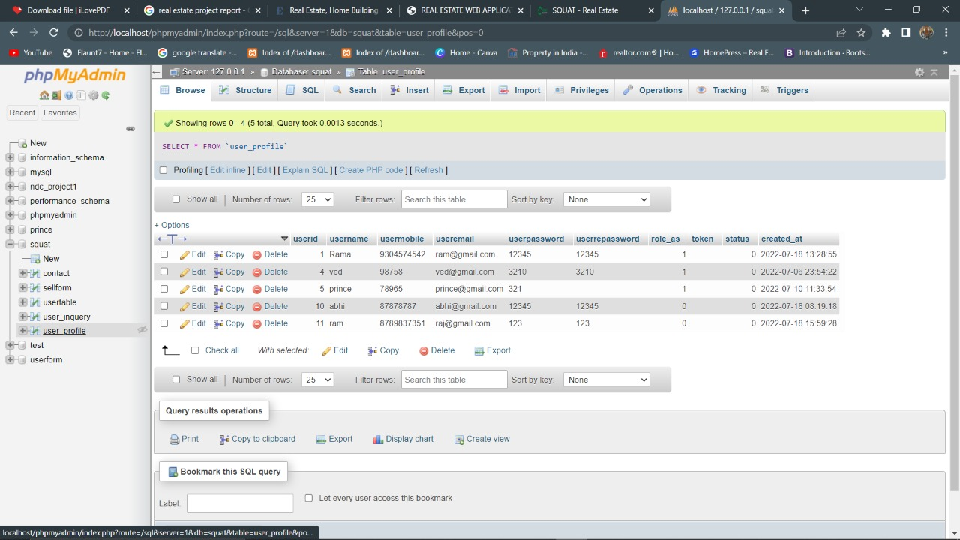

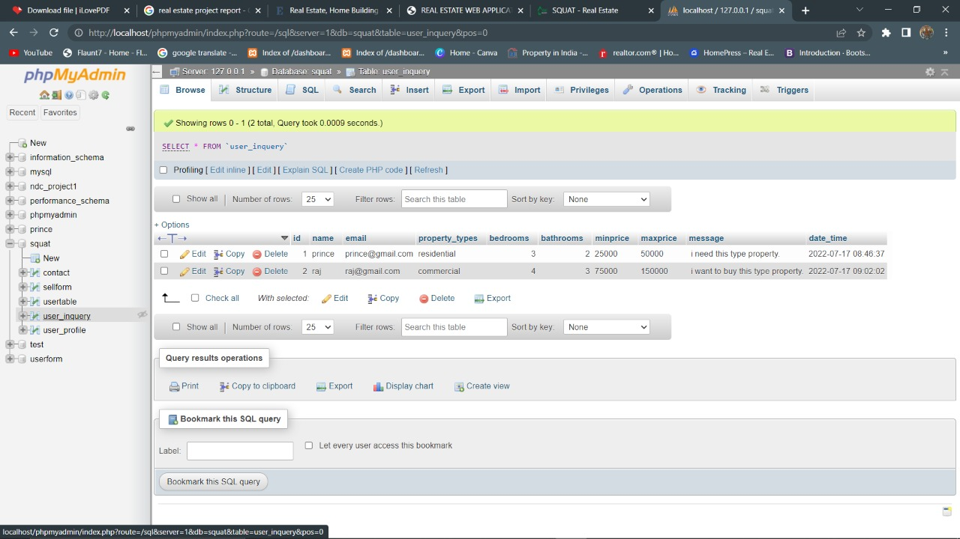

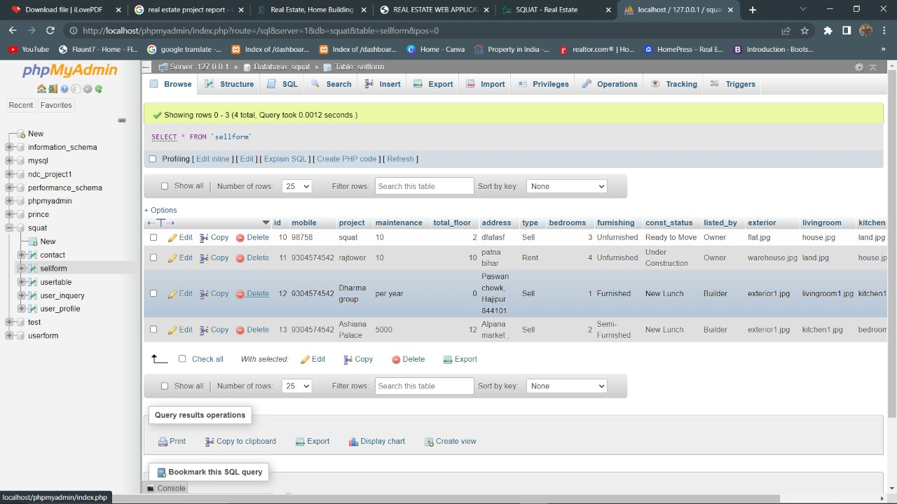

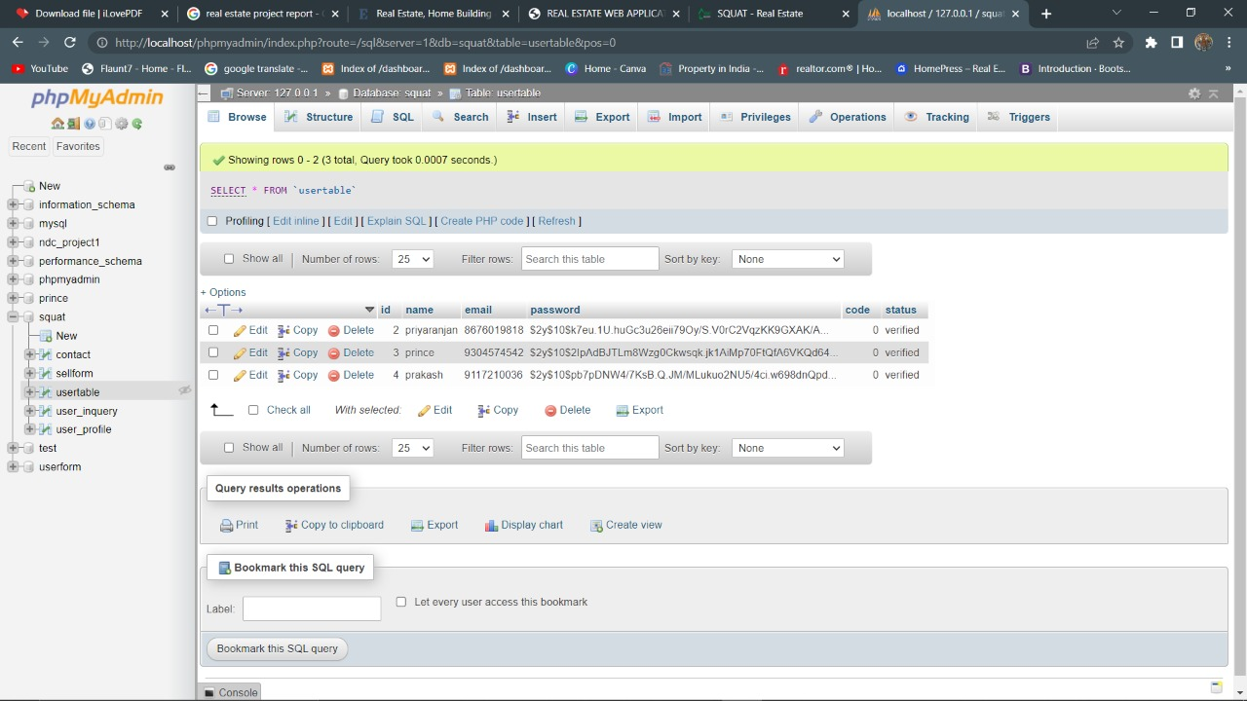

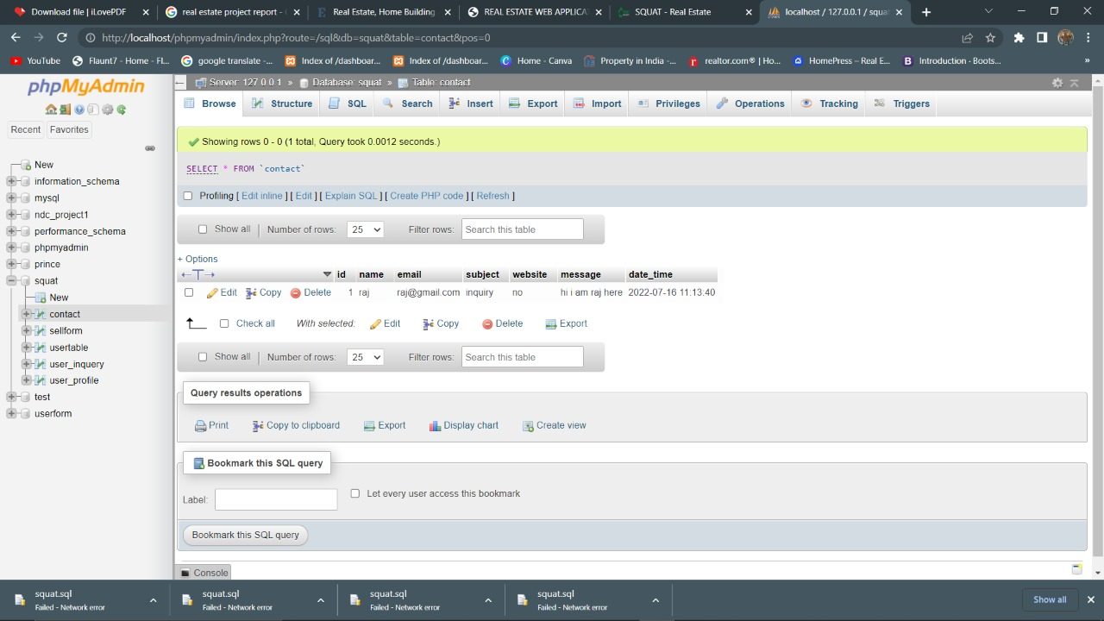

THANK YOU